FOR IMMEDIATE RELEASE
MARCH 3, 2023

OLIVER TREE AND DAVID GUETTA UNITE FOR “HERE WE GO AGAIN”

CHART-TOPPING, MULTI-PLATINUM ARTISTS JOIN FORCES FOR FIRST TIME EVER

RELEASED ALONGSIDE LYRIC VIDEO

LISTEN HERE | WATCH HERE

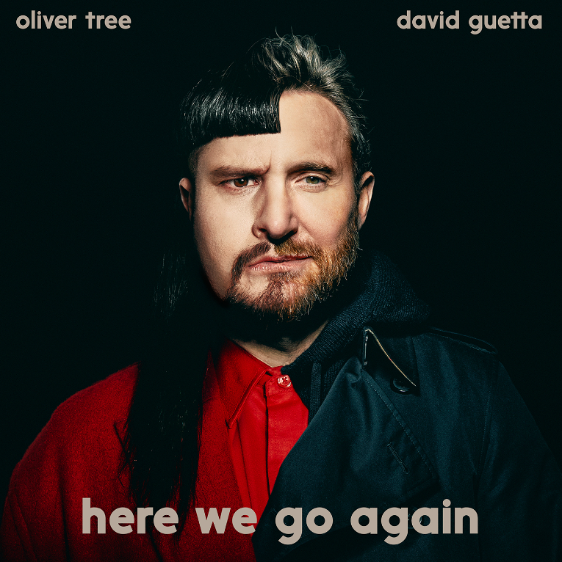
DOWNLOAD ARTWORK HERE

Chart-topping, multi-platinum, genre-bending artists Oliver Tree and David Guetta are teaming up for the first time ever with their electric new track, “Here We Go Again” - Listen HERE. The track is joined by a lyric video aligned with Oliver’s signature, eccentric aesthetic – Watch HERE.

“I recorded this song in London so I was channeling some heavy UK and Euro dance inspiration,” Oliver shared. “It only felt right when working with Dr. David Guetta. The lyrics tell a story of the never ending patterns that we repeat over and over again in our lives. I felt the concept tied nicely into the idea of the dance floor, where people are served one more drop after another… here we go again.”

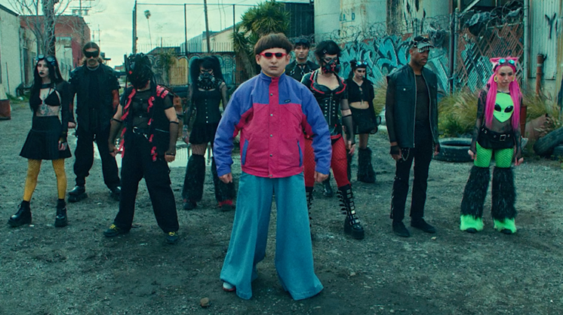
DOWNLOAD THUMBNAIL HERE

ABOUT OLIVER TREE
“Here We Go Again” follows the recent arrival of KSI’s “Voices (Feat. Oliver Tree)” - Watch the official music video HERE. Oliver wrapped up his very busy 2022 with the long-awaited release of Cowboy Tears Drown the World in a Swimming Pool of Sorrow, an expanded deluxe edition of his acclaimed sophomore LP, Cowboy Tears, available now HERE. Highlights include such recent favorites as “I Hate You,” “Placeholder,” and “Suitcase Full Of Cash,” the latter accompanied by an official visual featuring guest appearances from viral stars Alissa Violet, Tana Mongeau, Viking Barbie, and Melissa Ong, streaming now at Oliver’s YouTube channel HERE.

Coming in with a total of 35M monthly listeners on Spotify, Oliver is now the 77th most listened to artist on the platform. Now boasting more than 4B global streams, over 1B YouTube views, over 14.7M TikTok followers, and an cumulative social reach of over 20M, Oliver recently announced plans for his biggest headline show to date, a once-in-a-lifetime concert event set for June 20 at Morrison, CO’s world famous Red Rocks Amphitheatre. Special guests include Tai Verdes, UPSAHL, and Little Ricky ZR3. Additional live dates will be unveiled soon. For complete details and remaining ticket availability, please see www.olivertreemusic.com.

Last year also saw Oliver join forces with GRAMMY® Award-nominated producer Robin Schulz for the high-energy viral hit, “Miss You,” which swiftly amassed over 300M global streams following top 10 debuts on both Billboard’s “Hot Dance/Electronic Songs” chart and the UK’s Official Singles Chart. The track is accompanied by a typically quirky official music video, directed by Oliver and currently boasting more than 135M views via YouTube HERE.

ABOUT DAVID GUETTA
DJ. Producer. Artist. David Guetta is a musical trailblazer and an international icon. Currently the #4 most streamed artist on Spotify globally and with 2x Grammys awards, 11x Grammy nominations, 7x UK number 1 singles, over 35 billion global streams, 50 million records sold worldwide, and over 72 million monthly Spotify listeners to his name, he has been voted the world’s best DJ in the DJ Mag ‘Top 100’ three times and won the accolade for best electronic artist at the MTV Europe Music Awards. To round off 2022 he won two awards at the LOS40 Music Awards, two awards at MTV EMA’s, the ‘Dance Act of the Year’ award at the iHeartRadio Music Awards and ‘DJ of the Year’ award at the NRJ Music Awards, and was additionally named #1 Producer by 1001Tracklists. Guetta closed out the year in Latin America, performing in Peru for a New Year’s Eve extravaganza before setting out on a huge tour in January.

After a year of huge hits, Guetta began 2023 at #1 on the Global Spotify Chart with current global smash ‘I’m Good’ with Bebe Rexha. The track earned Guetta his eleventh Grammy nomination, receiving a nod for ‘Best Dance/Electronic Recording’, has garnered 1 billion global streams and simultaneously hit #1 at the US Top 40 & US Dance Radio charts. Guetta entered the 2023 awards season with nominations at the Grammys, iHeartRadio Awards, the QMusic Top 40 Awards, and at the Brits received a ‘Producer of the Year’ accolade in recognition of his production successes, and also delivered an incredible performance of hits.

Throughout 2022 he released a variety of collaborations including commercial hit ‘Don’t You Worry’ with Black Eyed Peas and Shakira and UK Top 5 pop anthem ‘Crazy What Love Can Do’ with Becky Hill and Ella Henderson. A master creative across genres, Guetta has also gone from strength to strength with his underground-focused Future Rave project alongside Morten; the duo released their eagerly awaited Future Rave EP ‘Episode 2’ in November, which featured the powerful lead single ‘You Can’t Change Me’ with Raye. Elsewhere he has provided remixes for some of the world’s biggest stars including pop royalty Coldplay, Dua Lipa and Megan Thee Stallion, Kodak Black... His final release of 2022 was an acid-fuelled remix of Sam Smith & Kim Petras’ ‘Unholy’. He is additionally working on new music for his underground alias Jack Back.
While maintaining an epic level of quality for his live streams during the pandemic and lockdown, he hosted his iconic United At Home series, a number of unforgettable concerts from Paris’ Louvre Museum, the Burj Khalifa in Dubai, the Icon Brickell in Miami, and atop the Rockefeller Center, raising $2 million in donations for numerous charities. Throughout 2022 Guetta appeared at many of the world’s biggest events and festivals, as well as his own residency at Encore Beach Club in Las Vegas and 2 shows a week in Ibiza: Hï Ibiza with Future Rave and Ushuaïa Ibiza with legendary party F*** ME I’M FAMOUS!.

As he continues to dominate the global charts and play some of the most exciting sets of his career, all while expanding his creative vision, exploring new sounds and evolving as an artist, David Guetta demonstrates time and time again why he is the most cherished electronic artist of our generation.

# # #

CONNECT WITH OLIVER TREE
WEBSITE | FACEBOOK | INSTAGRAM | SPOTIFY | TIK TOK | TWITTER | YOUTUBE

CONNECT WITH DAVID GUETTA
WEBSITE | FACEBOOK | INSTAGRAM | TIKTOK | TWITTER | YOUTUBE

CONTACT
JESSICA NALL // JESSICA.NALL@ATLANTICRECORDS.COM

