FOR IMMEDIATE RELEASE
MARCH 3, 2023

GENEVIEVE STOKES HERALDS NEW EP WITH “YOU & ME”

ALT-POP SONGSTRESS SHARES NEW SONG AND LIVE PERFORMANCE VIDEO

CATCHING RABBITS EP ARRIVES FRIDAY, APRIL 7

LISTEN TO “YOU & ME” | WATCH LIVE PERFORMANCE VIDEO
PRE-SAVE CATCHING RABBITS

DOWNLOAD PRESS PHOTOS + EP ARTWORK HERE

Acclaimed alt-pop singer-songwriter-pianist, Genevieve Stokes, has shared “You & Me,” the latest single released from her forthcoming EP, Catching Rabbits, arriving Friday, April 7TH. The emotional and brooding track is joined by a dreamy live performance video – watch HERE.

“‘You & Me’ is about the empty show of love in an unhealthy relationship,” says Genevieve.

Written by Stokes featuring production from superstar producer Tony Berg (Phoebe Bridgers, Paul McCartney, Taylor Swift), Catching Rabbits is available for pre-order/pre-save HERE. The six-song EP includes recent releases such as the self-soothing lullaby, “17,” and the emotionally charged “Can I,” the latter of which arrived alongside the EP’s exclusive announcement via Rolling Stone.

Catching Rabbits will also feature the EP’s lead single “Habits” which now boasts over 42M global streams after earning more than 50M views across a series of TikTok teases prior to release. The fan favorite track has recently seen yet another viral wave on TikTok with the sped-up sound garnering over 57K creates. A fantastical Alice’s Adventures in Wonderland-inspired music video – directed by Abbie Pitre and Roman Spataro and hailed by TEEN VOGUE as “the woodland fairy fantasy of your dreams” – is streaming now at YouTube HERE. In addition, a gorgeous live performance of “Habits” – filmed in Stokes’ beloved hometown of Portland, ME – is streaming now HERE.

Hailed by PAPER for her “gut wrenching ballads,” Stokes spent much of the past year touring alongside artists including Noah Kahan, Briston Maroney, Sarah Kinsley and Charlie Burg. Additional live dates will be announced soon, and updates can be found at genevievestokes.com/tour.

Genevieve taught herself piano at the age of eight, spending her teen years developing her own unique sound, inspired by iconic female musicians like Fiona Apple and Regina Spektor but infused with her deeply personal experience and perspective. All before releasing her debut EP, Stokes drew attention and applause for her intimate yet lush approach to alternative pop, amassing over 7M streams independently, ascending esteemed playlists and garnering support from Complex, EARMILK, Ones to Watch and more.

Named by Alternative Press as a “New Artist You Need To Hear,” Stokes made a striking major label debut with her angsty yet nostalgic 2021 EP, Swimming Lessons, highlighted by standout tracks, “Surface Tension,” “Parking Lot,” and “Running Away.” Recorded in a cabin just a stone’s throw from the 21-year-old artist’s childhood home, the critically acclaimed project went on to earn over 16M streams worldwide while receiving praise from publications including Flaunt, NYLON, Billboard, Refinery29, FLOOD, and more.

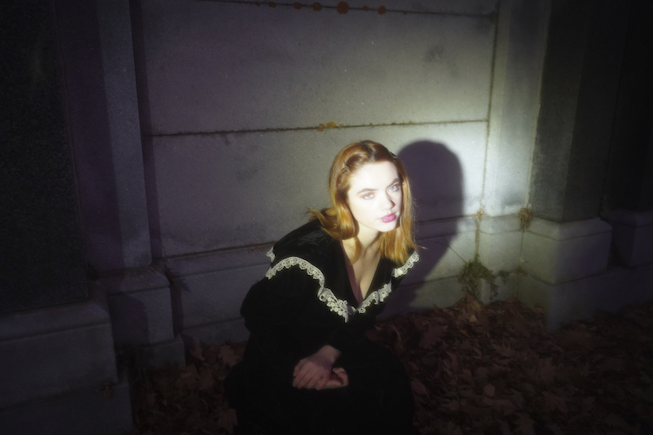
DOWNLOAD PRESS PHOTOS + EP ARTWORK HERE
CREDIT: ABBIE PITRE

CATCHING RABBITS EP TRACKLIST
Habits
You & Me
Can I
Book of Memories
Mara
17

CONNECT WITH GENEVIEVE STOKES
OFFICIAL | INSTAGRAM | TWITTER | YOUTUBE | FACEBOOK | TIKTOK | PRESS ASSETS

PRESS CONTACT:
ANDREW.GEORGE@ATLANTICRECORDS.COM

