FOR IMMEDIATE RELEASE
MARCH 10, 2023

corook opens up on “i’m not doing well”

nashville-based singer-songwriter shares deeply personal song
co-written with Wrabel and Ben Abraham

north american tour supporting Maddie Zahm now underway

listen to “i’m not doing well”

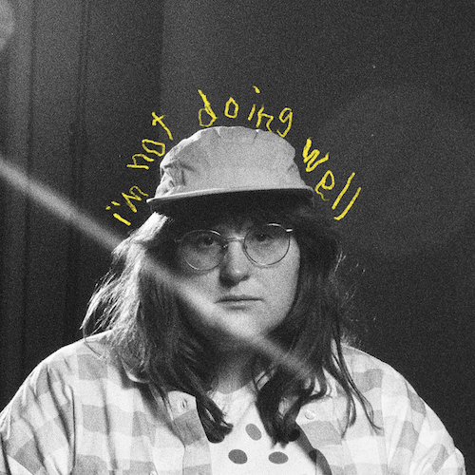
download hi-res artwork

“If specificity is the soul of narrative, then corook is one of the most naturally gifted storytellers in the game.” – BILLBOARD

Nashville-based singer-songwriter corook is setting forth on a new chapter in their musical journey with today’s premiere of “i’m not doing well,” co-written with Wrabel (Backstreet Boys, Kesha) and Ben Abraham (Demi Lovato, Sara Bareilles, Ben Platt).

“I got to write this song with two of my favorite writers, Wrabel and Ben Abraham, at my house in Nashville,” says corook. “To put it simply I wrote it when I was not doing well. Sometimes my sad is short, sometimes my sad is long and this time it felt long. I remember being embarrassed to tell them how I was actually doing but by the end of us writing the song I felt empowered saying how I felt. I recorded and mixed it in my bedroom studio in the cold January winter in hopes of capturing the rawness of my everyday life.”

corook – pronounced ‘co-rook’ – recently celebrated their 28th birthday with their first single of the new year, “the dog” and its heartbreaking music video (co-starring corook and their actual girlfriend) streaming now HERE. The poignant track was met by applause from PAPER, which simply raved, “Channeling Phoebe Bridgers, corook finds anguish and heartbreak in the small details of a breakup.”

After spending much of last year on the road, including their first-ever live runs (supporting K.Flay and Jukebox the Ghost) as well as their debut festival performance at Bonnaroo (featured in Rolling Stone) – the rising musician is currently traveling North America as special guest on Maddie Zahm’s sold-out “You Might Not Like Her” tour. Highlights include stops at NYC’s Bowery Ballroom (March 20) and Los Angeles’ famed Troubadour (April 11). For additional information, please visit www.corook.com.

Named as one of The Advocate’s “7 Queer Artists For Your Fall Playlist,” corook has become known for their ability to tackle deeply personal themes in their music and visuals through a humorous lens. Last spring, the genre-busting, Nashville-based musician blessed the world with their debut EP, achoo!, featuring such surprising and insightful tracks as “idk god,” “degree,” “bad friend,” and “sims” in addition to the fan favorite “snakes.” Further releases followed, among them the viral adult lullaby, “it’s ok!,” the unrestrained “BDSM,” the super-hot “hell yeah,” the heartfelt “your mom,” and the ode to self-worth, “smoothie.” corook also got vulnerable in front of the camera, reflecting on their mental health journey in an episode of Out Magazine’s “Love, Me” video series streaming now HERE.

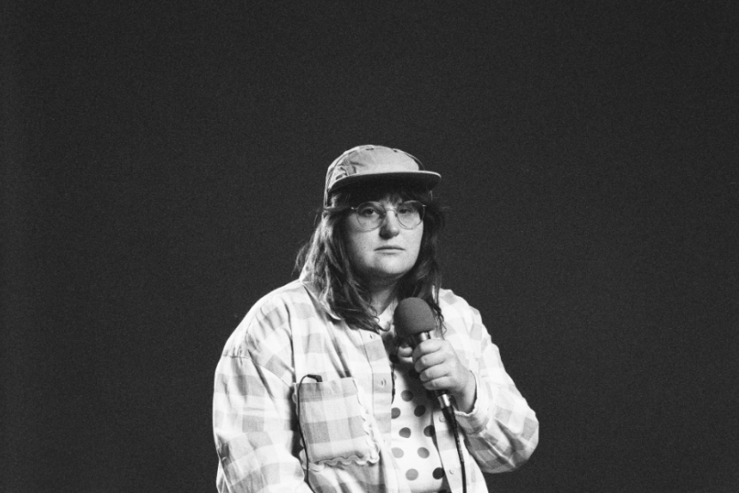
download press photo // credit: libby danforth

corook on tour

MARCH
10 – Kansas City, MO – Encore
12 – Minneapolis, MN – Amsterdam Bar & Hall
13 – Chicago, IL – SPACE
15 – Toronto, ON – Allied Music Center
17 – Boston, MA - Café 939 at Berklee
18 – Philadelphia, PA – World Café Live
20 – New York, NY – Bowery Ballroom
22 – Washington, DC – Union Stage
24 – Atlanta, GA – The Loft
27 – Nashville, TN – The Basement East

APRIL
11 – Los Angeles, CA – The Troubadour

connect with corook:
corook.com | instagram | tiktok | press assets

press contact:
andrew.george@atlanticrecords.com

