FOR IMMEDIATE RELEASE
FEBRUARY 16, 2023

QUANDO RONDO STEPS INTO NEW ENERGY WITH HIS NEW SINGLE “ME FIRST”
MARKS THE FIRST SINGLE FROM HIS UPCOMING ALBUM RECOVERY
DOWNLOAD/STREAM “ME FIRST”
WATCH/SHARE “ME FIRST”
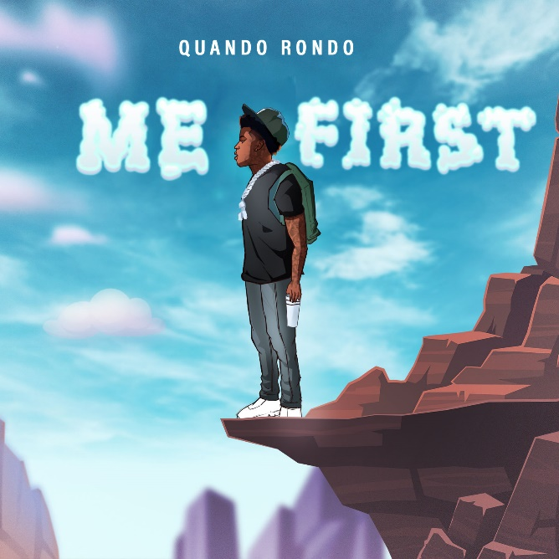
DOWNLOAD HI-RES ARTWORK

Quando Rondo is stepping into a new energy in 2023 with his first release of the year with the single “Me First.” The single is accompanied by a visual available for streaming now. “Me First” comes on the heels of the rising rap star’s most recent visual release “Heat Tucked.” The single was also on Quando’s collab mixtape, 3860, with his industry big brother, YoungBoy Never Broke Again.

“Me First,” sonically takes Quando back to his roots with a slowed down melody over a catchy beat. The track delivers a strong message, one that signifies Quando is ready to put his past behind him & put himself first from here on out. Quando teased “Me First” on his socials back in the Fall and fans continued to flood the comments with calls for Quando to release the full track. “Me First” will be the first single off of his upcoming album, Recovery slated for release early this year. It was also revealed this week that Quando and NoCap's song "New Ones" off of Quando's project "From The Neighborhood To The Stage," is now RIAA certified Gold.
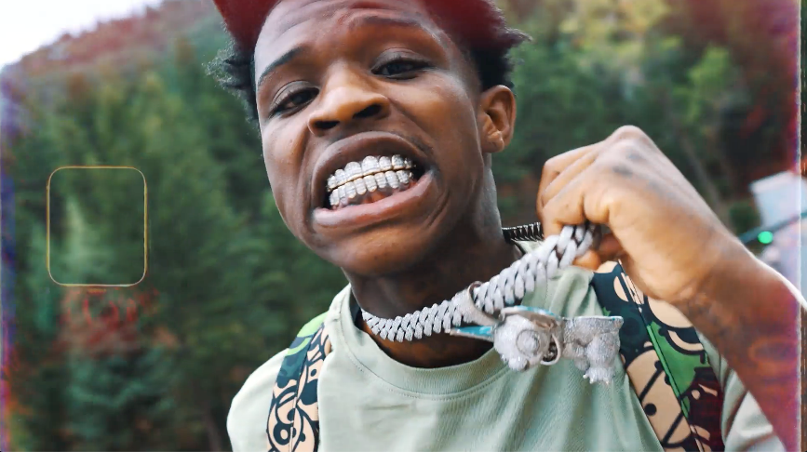

# # #
The multi-platinum Savannah, GA rapper spits with classic dexterity as he spouts off modern melodies with emotional precision and a head-nodding bounce. Since 2017, he has consistently amplified the spirit of the streets throughout the mainstream on his own terms, translating the struggles of Savannah (and hoods everywhere) into a dynamic documentary-style sound. “Give Me A Sign (Feat. YoungBoy Never Broke Again)” continues the rising star’s high-volume year, following such recently released tracks as “Cream Soda,” “It’s On,” “War Baby,” “24,” “10.27,” “Six-0 Business,” “Jakiyah” and his recent guest verse on YoungBoy Never Broke Again’s “Gangsta (Ft. Quando Rondo)” – the only feature on YoungBoy’s chart-topping 2022 mixtape, COLORS. What’s more, YoungBoy shouts out Quando on two of the mixtape’s standout tracks, “Bring It On” and “No Switch.”

Quando officially kicked off his busy 2022 with the previously released single, “Dead Wrong,” available for streaming and download HERE; an official music video is streaming HERE. The creative hot streak commenced with last year’s release of the critically acclaimed album, Still Taking Risks, and was swiftly followed by guest verses on the explosive Never Broke Again: The Compilation Vol. 1. A stunning series of singles also dropped, including “Blueprint,” “The Realest,” “Time Spent,” and “Shine,” all available now with official music videos streaming via YouTube. After a flurry of single releases throughout the year, Quando ended his 2022 in a major way with the release of collab mixtape with YoungBoy, entitled 3860.

CONNECT WITH QUANDO RONDO
OFFICIAL | INSTAGRAM | TWITTER | FACEBOOK | YOUTUBE

FOR ALL PRESS INQUIRIES, PLEASE CONTACT:
ARIANA.WHITE@ATLANTICRECORDS.COM

