FOR IMMEDIATE RELEASE
MARCH 24, 2023

QUANDO RONDO IS REFLECTING ON HIS RECOVERY ON HIS NEW ALBUM
RELEASE IS ACCOMPANIED BY A VISUAL FOR “WHERE WOULD I BE”
20-TRACK ALBUM INCLUDES A LONE FEATURE FROM YOUNGBOY NEVER BROKE AGAIN
TRAILER FOR HIS UPCOMING ALBUM DOCUMENTARY CAN BE VIEWED HERE
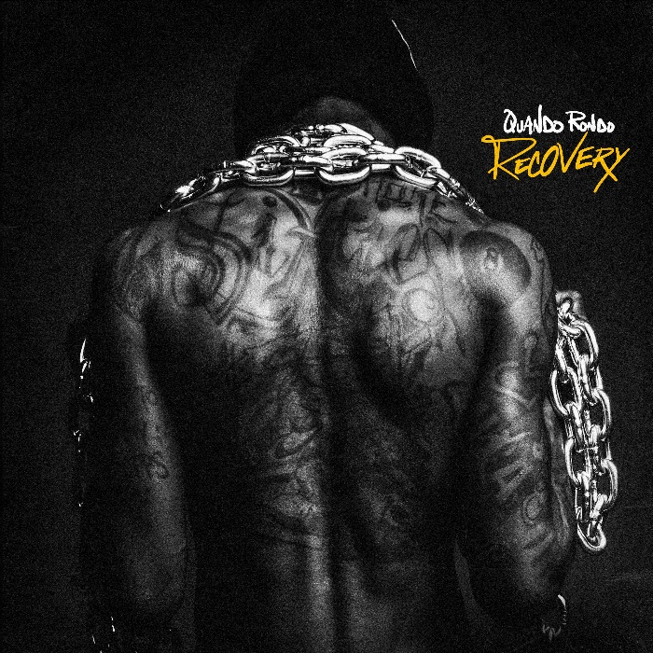
DOWNLOAD HI-RES ARTWORK
STREAM HERE | WATCH HERE
Quando Rondo is ready to right his wrongs and lay it all out on the line with the release of his new album, Recovery. The 20-track album includes a lone feature from YoungBoy Never Broke Again on their track “Give Me A Sign” which Quando released after the untimely passing of his cousin, Pabb. The album was accompanied by last night’s visual release for “Where Would I Be.” Recovery marks Quando’s first solo album in over 2 years. The album title is also a nod to him putting his past behind him and growing as both an artist, but more importantly as a man with a family that looks up to him. A few notable producers on the album include Bankroll Got It, DJ Chose, SephGotTheWaves, & CXBGoCrazy.
Last week, along with the pre-order for Recovery, Quando released the second single from the album, “Tear It Down.” Quando flows perfectly to compliment the beat of “Tear It Down” as he raps about his lifestyle. His vocals provide a more mature sound than his fans are used to – showing the world that he has evolved over the years. The visual is now boasting over 1M+ views in just a week. Quando also shared the trailer for his upcoming album documentary available to view HERE. Recovery serves as his reintroduction. It is setting him up to be taken seriously as an artist who has overcome everything thrown at him and come out stronger because of it. The 20-track project is a mix of the classic Quando Rondo melodic sound that propelled him to stardom, along with a new sound that he’s been developing over the past few years.

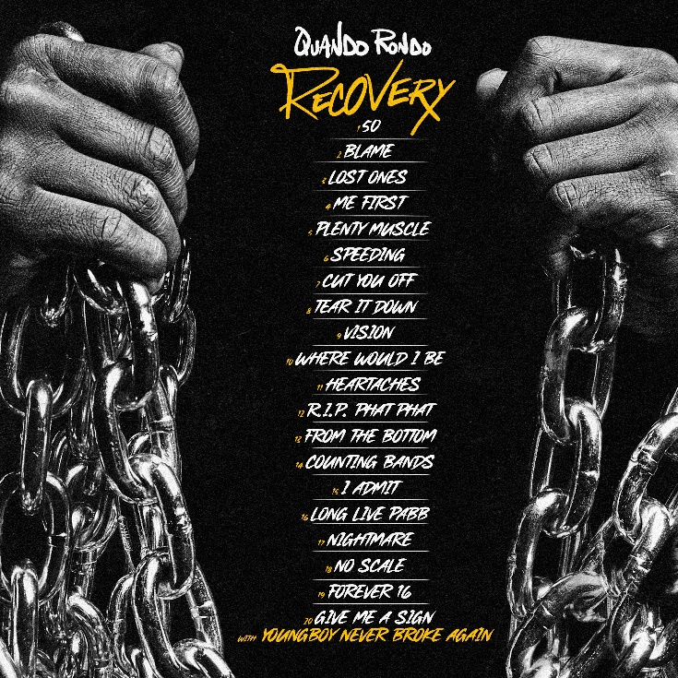

RECOVERY TRACKLIST

- 50
- Blame
- Lost Ones
- Me First
- Plenty Muscle
- Speeding
- Cut You Off
- Tear It Down
- Vision
- Where Would I Be
- Heartaches
- R.I.P. Phat Phat
- From The Bottom
- Counting Bands
- I Admit
- Long Live Pabb
- Nightmare
- No Scale
- Forever 16
- Give Me A Sign with YoungBoy Never Broke Again

# # #
QUANDO RONDO

When you know yourself, you can share your story. During a meteoric rise as one of hip-hop’s most enigmatic figures, Quando Rondo discovered himself. The Savannah, GA native went from D.I.Y. upstart to multiplatinum phenomenon, but he also simultaneously transformed from a complicated teen into a thoughtful young man. Along the way, he found fame and fortune, yet he lost friends and loved ones. Never letting his foot off the gas, he built a bulletproof catalog of bangers highlighted by platinum singles—“ABG,” “I Remember” [feat. Lil Baby], and “Imperfect Flower”—as well as a slew of gold singles, namely “Bacc to the Basics,” “Dope Boy Dreams,” “New Ones” [with NoCap], and “Scarred from Love,” to name a few. Meanwhile, his 2020 full-length debut, QPac, crashed the Top 25 of the Billboard 200. Throughout 2022, he assembled what would become “Recovery,” teasing its impending arrival with standouts such as “Long Live Pabb” (dedicated to the late Lul Pabb) and “Me First.” He made a conscious decision to dive deeper into his journey. After earning nearly 2 billion streams, over a dozen RIAA certifications, and widespread acclaim from Pitchfork, Complex, REVOLT, and many others, this sharp street storyteller divulges more than ever before on his 2023 third full-length album, Recovery [Atlantic Records].

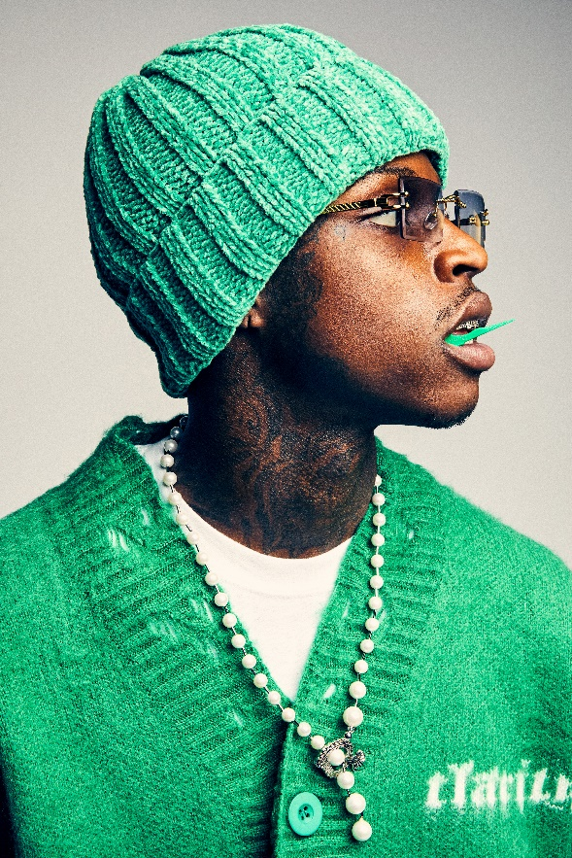
DOWNLOAD HI-RES PHOTOS
CREDIT: JIMMY FONTAINE

CONNECT WITH QUANDO RONDO
OFFICIAL | INSTAGRAM | TWITTER | FACEBOOK | YOUTUBE

FOR ALL PRESS INQUIRIES, PLEASE CONTACT:
ARIANA.WHITE@ATLANTICRECORDS.COM

