TIËSTO DROPS GLOBAL PARTY ANTHEM “ALL NIGHTER”
+ UNVEILS FORTHCOMING ALBUM DRIVE

DRIVE IS A CULMINATION & CELEBRATON OF THE LATEST PERIOD OF TIËSTO’S CAREER
OUT EVERYWHERE FRIDAY, APRIL 21
LISTEN TO “ALL NIGHTER” HERE | WATCH OFFICIAL VISUALIZER HERE
PRE-ORDER/PRE-SAVE DRIVE HERE

YOU’RE INVITED TO ATTEND THE OFFICAL PRE-LISTENING & 3D EXPERIENCE FOR DRIVE
EAGERLY AWAITED NEW ALBUM INCLUDES
INTERNATIONAL HIT SINGLES, “THE BUSINESS,” “DON’T BE SHY (WITH KAROL G),”
“THE MOTTO (WITH AVA MAX),” “HOT IN IT (WITH CHARLI XCX),”
“10:35 (WITH TATE MCRAE),” AND MORE

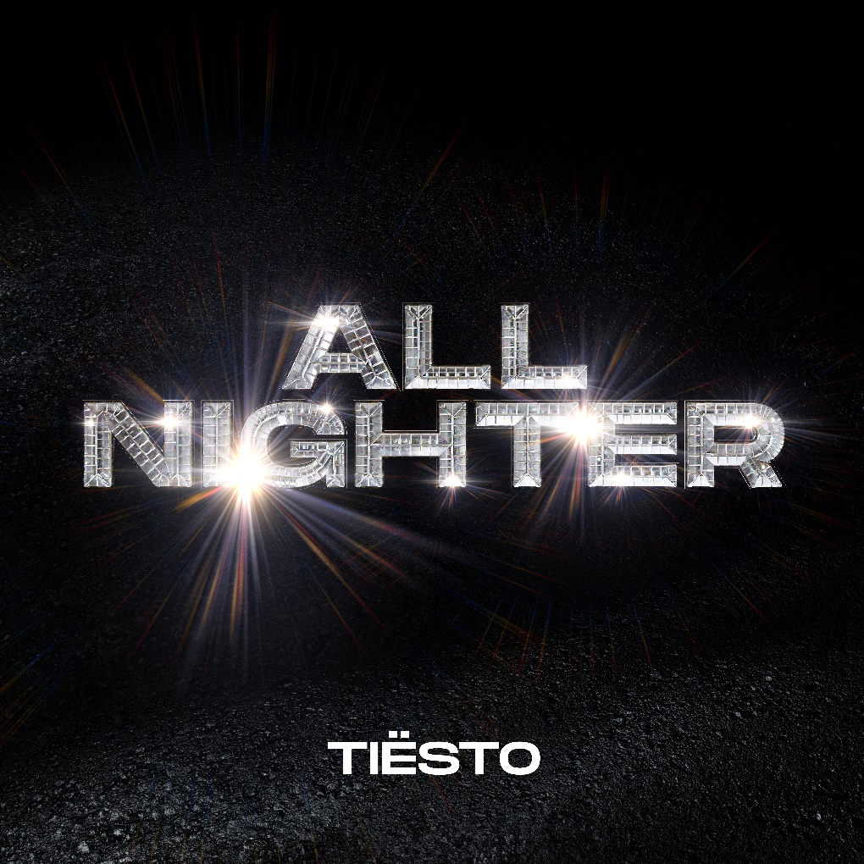
DOWNLOAD HI-RES ARTWORK

Tiësto has announced the release of his hugely anticipated new album, Drive, arriving everywhere via Atlantic Records on Friday, April 21st. The album, which features previously released singles, is the crowning achievement celebrating the latest period of his career. Pre-orders/pre-saves are available now. Drive is heralded by today’s premiere of the new single and opening track, “All Nighter,” available now at all DSPs and streaming services. An official (music/lyric) video is streaming now at YouTube. Tiësto has put together an exclusive visual/pre-listening experience for his album, taking place in Los Angeles on March 22nd. This will be a first of it’s kind 3D experience – and he’s giving his fans a chance to attend – enter here!
Drive showcases the sleek and sexy sound that’s become Tiësto’s signature. Named for the perpetual momentum of his creative calling and the physical movement his work continues to inspire, the album also includes such multi-million streaming worldwide hit singles as “The Business,” “Don’t Be Shy (With Karol G),” “The Motto (With Ava Max),” “Hot In It (With Charli XCX),” and “10:35 (With Tate McRae)”, which together have a combination of 3.5 billion streams. The album’s visual component pays homage to his life-long fascination with Formula 1 racing, with this art inspired by the 2004 Monaco Grand Prix, where a $430,000 diamond affixed to the front of a racecar disappeared forever – a tale that sets the album’s tone of sophisticated glitz and intrigue.
The concept album simulates an epic night out, certainly an experience Tiësto understands better than most. This nightlife voyage begins with “All Nighter” a call to arms for the madness to come. Ava Max then encourages listeners to “drop a few bills and pop a few champagne bottles” on “The Motto” before the evening shifts into full gear with the clock striking “10:35.” It’s then time to hit the dance floor and get down to “The Business”. This party then welcomes vocal guests A Boogie (“Chills (LA Hills)”), Charli XCX (“Hot In It”), The Black Eyed Peas (“Pump It Louder”) and Karol G, with the vibe then shifting into house music that will make you fall in love on the dancefloor (“I’d Bet”) and the alluring afterhours feel of “Back Around.” The LP closes with “Yesterday,” the one to play at dawn when all you want is to live the night over again. Named for the perpetual momentum of Tiësto’s career and the physical movement his work continues to inspire, Drive makes the thrill of the dancefloor available whenever, and wherever, listeners turn it on.
Tiësto is a pillar of electronic music and an artist that transcends beyond that – Tiësto is an experience. The artist born Tijs Verwest has found a particular sweet spot in this crossover realm, gaining critical acclaim and millions of new fans with a litany of hits including his first single upon signing with Atlantic Records, “The Business,” which has dominated airplay and charts worldwide since its September 2020 release, hitting #1 at US Dance radio while also garnering over 1.6B worldwide streams to date. A top 10 hit in ten countries, as well as a Top 50 success on Spotify in thirty-one countries, “The Business” was honored with “Best Dance/Electronic Recording” nomination at the 64th Annual GRAMMY® Awards along with 15 platinum certifications and eight gold certifications in countries around the world. “Don’t Be Shy” with Karol G followed, marking Karol G’s first-ever English language song and the first Latin Artist collaboration for Tiësto. The historic track currently boasts over 867M streams, over 1.2M TikTok creates, and video views exceeding 331M. “The Motto” with Ava Max proved another blockbuster, reaching the top 5 on Billboard’s “Hot Dance/Electronic Songs” chart while earning more than 930M worldwide streams to date. “Hot In It” with Charli XCX reach the top 10 on Billboard’s “Hot Dance/Electronic Songs” chart, fueled in part by over 200M views across TikTok and IG Reels and over 122M streams to date.““10:35,” the worldwide hit single co-created by Tiësto and multi-platinum singer/songwriter Tate McRae in partnership with Dubai’s new ultra-luxury resort Atlantis The Royal, proved an immediate success upon its release late last year, earning over 137M worldwide spins while ascending to the upper reaches of singles charts around the globe, including the top 5 on Billboard’s “Hot Dance/Electronic Songs.”.
# # #

TIËSTO
DRIVE
(Atlantic Records)
Release Date: Friday, April 21

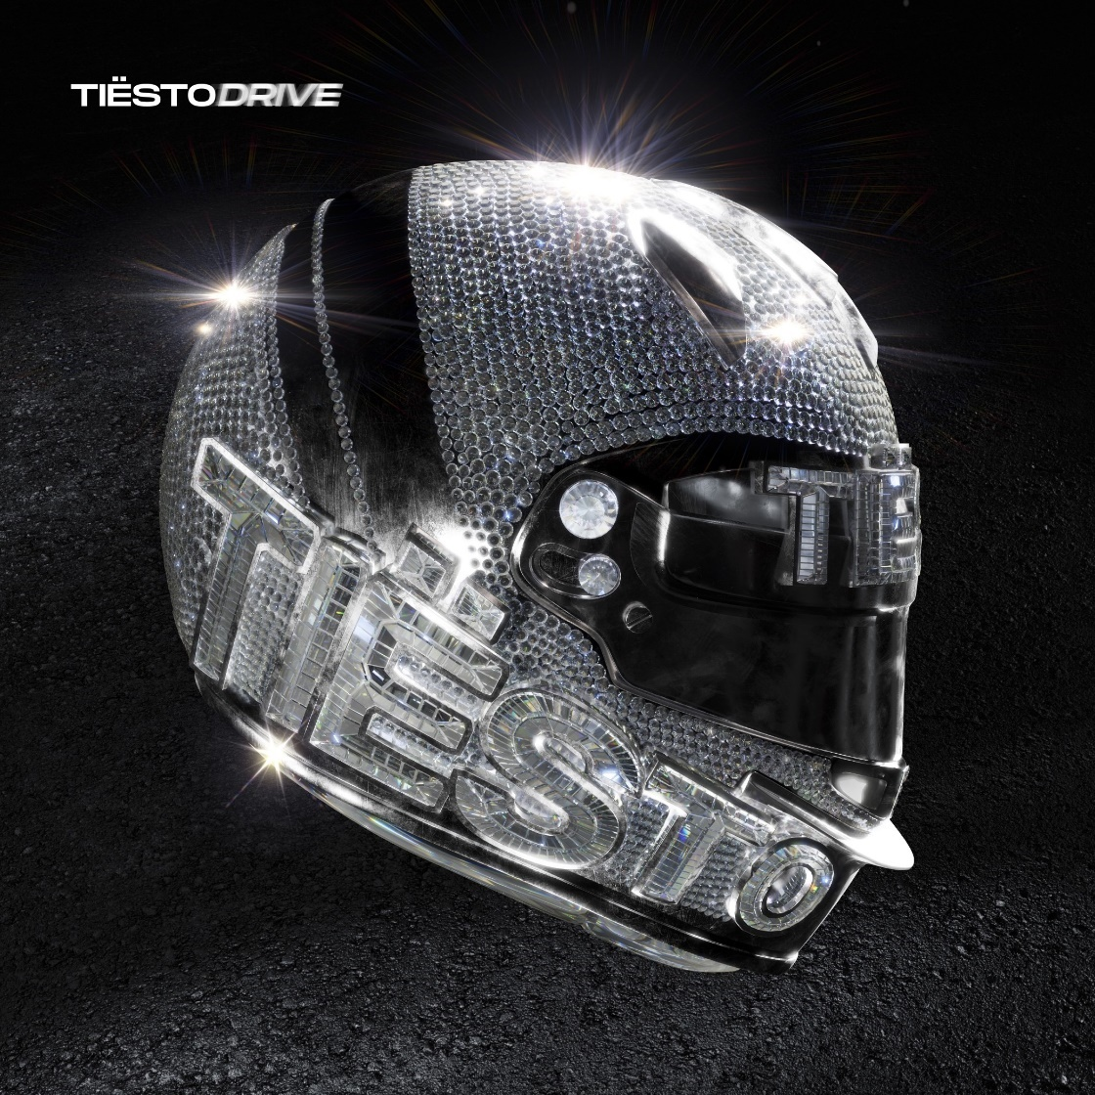
Tracklist:
- All Nighter
- The Motto with Ava Max
- 10:35 with Tate McRae
- The Business
- Chills (LA Hills) with A Boogie With Da Hoodie
- Hot In It with Charli XCX
- Pump It Louder with Black Eyed Peas
- Learn 2 Love
- Don’t Be Shy with Karol G
- Bet My Dollar with Freya Riding
- Back Around with AR/CO
- Lay Low

# # #

DOWNLOAD PRESS PHOTO HERE

# # #

CONNECT WITH TIËSTO:
OFFICIAL | FACEBOOK | INSTAGRAM | SPOTIFY | TIKTOK | TWITTER | YOUTUBE

FOR MORE INFORMATION ON TIËSTO:
Paige Rosoff – Atlantic Records
Paige.Rosoff@atlanticrecords.com

