GENRE-BENDING ARTIST GRANDMA RELEASES “BLUE ATLANTA”
& ANNOUNCES ANGELHOOD EP, OUT JULY 15TH

FOLLOWS HYPNOTICALLY TRANSCENDENT SINGLE “I MET GOD ONLINE”

LISTEN TO “BLUE ATLANTA” HERE
WATCH OFFICIAL MUSIC VIDEO HERE

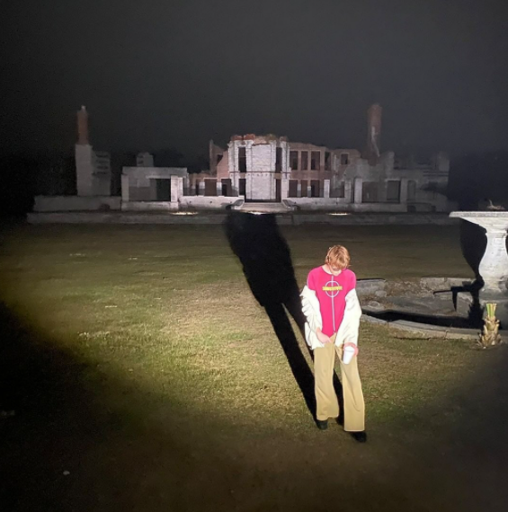
DL SINGLE ART // DL PRESS PHOTO

Following his April single “I Met God Online,” genre-bending alternative artist grandma releases “Blue Atlanta,” a dreamy ode to darkness and disengagement. Listen HERE and watch the music video HERE. grandma also announces his next EP, “Angelhood” today, which is set for a July 15th release.
“Blue Atlanta is about the imaginative avenues I created at a time of extreme loss. When I began to hate my environment and my inner world grew dull all I could do was detach. The video is about unfolding and breaking away from the life I created that caused me so much pain. Whether it was friends dying to addiction or suicide I just felt the light went dimmer and dimmer,” says grandma of the track. Watch the video, co-directed by Jack Dalton and grandma himself, HERE.
“I Met God Online,” released last month, chronicles the nonlinear nature of love in the digital age—failed talking stages, psychosexual pining, miscommunication and vibe shifts— intertwined with a fascinating strain of theism. ”I Met God Online” is about people’s fascination with internet esotericism,” says grandma. “A meditation on how someone’s life and internet presence can amorphously become someone else’s religion, obsession, or gospel.”

Hailed by Highsnobiety for “crafting music that pushes the notion of genre experimentation and fusion to unimaginably innovative heights,” grandma – a.k.a. multi-instrumentalist/producer Liam Hall – has earned applause for his fascinating amalgam of bedroom hip-hop, raw funk, alternative R&B, and lo-fi pop, showcased on 2019’s debut mixtape, Even If We Don’t Get It Together. The project – which features such groundbreaking tracks as “Stomp and Grind (Feat. Rico Nasty),” “Downtown Life,” and “Shallow Water,” – was followed in 2020 by an extensive string of chameleonic singles, including “Everybody’s On Their Phone,” which was featured on SiriusXM Alt Nation’s Advanced Placement and described by PAPER Magazine as a “reassuring and observant new song”, and “Virtually Anything,” an acclaimed collaboration with anti-pop star sophie meiers which earned acclaim from Nuance Magazine as “an extremely enticing track that is a must listen for any alternative/R&B fans.”

Known throughout Atlanta’s pop and hip-hop scenes for his skills as a singer, songwriter, musician, producer, programmer, arranger, and visual artist, grandma has received a wide range of media attention, with Pigeons & Planes naming him “Best New Artist of the Month” and A1234 declaring, “grandma, I have no doubt, will soon be the soundtrack to many people’s adolescence as his genre-defying talent speaks to a whole new generation of music lovers.” The preternaturally talented polymath maintained a steady flow of tracks through 2020, including “Chills,” “Bested,” and “Growing Up Is Strange,” all of which were accompanied by self-made companion videos, streaming now at his official YouTube channel HERE.

Now grandma is poised to push his distinctive brand of personal pop ever higher, reaching heavenward with a one-of-a-kind sound and vision unlike any other. Expect more music from this new chapter soon.

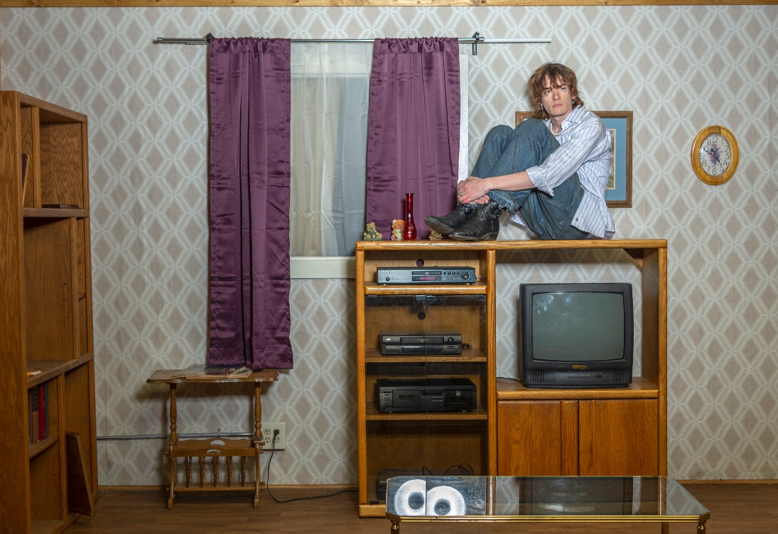
DOWNLOAD PRESS PHOTOS

CONNECT WITH GRANDMA
INSTAGRAM | TIK TOK | TWITTER | YOUTUBE

For press inquiries, please contact:
Kelly McWilliam // Kelly.McWilliam@AtlanticRecords.com
Gabrielle Reese // Gabrielle.Reese@AtlanticRecords.com

