FOR IMMEDIATE RELEASE
APRIL 7, 2023

ARDEN JONES IS BACK WITH “FVCKED UP”

CALIFORNIA SINGER/SONGWRITER/RAPPER/MULTI-INSTRUMENTALIST SHARES
EAGERLY AWAITED NEW SINGLE FOLLOWING RECENT STRING OF VIRAL TEASERS

AGE TAPE MINI RUNS BEGIN APRIL 18 IN SANTA BARBARA, CA
INCLUDES FESTIVAL PERFORMANCE AT BOTTLEROCK NAPA VALLEY

AGE TAPE MINI RUN PT. 2 ANNOUNCED TODAY
TICKETS ON SALE AT 11 AM PT

NEW TRACKS TO PREMIERE EVERY THREE WEEKS THROUGHOUT TOUR

LISTEN TO “FVCKED UP” HERE

DOWNLOAD ARTWORK HERE

“Nobody keeps it real quite like Arden Jones.” – PEOPLE

Rising California singer/songwriter/rapper/multi-instrumentalist Arden Jones is back with his eagerly awaited new single, “fvcked up,” available now via vnclm_ x Atlantic Records. The track, co-written by Jones with Roy Lenzo (Lil Nas X, Cardi B) and produced by longtime collaborator F E R R O (Skrillex, Faouzia), was heralded with a recent series of viral teasers that have already drawn over 750K views on TikTok alone.

“fvcked up” kicks off a busy spring and summer for Jones, with more new music and string of Age Tape Mini Runs set for the upcoming months. The live schedule gets underway later this month with a trio of home state headline shows, beginning April 18 at Santa Barbara, CA’s Soho Restaurant & Music Venue. Announced today is Age Tape Mini Run Pt. 2, which includes a festival performance at BottleRock in Napa, CA and stops in Dallas, Nashville and more. Tickets go on sale today at 11 AM PT. For complete details and ticket availability, please visit www.ardenjonesmusic.com/tour.

While on the road, Jones will continue to share new music with his fast-growing cadre of fans, with original tracks set to premiere every three weeks. The ambitious schedule follows the recent single, “careless 2.0,” as well as the 21-year-old Marin County, CA-born artist’s groundbreaking age tape series, 10 unique releases collecting songs on the first Thursday of every month throughout 2022. The 10th and most recent release, age tape 0, collects such popular favorites as “mr. sunshine,” “horror story,” “indifferent,” “serotonin highs (feat. Allen Haley),” and the viral hit “starstruck,” (the latter of which garnered Jones more than 20M views across TikTok and Instagram Reels) alongside five brand new songs including standout track “not afraid at all.”

Known for an irresistible pop approach that bottles the sunshine of an endless California summer, Arden Jones has already earned over 160M worldwide streams, more than 15M video views, and 2.3M monthly Spotify listeners, jumpstarted by hugely popular tracks such as 2021’s acclaimed vnclm_ x Atlantic Records single, “SMILE,” as well as the viral hit, “Parallel Parking.” Named among PEOPLE’s 2022 “Talented Emerging Artists You Should Be Listening to All Summer Long,” Jones – who has spent much of the past two years touring alongside fellow breakout pop stars such as Tai Verdes, Thomas Headon, and Chelsea Cutler – has drawn a wide range of media attention in recent months, spanning Teen Vogue, Pop Dust, Ones To Watch, Entertainment Tonight, and a cover appearance in Rival Magazine, to name but a few.

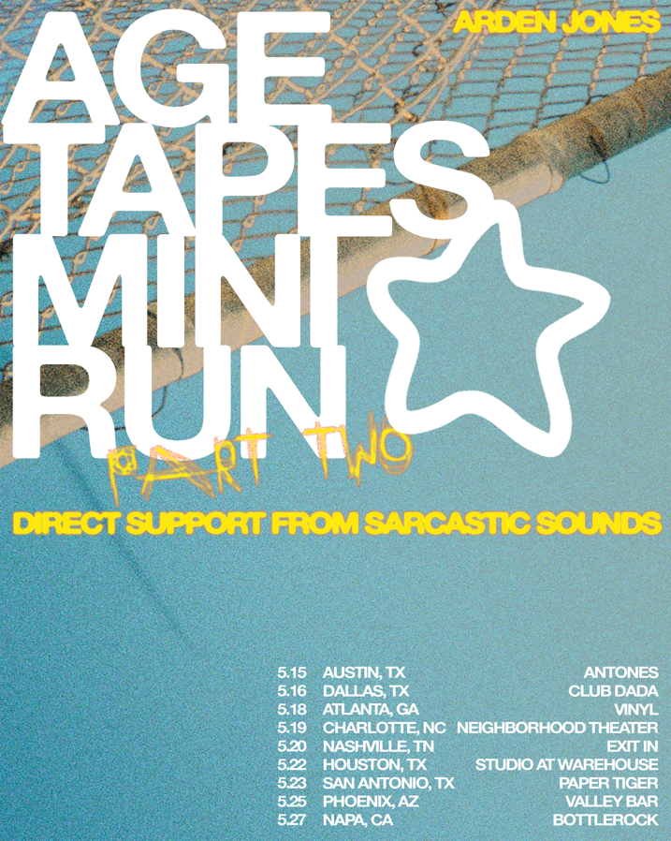

ARDEN JONES
NORTH AMERICAN TOUR 2023

APRIL
18 – Santa Barbara, CA – Soho Restaurant & Music Venue
20 – Santa Cruz, CA – The Catalyst Atrium
21 – Sacramento, CA – Harlow’s

MAY
15 – Austin, TX – Antones
16 – Dallas, TX – Club Dada
18 – Atlanta, GA – Vinyl
19 – Charlotte, NC – Neighborhood Theater
20 – Nashville, TN – Exit In
22 – Houston, TX – Studio at Warehouse
23 – San Antonio, TX – Paper Tiger
25 – Phoenix, AZ – Valley Bar
26-28 – Napa, CA - BottleRock Napa Valley 2023 *

* Festival Appearance

# # #

DOWNLOAD HI-RES PRESS PHOTO
CREDIT: SJ SPRENG

CONNECT WITH ARDEN JONES
WEBSITE | INSTAGRAM | TIKTOK | TWITTER | YOUTUBE | SPOTIFY

For press inquiries, please contact:
Jessica Nall // Jessica.Nall@atlanticrecords.com
Gabrielle Reese // Gabrielle.Reese@atlanticrecords.com

