FOR IMMEDIATE RELEASE
APRIL 3, 2023

AVA MAX ANNOUNCES US HEADLINE TOUR (FINALLY)

US LEG COMPLETES WORLD TOUR THAT INCLUDES SOLD-OUT EUROPEAN RUN

RIAA MULTI-PLATINUM CERTIFIED POP STAR’S CRITICALLY ACCLAIMED
SOPHOMORE ALBUM DIAMONDS & DANCEFLOORS OUT NOW
LISTEN HERE

“GHOST” VISUALIZER OUT NOW – WATCH HERE

TOUR GETS UNDERWAY MAY 31 IN DETROIT, MI
TICKETS ON SALE FRIDAY, APRIL 7

RIAA multi-platinum certified global pop sensation Ava Max has announced the US dates of her global headline tour, “Ava Max On Tour (Finally).” The US leg gets underway May 31st in Detroit, MI and includes stops at New York’s Irving Plaza and Los Angeles’ The Fonda Theatre before wrapping up on July 1st in Milwaukee, WI. Tickets for the US dates go on sale this Friday, April 7th at 10 AM PT / 1 PM ET. For more information, please visit https://www.avamax.com/tour/.
Ava – who recently celebrated the release of Diamonds & Dancefloors with a sold-out headline event at Los Angeles, CA’s famed Hollywood Forever Cemetery – is currently set to embark on her biggest world tour to date, with a sold out EU/UK run including stops in the UK, Belgium, France, the Netherlands, Norway, Switzerland, Italy, Portugal, Germany, Spain, and Finland. North American dates include a top-billed performance at Pittsburgh, PA’s Pride on the Shore (June 3) as well as a headline concert at Milwaukee, WI’s BMO Pavilion (July 1).

Diamonds & Dancefloors, the eagerly awaited follow-up to Ava’s RIAA Platinum-certified 2020 debut album Heaven & Hell, includes such passionately self-assured singles as “One of Us,” “Cold As Ice,” “Dancing’s Done,” “Weapons,” “Maybe You’re The Problem,” and “Million Dollar Baby,” the latter of which now boasts almost 145M global streams after garnering 10M streams and 8M music video views in just two weeks after its release. Hailed by PAPER as “a euphoric euro dance number,” “Million Dollar Baby” is joined by an official music video, directed by Andrew Donoho (Khalid, Janelle Monae, Paul McCartney), currently boasting over 30M views HERE. Most recently, Ava shared the official visualizer for “Ghost,” the latest single from her acclaimed sophomore album.

AVA MAX – US TOUR

MAY
31 – Detroit, MI – St Andrews Hall

JUNE
1 – Chicago, IL – House of Blues Chicago
3 – Pittsburgh, PA – Stage AE *Pittsburgh Pride
4 – Philadelphia, PA – Theatre of Living Arts
6 – Boston, MA – Paradise Rock Club
8 – New York, NY – Irving Plaza
9 – Silver Spring, MD – The Fillmore Silver Spring
11 – Atlanta, GA – Buckhead Theatre
12 – Nashville, TN – Brooklyn Bowl
15 – Houston, TX – House of Blues Houston
16 – Dallas, TX – The Echo Lounge & Music Hall
19 – San Diego, CA – House of Blues San Diego
20 – Los Angeles, CA – The Fonda Theatre
22 – San Francisco, CA – The Fillmore
24 – Seattle, WA – Neptune Theatre
25 – Portland, OR – Crystal Ballroom
28 – Denver, CO – Summit Music Hall
30 – Minneapolis, MN – Varsity Theater

JULY
1 – Milwaukee, WI – BMO Harris Pavilion (Summerfest)

###

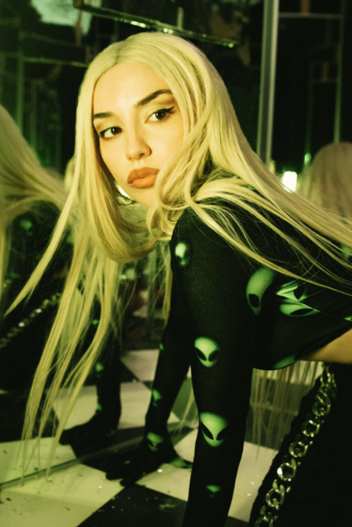
DOWNLOAD HI-RES PRESS PHOTO
CREDIT MARILYN HUE

WHAT CRITICS ARE SAYING ABOUT DIAMONDS & DANCEFLOORS

“…Diamonds & Dancefloors is shaping up to be a more introspective record as Max ruminates on the times she’s been hurt. But rather than wallow in self-pity, she picks herself up and heads straight to the dancefloor” – FORBES

“Ava Max is partying like it’s 2000 and 2004 on the thumping ‘Million Dollar Baby,’ a sleek, calisthenic pop song...” – THE NEW YORK TIMES

“With touches of Eighties synths and retro-futurism, the Albanian American pop star delivers electro-pop bangers that will make you dance and cry at the same time” – ROLLING STONE

"'Weapons' is Ava Max doing what she does best –– conjuring empowering, technicolor Europop that's camp and impeccably constructed" – PAPER MAGAZINE

“The summery anthem [Maybe You’re The Problem] builds off of the momentum that her mammoth hit ‘Sweet but Psycho’ established, and if this is what the rest of her highly-anticipated album sounds like, we’re in for a real treat” – CONSEQUENCE

“Maybe you're the problem, and maybe this is the most upbeat breakup song ever….this song was made for blasting at full volume and dancing with your girlfriends.” – V MAGAZINE

###

CONNECT WITH AVA MAX:
OFFICIAL I INSTAGRAM I TIKTOK | TWITTER I FACEBOOK | YOUTUBE

Press Contacts:
Kelly McWilliam / Kelly.McWilliam@atlanticrecords.com
Ashley Kalmanowitz / Ashley.Kalmanowitz@atlanticrecords.com

