FOR IMMEDIATE RELEASE
APRIL 14, 2023

BAZZI MARKS FIFTH ANNIVERSARY OF COSMIC WITH “EYES”

CHART-TOPPING SINGER-SONGWRITER CELEBRATES RIAA PLATINUM-CERTIFIED DEBUT
WITH PREVIOUSLY UNRELEASED FAN FAVORITE FROM ORIGINAL ALBUM SESSIONS
LISTEN HERE

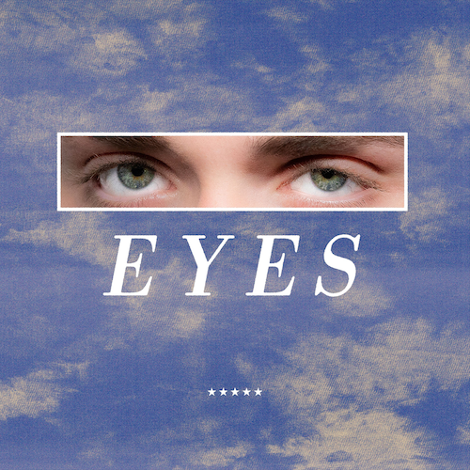
DOWNLOAD ARTWORK HERE // CREDIT: HENRY AMMANN

Chart-topping multiplatinum pop phenomenon Bazzi is celebrating the fifth anniversary of his RIAA Platinum-certified debut album, COSMIC, with today’s premiere of “Eyes,” a previously unreleased fan favorite from the original album sessions – Listen HERE.

“Eyes” follows Bazzi’s acclaimed third solo album, INFINITE DREAM. Highlights include the celestial single, “Heaven,” joined by an official companion video which premiered on MTV Live, MTVU, MTV Biggest Pop, and on the Paramount Times Square billboards. INFINITE DREAM also features such standouts as “Will It Ever Feel The Same?,” “I Like That” (featured in Amazon’s hit series, The Summer I Turned Pretty), “Young & Alive,” and the powerful anthem, “Miss America,” the latter accompanied by an official music video – co-starring actor Dylan Sprouse and supermodels Barbara Palvin and Yovanna Ventura.

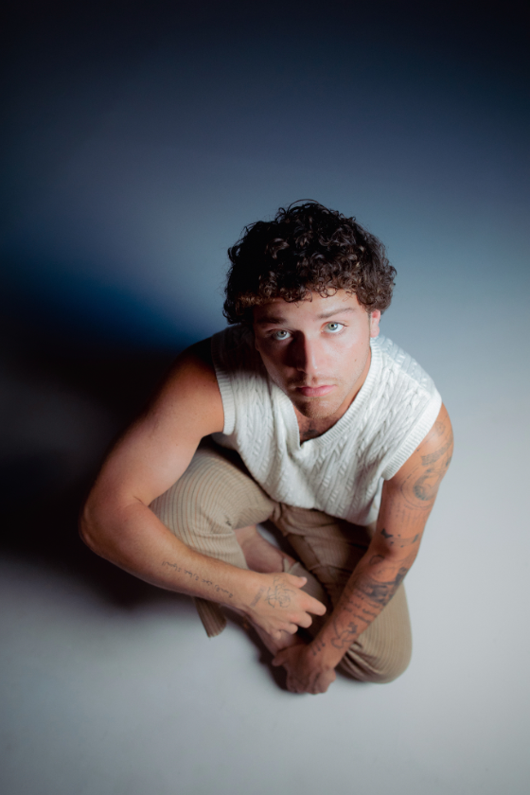
DOWNLOAD HI-RES PRESS PHOTO HERE
CREDIT: HENRY AMMANN

ABOUT BAZZI:
Born to a Lebanese immigrant father and American mother in Canton, MI, Bazzi and his dad moved to California during his senior year where he single-handedly wrote and produced a series of viral smashes like “Alone” and “Beautiful,” earning millions of worldwide streams and top 10 placement on a variety of influential playlists. Now with over 1.9 billion streams to date, 2018’s 5x RIAA Platinum-certified “Mine“ proved Bazzi’s true breakthrough, ascending to #1 at CHR/Top 40 and making the top 20 on Billboard’s “Hot 100” after reaching #1 on virtually all streaming platforms. As if all that weren’t enough, the “Mine” companion video boasts nearly 196 million views via YouTube alone. Praised by Playboy for its “genre-bending…warts-and-all approach to songwriting,” Bazzi’s RIAA Platinum-certified debut album, COSMIC, debuted among the top 15 on the SoundScan/Billboard 200 upon its 2018 release, earning over 6.2 billion global streams with hits like the 4x Platinum-certified, top 40 hit duet version of “Beautiful (Ft. Camila Cabello),” accompanied by a spectacular companion visual now with over 193 million views. In 2019, Bazzi unveiled his first ever mixtape, SOUL SEARCHING, collecting over 2.1 billion streams on the strength of such RIAA platinum certified singles as “I.F.L.Y.“ and “Paradise.” Hailed by Billboard as “his most personal work to date,” the project made a top 20 debut on the Billboard 200, while “Paradise” proved one of Bazzi’s biggest hits with over 716 million global streams and counting.

Bazzi made the most of his 2020, releasing a string of intimate and deeply confessional tracks – including “Young & Alive,” “Renee’s Song,” “I Got You,” “I Don’t Think I’m Okay,” and “Crazy” – all of which drew millions of streams around the world. Bazzi followed the impressive singles run with his 2021 hit “I Like That,” which was joined by a colorful official music video directed by Christian Breslauer (Roddy Ricch, Doja Cat, Yungblud) and co-starring such close personal friends as high profile influencers Luca Sabbat, Scarlett Rose Leithold, Charlotte D’Alessio, Valentina Bilbao, Bruna Lirio, Chandler Lovelle, Duke Nicholson, and more.

Currently boasting over 9 billion catalogue streams worldwide, Bazzi celebrated his latest album INFINITE DREAM with an epic North American headline tour last year – his biggest live run to date.

# # #

CONNECT WITH BAZZI
BAZZIOFFICIAL.COM | FACEBOOK| INSTAGRAM| TWITTER | YOUTUBE

For press inquiries, please contact:
Kelly McWilliam // Kelly.McWilliam@atlanticrecords.com

