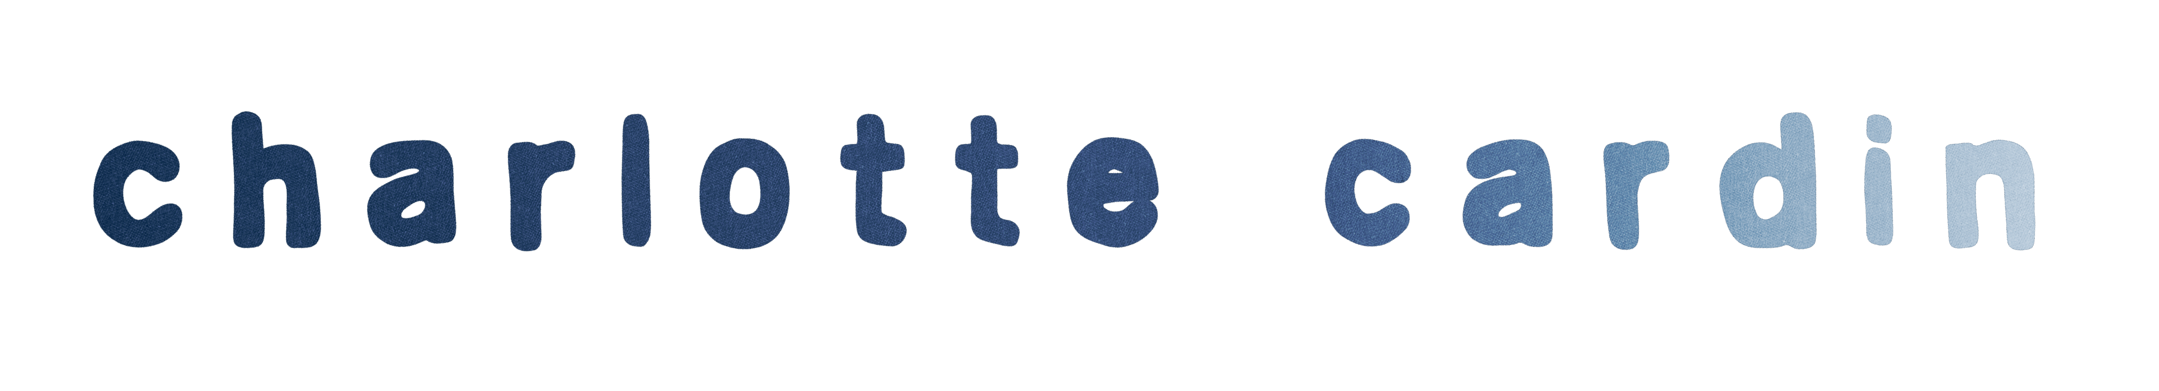
As if sculpting a statue, we chip away at one layer after another to uncover our true selves. In doing so, we shed insecurities and inhibitions and embrace our identity. Charlotte Cardin continues to learn about herself through her music. The more she learns, the closer she connects. The Montréal-born and Paris-based singer, songwriter, and creator exhales raw truths through a haze of nocturnal production, leaving pieces of her story on tape. After generating hundreds of millions of streams and earning widespread praise courtesy of Harper’s BAZAAR, The FADER, Interview, W Magazine, and more, the four-time JUNO Award winner is opening up like never before.

“Making music was always my way to feel like I was not only in touch with myself, but attuned to the world through telling stories and achieving self-discovery,” she observes. “In a way, my purpose was to connect with other people through my introspection. I’ve owned up to a lot of instincts, needs, and realizations, and I’ve decided to make a move to do what feels right.”

Surrounded by music as a kid, writing and performing always felt right. Following the Big Boy EP and Main Girl EP, Charlotte emerged as an international phenomenon with her 2021 debut Phoenix. At the 2022 JUNO Awards, the LP took home “Album of the Year” and “Pop Album of the Year,” while “Meaningless” garnered “Single of the Year” and she personally received “Artist of the Year.” Not to mention, it picked up the Felix Award for “Anglophone Album of the Year.” Inciting unanimous tastemaker applause, HYPEBAE christened her “one of Canada’s brightest young talents.” Following sold out headline dates and powerhouse turns at Bonnaroo and Festival d’Été de Québec, she topped the bill at Osheaga, marking a momentous Montréal homecoming. Along the way, she carefully assembled what would become her forthcoming sophomore full-length.

She starts sharing with the single “Confetti.” Snaps brush up against a thick bassline as her honeyed intonation melts into piano on the chorus, “I feel like a zombie. I’ll die at the party. You’ll find my body fully covered in confetti,” as harmonies twirl atop a danceable beat.

“It’s an ode to introverts,” she reveals. “I get anxious in social situations, so I tend to act in a way that isn’t fully me because of expectations. It’s about how you don’t need to be loud to be a badass and own up to who you are. You don’t need to be what other people want to be happy.”

