FOR IMMEDIATE RELEASE
APRIL 4, 2023

DON TOLIVER ANNOUNCES THEE LOVE SICK TOUR 2023

FEATURING SPECIAL GUESTS PI’ERRE BOURNE AND MORE

TICKETS AVAILABLE STARTING WEDNESDAY, APRIL 5

GENERAL ONSALE BEGINS FRIDAY, APRIL 7 AT 10 AM LOCAL ON LIVENATION.COM

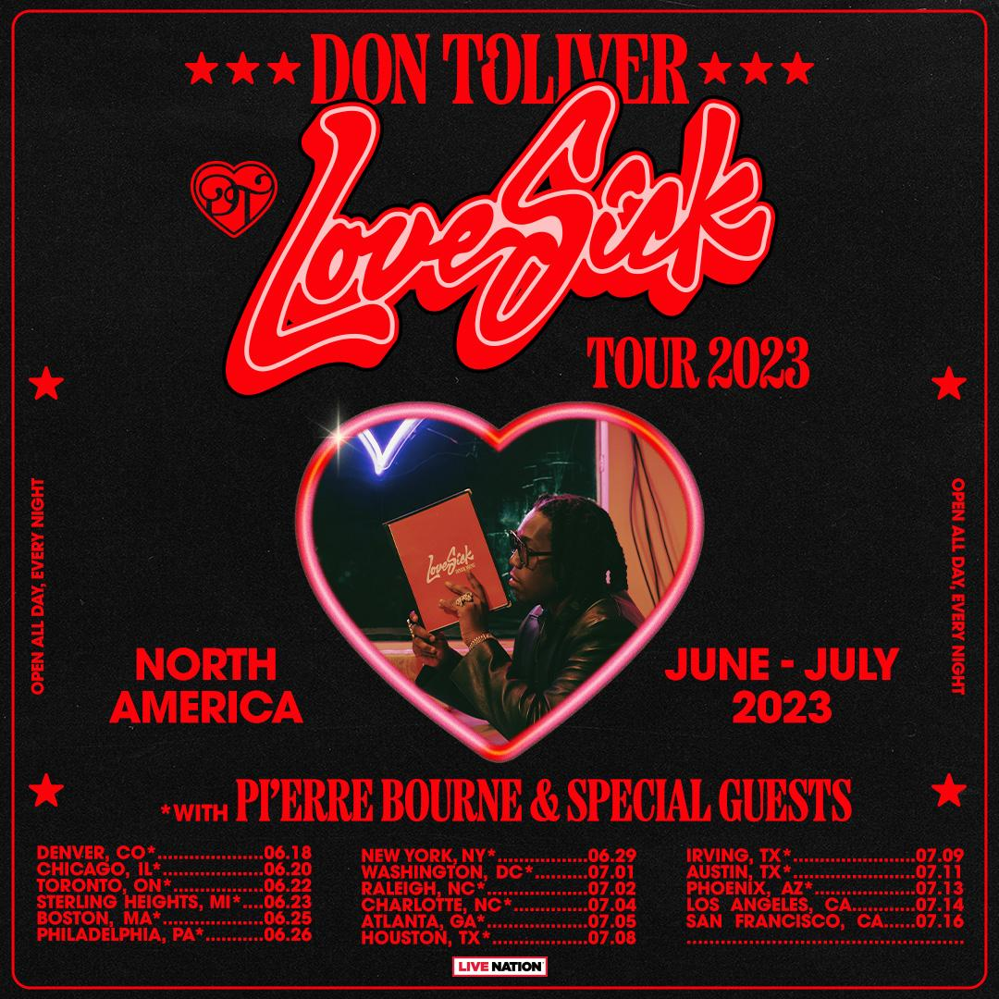
DOWNLOAD PRESS PHOTOS AND TOUR ADMAT HERE

Following the release of his third studio album, Love Sick, hip-hop soul artist Don Toliver announces Thee Love Sick Tour 2023 featuring special guests Pi’erre Bourne and more. Produced by Live Nation, the 17-city tour kicks off on Sunday, June 18 in Denver at Fillmore Auditorium, with stops across North America in Toronto, New York, Houston, Los Angeles and more before wrapping up on Saturday, July 16 at The Masonic in San Francisco.
Love Sick includes singles, “Slow Motion (Feat. Wizkid)” and “4 Me (Feat. Kali Uchis),” as well as “Leave The Club (Feat. Lil Durk & GloRilla),” and stand out track “Private Landing (Feat. Future & Justin Beiber.) The album arrived alongside a self-written short film, Love Sick, presented by Rotation – the hip-hop and R&B brand from Amazon Music – streaming now exclusively on Prime Video. Watch Here.
Love Sick was quickly upgraded into an expanded deluxe edition available now via Cactus Jack/Atlantic Records. The deluxe includes four additional tracks, including such brand new bangers as “Embarrassed (Feat. Travis Scott),” “Luckily I’m Having (Feat. Teezo Touchdown),” ,“No Pole,” and “Geronimo,” all available now for streaming and download. Expanded deluxe edition available HERE.
TICKETS: Tickets will be available starting with Spotify and Live Nation presales beginning Wednesday, April 5 at 10 AM local time until Thursday, April 6 at 10 PM local time. The general on sale will begin Friday, April 7 at 10am local time at livenation.com.

VIP: The tour will also offer a variety of different VIP packages and experiences for fans to take their concert experience to the next level. Packages vary but include premium tickets, limited edition gift item, VIP laminate and lanyard, early entry into the venue. For more information, visit vipnation.com.

THEE LOVE SICK TOUR 2023 DATES

JUNE
18 – Denver, CO – Fillmore Auditorium
20 – Chicago, IL – Byline Bank Aragon Ballroom
22 – Toronto, ON – RBC Echo Beach
23 – Sterling Heights, MI – Michigan Lottery Amphitheatre at Freedom Hill
25 – Boston, MA – MGM Music Hall at Fenway
26 – Philadelphia, PA – Skyline Stage at The Mann
29 – New York, NY – Theater at The Garden

JULY
01 – Washington, DC – The Anthem
02 – Raleigh, NC – Red Hat Amphitheater
04 – Charlotte, NC – Skyla Credit Union Amphitheatre
Jul 05 – Atlanta, GA – Coca-Cola Roxy
Jul 08 – Houston, TX – 713 Music Hall
09 – Irving, TX – The Pavilion at Toyota Music Factory
11 – Austin, TX – Moody Amphitheater
13 – Phoenix, AZ – Arizona Financial Theatre
14 – Los Angeles, CA – YouTube Theater
16 – San Francisco, CA – The Masonic

About Don Toliver
Soul singer, songwriter, and artist Don Toliver has earned worldwide attention for a unique sound that calls out his myriad musical influences of hip-hop, smoked-out R&B, ambitious pop, and even a bit of rock ‘n’ roll, creating a genre-bending lane of his own. After the 2018 mixtape Donny Womack, the Houston, TX native assembled his full-length debut, Heaven Or Hell, which claimed spots on mid-year and year-end lists by Complex and XXL, while Rolling Stone championed him among the “10 Biggest Breakthrough Artists of 2020.” Don then joined forces with Internet Money, NAV, and Gunna for the 4x platinum banger “Lemonade,” which they also performed on NBC’s The Tonight Show Starring Jimmy Fallon. 2021 saw Don team with Lil Durk and Latto for “Fast Lane,” the lead track on Atlantic Records’ F9: The Fast Saga (Original Motion Picture Soundtrack), followed by the blockbuster release of Life of a DON, once again showcasing his fluid ability to exist in multiple soundscapes and featuring production by Mike Dean, Hit-Boy, Mustard, and more. Through it all, he has gathered billions of streams, scored platinum plaques, and received praise courtesy of everybody from such media outlets as V MAN, W Magazine, Interview, and more. 2023 now marks a spectacular new era for Don as he released his third studio album, Love Sick via Atlantic Records/Cactus Jack, alongside a self-written short film presented by Rotation—the hip-hop and R&B brand from Amazon Music—available exclusively on Prime Video.

MEDIA CONTACTS:

Don Toliver
Brittany Bell | brittanybell@atlanticrecords.com

Live Nation Concerts
Monique Sowinski | moniquesowinski@livenation.com
Navier Grimes | naviergrimes@livenation.com
Maya Sarin | mayasarin@livenation.com

To apply for media credentials for show coverage:
livenation.com/pressrequests

