

**ED SHEERAN ANNOUNCES NEW SINGLE “EYES CLOSED” OUT MARCH 24**

***FROM THE NEW ALBUM “–” AVAILABLE EVERYWHERE MAY 5***

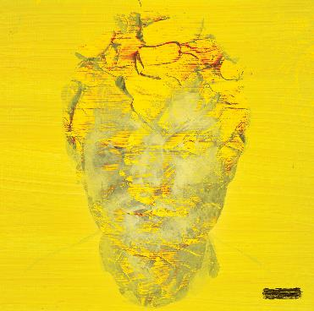

An album that revisits Ed’s singer/songwriter roots, and one that was written against a backdrop of personal grief and hope, **“-“** presents one of the biggest stars on the planet at his most vulnerable and honest. In Ed’s own words:

***“I had been working on Subtract for a decade, trying to sculpt the perfect acoustic album, writing and recording hundreds of songs with a clear vision of what I thought it should be. Then at the start of 2022, a series of events changed my life, my mental health, and ultimately the way I viewed music and art.***

***Writing songs is my therapy. It helps me make sense of my feelings. I wrote without thought of what the songs would be, I just wrote whatever tumbled out. And in just over a week, I replaced a decade’s worth of work with my deepest darkest thoughts.  
  
Within the space of a month, my pregnant wife got told she had a tumour, with no route to treatment until after the birth. My best friend Jamal, a brother to me, died suddenly and I found myself standing in court defending my integrity and career as a songwriter. I was spiralling through fear, depression and anxiety.***

***I felt like I was drowning, head below the surface, looking up but not being able to break through for air.   
  
As an artist I didn’t feel like I could credibly put a body of work into the world that didn’t accurately represent where I am and how I need to express myself at this point in my life. This album is purely that. It’s opening the trapdoor into my soul. For the first time I’m not trying to craft an album people will like, I’m merely putting something out that’s honest and true to where I am in my adult life.   
  
This is last February’s diary entry and my way of making sense of it. This is Subtract.”***

* * *

**ED SHEERAN PHOTOGRAPHED BY ANNIE LEIBOVITZ:**

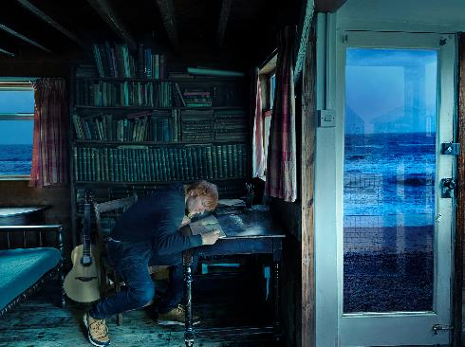

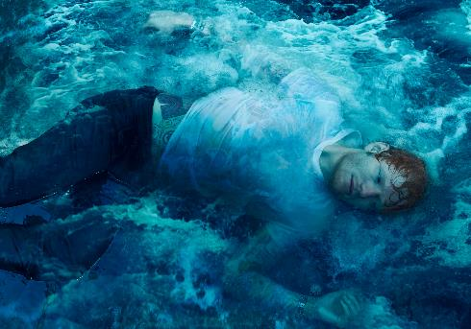

[**DOWNLOAD NEW PHOTOS & "-" ALBUM ARTWORK**](https://nam04.safelinks.protection.outlook.com/?url=https%3A%2F%2Fwarnermusicgroup.box.com%2Fs%2Fe7mj6xsel81o5w8ej9k36xr8ao16qbxv&data=05%7C01%7CTaylor.Apel%40atlanticrecords.com%7C0a732575e2d04e4c848b08db20b8ba09%7C8367939002ec4ba1ad3d69da3fdd637e%7C0%7C0%7C638139749996573686%7CUnknown%7CTWFpbGZsb3d8eyJWIjoiMC4wLjAwMDAiLCJQIjoiV2luMzIiLCJBTiI6Ik1haWwiLCJXVCI6Mn0%3D%7C3000%7C%7C%7C&sdata=f1OoTmERKOBiU1BpVmwx0vxwjZyIVq9dr%2FWZQZbulo8%3D&reserved=0)

**“-“ TRACKLIST:**

Boat

Salt Water

Eyes Closed

Life Goes On

Dusty

End Of Youth

Colourblind

Curtains

Borderline

Spark

Vega

Sycamore

No Strings

The Hills of Aberfeldy

* * *

**FOR MORE ON ED SHEERAN:**

[OFFICIAL WEBSITE](https://nam04.safelinks.protection.outlook.com/?url=http%3A%2F%2Fwww.edsheeran.com%2Fsplash%2F6thjan&data=05%7C01%7CTaylor.Apel%40atlanticrecords.com%7C0a732575e2d04e4c848b08db20b8ba09%7C8367939002ec4ba1ad3d69da3fdd637e%7C0%7C0%7C638139749996573686%7CUnknown%7CTWFpbGZsb3d8eyJWIjoiMC4wLjAwMDAiLCJQIjoiV2luMzIiLCJBTiI6Ik1haWwiLCJXVCI6Mn0%3D%7C3000%7C%7C%7C&sdata=a9ZBDtAZlK28qc4yGFpbNXK5g%2FPT7cxu%2FqZv4DBb7Yo%3D&reserved=0) | [INSTAGRAM](https://nam04.safelinks.protection.outlook.com/?url=https%3A%2F%2Fwww.instagram.com%2Fteddysphotos%2F&data=05%7C01%7CTaylor.Apel%40atlanticrecords.com%7C0a732575e2d04e4c848b08db20b8ba09%7C8367939002ec4ba1ad3d69da3fdd637e%7C0%7C0%7C638139749996573686%7CUnknown%7CTWFpbGZsb3d8eyJWIjoiMC4wLjAwMDAiLCJQIjoiV2luMzIiLCJBTiI6Ik1haWwiLCJXVCI6Mn0%3D%7C3000%7C%7C%7C&sdata=pLny2RodNvCpifpnSPBhae9fyPIGVjZ0pbbkRrfYSNE%3D&reserved=0) | [FACEBOOK](https://nam04.safelinks.protection.outlook.com/?url=https%3A%2F%2Fwww.facebook.com%2FEdSheeranMusic%2F&data=05%7C01%7CTaylor.Apel%40atlanticrecords.com%7C0a732575e2d04e4c848b08db20b8ba09%7C8367939002ec4ba1ad3d69da3fdd637e%7C0%7C0%7C638139749996573686%7CUnknown%7CTWFpbGZsb3d8eyJWIjoiMC4wLjAwMDAiLCJQIjoiV2luMzIiLCJBTiI6Ik1haWwiLCJXVCI6Mn0%3D%7C3000%7C%7C%7C&sdata=wDDdx8C%2FjPt8sdzl91cxOT66HropMnPH%2B49QG%2BIQmys%3D&reserved=0) | [TWITTER](https://nam04.safelinks.protection.outlook.com/?url=https%3A%2F%2Ftwitter.com%2Fedsheeran%3Fref_src%3Dtwsrc%255Egoogle%257Ctwcamp%255Eserp%257Ctwgr%255Eauthor&data=05%7C01%7CTaylor.Apel%40atlanticrecords.com%7C0a732575e2d04e4c848b08db20b8ba09%7C8367939002ec4ba1ad3d69da3fdd637e%7C0%7C0%7C638139749996729915%7CUnknown%7CTWFpbGZsb3d8eyJWIjoiMC4wLjAwMDAiLCJQIjoiV2luMzIiLCJBTiI6Ik1haWwiLCJXVCI6Mn0%3D%7C3000%7C%7C%7C&sdata=STAvcDM3xkkEybgL5hoT3elVLsL6s5evlEPTpR8ARIo%3D&reserved=0) | [YOUTUBE](https://nam04.safelinks.protection.outlook.com/?url=https%3A%2F%2Fwww.youtube.com%2Fuser%2FEdSheeran&data=05%7C01%7CTaylor.Apel%40atlanticrecords.com%7C0a732575e2d04e4c848b08db20b8ba09%7C8367939002ec4ba1ad3d69da3fdd637e%7C0%7C0%7C638139749996729915%7CUnknown%7CTWFpbGZsb3d8eyJWIjoiMC4wLjAwMDAiLCJQIjoiV2luMzIiLCJBTiI6Ik1haWwiLCJXVCI6Mn0%3D%7C3000%7C%7C%7C&sdata=7ghMNrixrYPKSaQFMsKcEox7CoXT8va4ZRrBHPLwWzA%3D&reserved=0)

**PRESS CONTACTS:**

Glenn Fukushima –  [glenn.fukushima@300elektra.com](mailto:glenn.fukushima@300elektra.com)

Jason Davis –  [jason.davis@atlanticrecords.com](mailto:jason.davis@atlanticrecords.com)