FOR IMMEDIATE RELEASE
APRIL 14, 2023

FAOUZIA SHARES “I’M BLUE”

ETHEREAL RENDITION OF EIFFEL 65’S GLOBAL #1 HIT, “BLUE (DA BA DEE),”
GETS OFFICIAL RELEASE FOLLOWING WORLDWIDE VIRAL SUCCESS

LISTEN TO “I’M BLUE” HERE

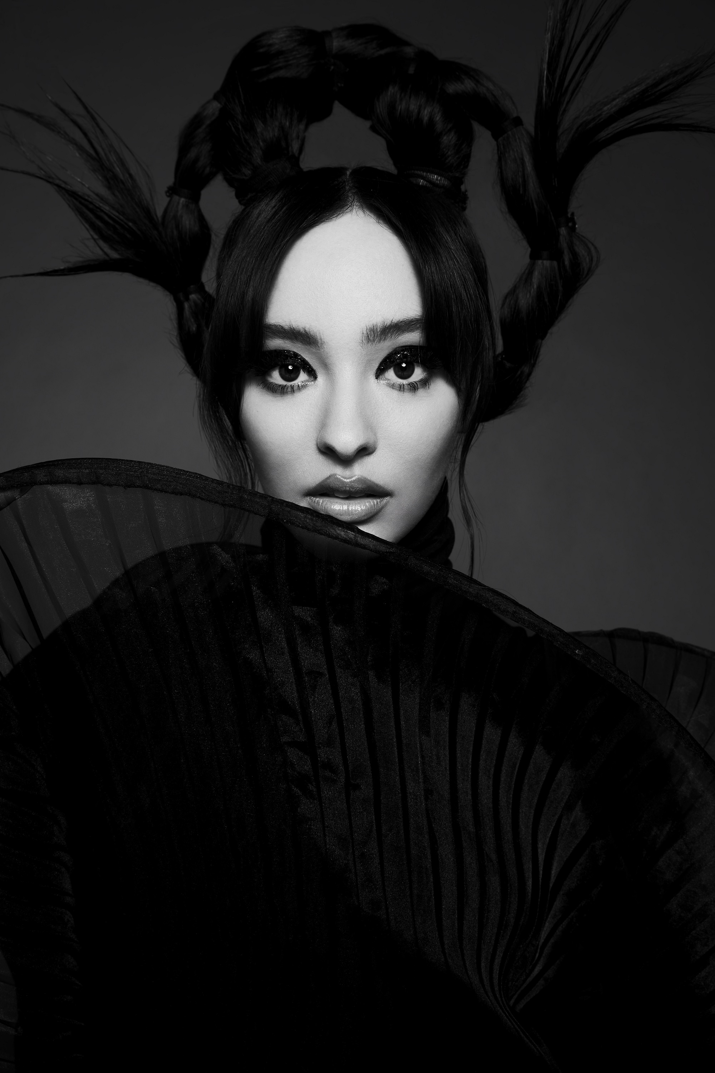
DOWNLOAD PRESS PHOTO + ARTWORK HERE

“One of the most powerful new voices you’ll hear this year.”
– BILLBOARD

“What sets the singer-songwriter apart, though, is a stirring inflection that nods to her Arab roots”
– ENTERTAINMENT WEEKLY

“Faouzia is the Next Big Thing”
– BUSTLE

Internationally acclaimed Moroccan-Canadian singer/songwriter/multi-instrumentalist Faouzia has shared her viral hit single, “I’m Blue.” A haunting and ethereal new rendition of Eiffel 65’s worldwide #1 hit, “Blue (Da Ba Dee),” the track was first recorded by Faouzia more than three years ago, earning millions of worldwide streams and over 4.6M video views via YouTube HERE. Last month then saw “I’m Blue” featured in the smash Netflix series, Red Rose, rocketing it to Shazam’s “Top 200” in Germany, France, and the UK.

With collaborations with John Legend, Kelly Clarkson, David Guetta, and more Faouzia has been named one of Variety’s “Artists to Watch for the 2022 Grammys,” Vogue’s “Style Stars Set to Make 2022 Exciting,” PEOPLE’s “Talented Emerging Artists Making Their Mark on the Musical Landscape,” and Entertainment Weekly’s “Artists to Watch in 2022” and has amassed over 1.1B global streams. Boasting a combined social reach of over 11M followers, over 2.26M YouTube subscribers, 2M Instagram followers and more than 3.4M Tik Tok followers, Faouzia has cemented herself as a surefire artist to watch.

CONNECT WITH FAOUZIA
WEBSITE | FACEBOOK | INSTAGRAM | TIK TOK | TWITTER | YOUTUBE

