JACK HARLOW ANNOUNCES NEW ALBUM ‘Jackman.’
OUT THIS FRIDAY, APRIL 28

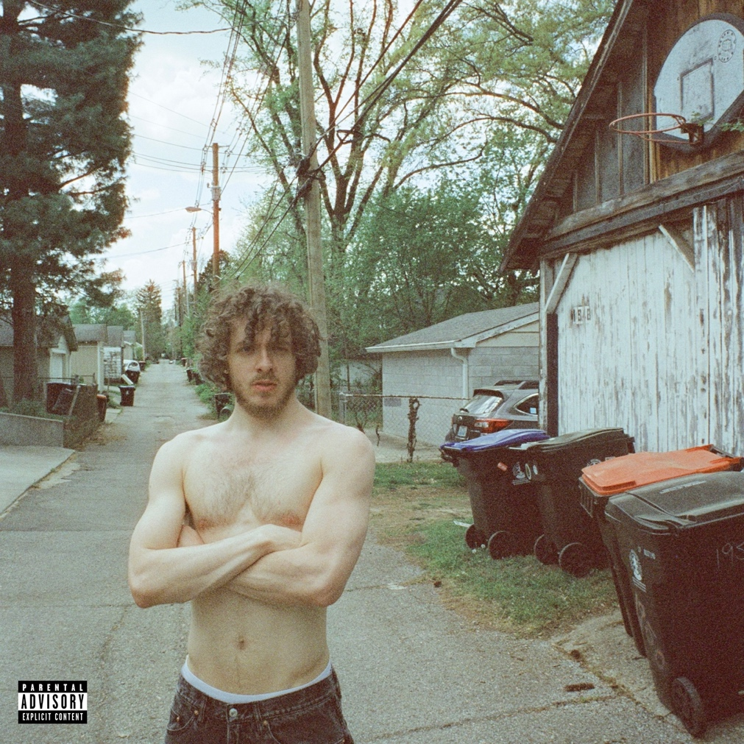

LOUISVILLE NATIVE SET TO BE HONORED NEXT WEEK WITH “HOMETOWN HEROES” BANNER IN LOUISVILLE, KY

MULTIPLE GRAMMY-NOMINATED RAPPER/ACTOR/ENTREPRENEUR MAKES BIG SCREEN DEBUT IN “WHITE MEN CAN’T JUMP” STREAMING ON HULU MAY 19

ABOUT JACK HARLOW
Hailed as the “hitmaker of tomorrow” by Variety, multiple GRAMMY-nominated rapper/actor/entrepreneur born Jackman Harlow is one of music’s brightest stars. The Louisville, KY native boasts six GRAMMY Award nominations, two #1 singles, nearly 30 RIAA platinum certifications, and over 10 billion career streams to date. Harlow released his critically acclaimed, RIAA platinum certified debut album, THATS WHAT THEY ALL SAY in December 2020, which featured the chart-topping, 8x Platinum worldwide hit, “WHATS POPPIN,” which earned him his first GRAMMY nomination for “Best Rap Performance,” along with a wide array of other award nominations.

The Generation Now/Atlantic Records rap superstar reached even greater heights in May 2022, with his Gold-certified sophomore album, COME HOME THE KIDS MISS YOU, highlighted by the bombastic Platinum-certified lead single “Nail Tech” and the chart topping, multiple-GRAMMY-nominated, 2X platinum single “First Class,” which made a spectacular debut at atop the Billboard “Hot 100,” marking his first solo #1 single, while earning the biggest streaming week of 2022.

The Generation Now/Atlantic Records star has graced the covers of Rolling Stone, GQ, Forbes, Variety, Complex, SPIN, Footwear News and XXL’s coveted Freshman Class Issue, and brought his captivating live show to TV with performances on Saturday Night Live, The Tonight Show Starring Jimmy Fallon, Jimmy Kimmel Live!, MTV Video Music Awards, BET Awards and Kids Choice Awards, to name a few.

This Spring, Harlow will make his acting debut, starring in the remake of the cultural classic, “White Men Can’t Jump.”

For all press inquiries, please contact:
Jason Davis – jason.davis@atlanticrecords.com

* * *

NEW PRESS IMAGE – Photo Credit: Julian Buchan
*download here; please use only this image*



  

