KAMAUU OFFICIALLY ANNOUNCES DEBUT ALBUM
LACUNA IN THE HOUSE OF MIRRORS

ARRIVING 4/28, AVAILABLE FOR PRE-ORDER NOW

FEATURES INCLUDE TOBE NWIGWE, KOJEY RADICAL, SIIMBIIE LAKEW, AND COCOA SARAI

INCLUDES THE RECENTLY RELEASED SINGLES “ANTIDOTE” AND “FLINGS”

WILL BE PERFORMING AT THE SOMETHING IN THE WATER FESTIVAL ON 4/29

PRE-ORDER LACUNA IN THE HOUSE OF MIRRORS
WATCH/SHARE “ANTIDOTE”
WATCH/SHARE “FLINGS”

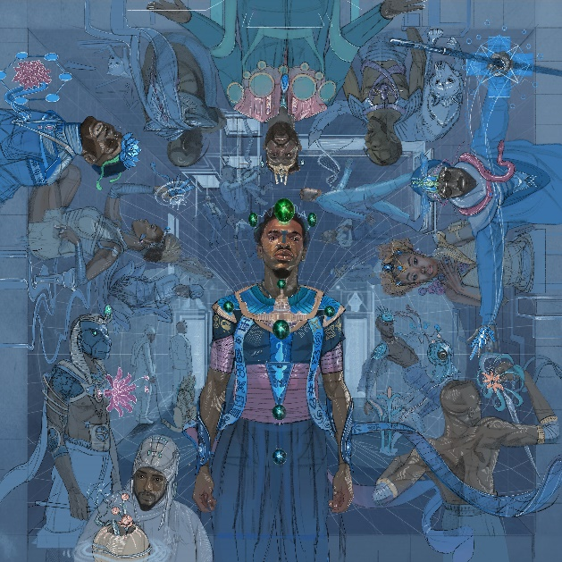
DOWNLOAD HI-RES ARTWORK

Multi-hyphenate artist, KAMAUU, has officially launched the pre-order for his highly-anticipated debut album, LACUNA In The House of Mirrors. The 11-track album features Grammy-nominated Houston artist, Tobe Nwigwe, British artist, 6x MOBO nominee, Mercury, and Brit nominated artist Kojey Radical as well as Siimbiie Lakew, and Cocoa Sarai.
LACUNA In The House of Mirrors is a sonic documentation chronicling a series of reflections and introspections. Visually, KAMAUU presents a more honest and vulnerable self-portrait via dynamic revelations on reflective surfaces. In this presentation, we explore the perceived dissonance between KAMAUU’s self-perception and the objective reflection of mirrors. The album also features previously released singles “antidote” featuring Kojey Radical and Siimbiie Lakew and “flings.” “flings” served as a reflection on pain, escapism, addiction, and the degradation of spiritual health while “antidote” is about the importance of spiritual wealth, soul gold.
In preparation for the release of his debut album, KAMAUU has stayed quite active. He recently connected with The Hopeless Romantic Society to talk “flings” and some of his views on love, romance, and connection. KAMAUU also sat down with the Dirty Street Confessions Podcast to discuss the origins of his name, his creative process, and so much more. The innovative artist has also stepped into the role of composer for the contemporary dance company A.I.M. by Kyle Abraham. The shows kicked off on 4/4 and will run through 4/9 at the Joyce Theater. Tickets can be purchased at https://www.joyce.org/performances/aim-kyle-abraham. He will also be performing at the upcoming Something In The Water Festival on 4/29. KAMAUU has also continued to embark on a series of sound bath events across the world to promote healing and connection with his most recent event held in London. His catalog boasts over 147M global audio streams to date and his ever-growing YouTube channel now boasts over 44M views.

LACUNA IN THE HOUSE OF MIRRORS
KAMAUU
(4/28)
- switch up
- don’t play with my money (feat. Tobe Nwigwe)
- the vibe
- advantages
- antidote (feat. Kojey Radical & Siimbiie Lakew)
- flings
- for my love
- open letter
- driving scenes (feat. Cocoa Sarai)
- situations
- home

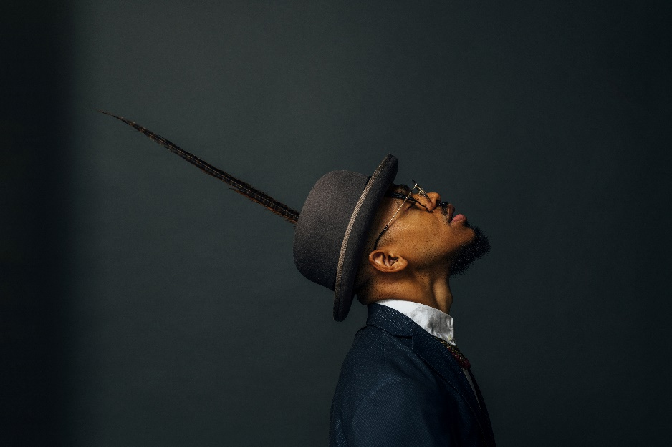
DOWNLOAD HI-RES IMAGES HERE
Credit: Arturo Olmos

KAMAUU
Maryland-born and based artist, rapper, poet, and thinker KAMAUU made his first proper debut with his appearance on “QUEEN” from No Wyld’s critically acclaimed Ascension EP after officially signing with Atlantic Records in 2015. His unique sonic experimentation made huge waves in 2016, when he released A Gorgeous Fortune EP. His first solo single “Jusfayu” went on to generate over 21.8M global streams and was handpicked by NPR as one of their “Songs We Love.” KAMAUU was also featured on The Birth of a Nation: The Inspired By Album with “The Icarus.” A year later, he unleashed his full-length mixtape, TheKAMAUU-CASSETTE: ŭRTH GōLD, and continued to stoke buzz. He later carefully assembled his third offering for the label, TheKAMAUU-CASSETTE: MíXD GRēēNS which was released during the summer of 2019. Since then KAMAUU has dropped a few notable singles including “MANGO” feat. Adi Oasis (17M+ views) and the remix feat. Masego. The first single from his highly anticipated debut album LACUNA In the House of Mirrors, “flings,” is a seamless, high-energy blend of R&B, funk, and hip-hop. Produced by DJ FU with co-production from Mick Schultz, it’s a distinctive reflection on pain, escapism, addiction, and the degradation of spiritual health. “flings” was followed up by “antidote,” a single about the importance of spiritual wealth, soul gold.
KEEP UP WITH KAMAUU
INSTAGRAM | TWITTER | FACEBOOK | YOUTUBE | WEBSITE

PRESS CONTACT
SELAM BELAY // SELAM.BELAY@ATLANTICRECORDS.COM

