FOR IMMEDIATE RELEASE
APRIL 14, 2023

KELLY CLARKSON UNVEILS NEW SINGLES “mine” / “me”

TENTH STUDIO ALBUM chemistry OUT JUNE 23RD VIA ATLANTIC RECORDS

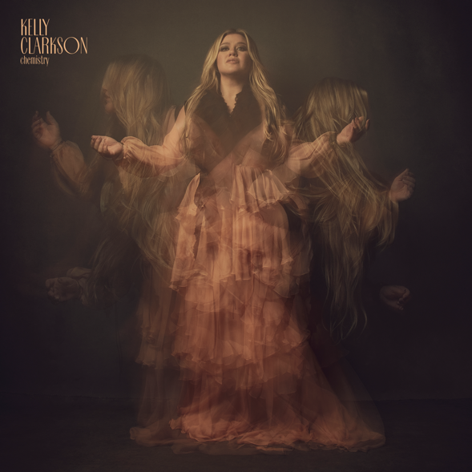
DOWNLOAD HIGH-RES IMAGES + ARTWORK

STREAM “mine” / “me”: https://atlantic.lnk.to/mine-me
PRE-ORDER chemistry: https://Atlantic.lnk.to/chemisty

GRAMMY-winning global superstar Kelly Clarkson has unveiled double singles “mine” / “me” – the first taste of her highly anticipated tenth studio album chemistry, arriving June 23rd and available for pre-order now via Atlantic Records.

“Having chemistry with someone is an incredible, and overwhelming, feeling. It’s like you have no choice in the matter. You are just drawn to each other. This can be good and bad. This album takes you down every path that chemistry could lead you down.” – KELLY CLARKSON

The pair of songs perfectly compliment and contrast, showcasing the lyrical complexity featured on the project three years in the making. Soaring vocals and a mounting instrumental find Clarkson lyrically honest-as-ever on “mine,” chanting “go ahead and break my heart, that’s fine” before craving karmic retribution. Meanwhile the focus shifts inward on “me,” a triumphant anthem of self-empowerment co-written with GRAMMY-nominated rising star GAYLE. Culminating with the lyric “don’t need to need somebody when I’ve got me,” the song’s message proves equally intimate and universal.

“We decided to release ‘mine’ and ‘me’ at the same time because I didn’t want to release just one song to represent an entire album, or relationship. There are many stages of grief and loss on this album. Each song is a different stage and emotional state.” – KELLY CLARKSON

chemistry was first announced last month alongside an exclusive Las Vegas engagement, chemistry…an intimate night with Kelly Clarkson, opening Friday, July 28, 2023 at Bakkt Theater at Planet Hollywood Resort & Casino. Designed exclusively for the Bakkt Theater stage, Clarkson and her longtime band will immerse fans in an intimate music experience that spans her two-decade long catalog of award-winning hits. For more information and to purchase tickets, please visit ticketmaster.com/KellyVegas.

One of the most popular artists of this era, Kelly Clarkson has sold more than 25 million albums and 40 million singles worldwide. The Texas-born singer-songwriter first came to fame in 2002 as the winner of the inaugural season of American Idol and quickly became one of pop’s top singles artists, in addition to the first artist to top each of Billboard’s pop, adult contemporary, country and dance charts. chemistry marks her tenth studio album and third full-length release with Atlantic Records, following 2017’s Meaning of Life and 2021’s When Christmas Comes Around…. Meanwhile on the small screen, her multi-Emmy Award-winning daytime talk show, The Kelly Clarkson Show, is currently filming its 4th season (while already picked up through 2025), and her tenure as multi-season champion coach on The Voice resumes for the show’s current 23rd season.
chemistry track list:
1. skip this part
2. mine
3. high road
4. me
5. down to you
6. chemistry
7. favorite kind of high
8. magic
9. lighthouse
10. rock hudson
11. my mistake
12. red flag collector
13. i hate love (feat. Steve Martin)
14. that’s right (feat. Sheila E.)

DOWNLOAD HIGH-RES IMAGES + ARTWORK
(photo credit: Brian Bowen Smith)

For more information, please visit:
KellyClarkson.com | Instagram | YouTube | TikTok |Facebook | Twitter | Press Assets

For press inquiries:
Sheila Richman | Sheila.Richman@atlanticrecords.com
Ted Sullivan | Ted.Sullivan@atlanticrecords.com

