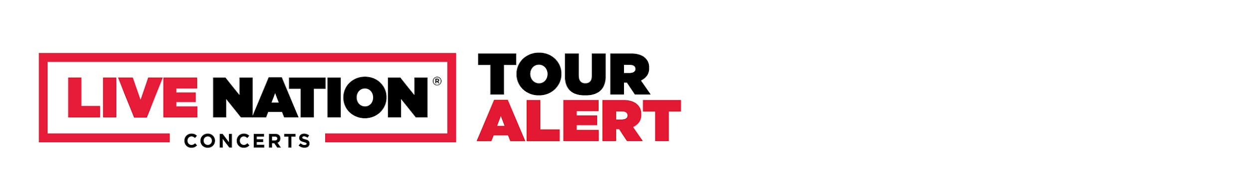
EMBARGOED UNTIL MONDAY, APRIL 3 @ 12 NOON ET
MELANIE MARTINEZ ANNOUNCES
2023 NORTH AMERICAN PORTALS TOUR

THE ALT-POP PHENOMENON WILL PERFORM AS OTHERWORLDLY CREATURE
CRY BABY FOR THE ENTIRE TOUR

NEW ALBUM PORTALS AVAILABLE NOW

Presale Tickets Available Starting Weds., Apr. 5; General Onsale Begins Fri., Apr. 7 at 10 AM Local Time on LiveNation.com
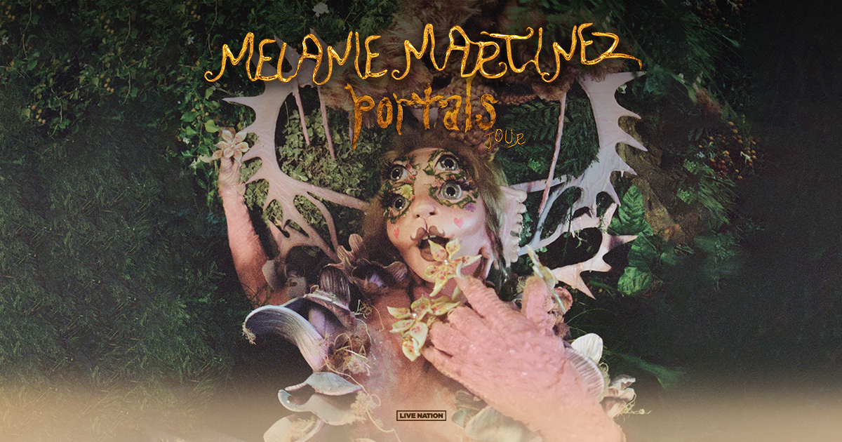
For approved artist images and hi-res tour art, please download HERE.
Off the heels of the release of her latest album, PORTALS, Melanie Martinez today announced a 29-city tour of the same name. Produced by Live Nation, the highly anticipated run will kick off on May 30 at Fillmore Auditorium in Denver making stops across the U.S. and Canada in San Francisco, New York, Chicago and more before wrapping up in Montreal at MTELUS on July 15.

The 13-track PORTALS is highlighted by new single “VOID,” written and produced by Martinez, available now HERE. Martinez first unveiled PORTALS last month with an instantly viral TikTok video causing pandemonium among fans around the globe, with teasers surpassing 115 MILLION views across socials. Hugely anticipated festival appearances this past month at Lollapalooza Argentina, Lollapalooza Chile, Bogota, Columbia’s Estéreo Picnic, and Lollapalooza Brazil saw Melanie Martinez debuting new songs for the very first time, performing as an otherworldly new creature which is a rebirth of her alter ego “Cry Baby.”

The PORTALS Tour will find Martinez exclusively performing as Cry Baby at every show, where fans can enjoy hearing songs from her latest album.

TICKETS: Tickets will be available starting with Melanie Martinez’s mailing list presale (details below) beginning Wednesday, April 5. Additional presales will run throughout the week ahead of the general onsale beginning Friday, April 7 at 10 AM local time at LiveNation.com.

​​Fans can take part in the Melanie Martinez mailing list presale by joining her email list HERE by Tues, Apr 4 @ 5 PM PT to receive the presale code to their inbox.

PORTALS TOUR DATES:
Tue May 30 – Denver, CO – Fillmore Auditorium
Thu Jun 01 – Sandy, UT – Sandy Amphitheater
Sat Jun 03 – Seattle, WA – WAMU Theater
Sun Jun 04 – Portland, OR – Alaska Airlines' Theater of the Clouds
Tue Jun 06 – San Francisco, CA – Bill Graham Civic Auditorium
Wed Jun 07 – Wheatland, CA – Hard Rock Live Sacramento
Fri Jun 09 – Inglewood, CA – YouTube Theater
Sat Jun 10 – San Diego, CA – Viejas Arena
Mon Jun 12 – Phoenix, AZ – Arizona Financial Theatre
Thu Jun 15 – Irving, TX – The Pavilion at Toyota Music Factory
Fri Jun 16 – Houston, TX – 713 Music Hall
Sat Jun 17 – Austin, TX – Moody Amphitheater
Tue Jun 20 – Tampa, FL – Yuengling Center
Wed Jun 21 – Hollywood, FL – Hard Rock Live
Fri Jun 23 – Atlanta, GA – Cadence Bank Amphitheatre at Chastain Park
Sat Jun 24 – Charlotte, NC – Skyla Credit Union Amphitheatre
Tue Jun 27 – Bridgeport, CT – Hartford Healthcare Amphitheater
Wed Jun 28 – New York, NY – Radio City Music Hall
Fri Jun 30 – Philadelphia, PA – Skyline at The Mann
Sat Jul 01 – Boston, MA – MGM Music Hall at Fenway
Sun Jul 02 – Washington DC – The Anthem
Wed Jul 05 - Cleveland, OH - Nautica Pavilion*
Fri Jul 07 – Cincinnati, OH – Andrew J Brady Music Center
Sat Jul 08 – Sterling Heights, MI – Michigan Lottery Amphitheatre at Freedom Hill
Mon Jul 10 – St. Louis – Saint Louis Music Park
Tue Jul 11 – Chicago, IL – Byline Bank Aragon Ballroom
Wed Jul 12 – Minneapolis, MN – The Armory
Fri Jul 14 – Toronto, ON – Meridian Hall
Sat Jul 15 – Montreal, QC – MTELUS

*not a Live Nation show
About Melanie Martinez
Melanie Martinez is a multi-Platinum, 12 billion-streaming alt-pop phenomenon. PORTALS marks the 27-year-old NYC-born singer-songwriter-filmmaker’s first full-length release in nearly four years following her 2 billion-streaming, RIAA Gold-certified second album, K-12. K-12 proved a sensation upon its release, entering the Billboard 200 at #3 with further debuts at #1 on the Alternative album chart, and #1 on the Soundtrack album chart. Hailed by Forbes as “a perfect conceptual album in the streaming age,” K-12 also serves as a soundtrack companion to an eerily enchanting musical film written, directed, and starring Martinez. K-12 the film debuted as the 6th highest grossing film in the US on the day of its September 3, 2019 theatrical release, with one-night-only screenings in over 425 cinemas in 32 countries.
Martinez truly set forth on what has proven a remarkable creative journey with her 2015 debut album, CRY BABY. CRY BABY took on a stunning second life in 2020 when the longtime fan-favorite “Play Date“ exploded into a true alt-pop sensation with millions of user-generated videos across TikTok. Now boasting over 1 billion worldwide streams along with 2x RIAA Platinum certification, “Play Date” propelled CRY BABY back onto the upper half of the Billboard 200 more than five years after its initial release. Named to Forbes’ “30 Under 30 2021” thanks in part to the renewed success of “Play Date,” Martinez has brought her idiosyncratic vision to an array of diverse enterprises, including last year’s instantly sold-out collaboration with footwear brand Koi. In addition to her myriad musical and visual efforts, Martinez has also shown herself to be an unforgettable live performer via sold-out headline shows and festival performances around the planet.

About Live Nation Entertainment
Live Nation Entertainment (NYSE: LYV) is the world’s leading live entertainment company comprised of global market leaders: Ticketmaster, Live Nation Concerts, and Live Nation Sponsorship. For additional information, visit www.livenationentertainment.com.

MEDIA CONTACTS:

Melanie Martinez
Christina Kotsamanidis | Christina.Kotsamanidis@atlanticrecords.com
Gabrielle Reese | Gabrielle.Reese@atlanticrecords.com

Live Nation Concerts
Monique Sowinski | moniquesowinski@livenation.com
Nadine Peña | nadinepena@llivenation.com

To apply for media credentials for show coverage:
livenation.com/pressrequests

