NIKO RUBIO SHARES NEW SONG “SEE ME NOW”

DOWNLOAD/STREAM

FORTHCOMING EP UN MILIÓN DE BESOS DUE OUT THIS MAY

RISING SINGER/SONGWRITER NAMED “LATIN ACTS TO MAKE IT BIG IN 2023” BY ROLLING STONE AND “EMERGING ARTISTS TO WATCH” BY PEOPLE

“See Me Now” was written during a turning point in my life, I was getting over a relationship and really processing those emotions. This song feels extremely euphoric and was my step at moving on and being ok with it. Writing this song made me realize the person I was with didn’t see me for who I was and that I needed to move on.”

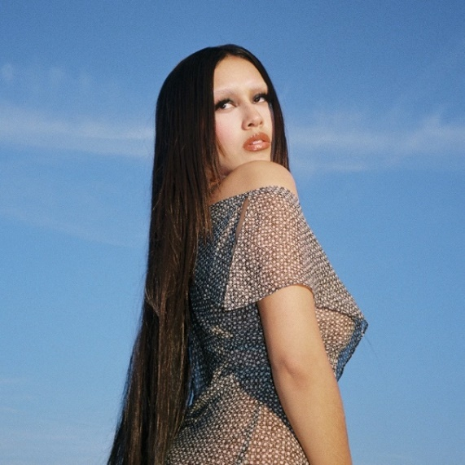
DOWNLOAD HI-RES PRESS PHOTOS

New York, NY – April 20, 2023 – Rising singer-songwriter Niko Rubio releases new song, “See Me Now,” available today via Sandlot Records/Atlantic Records. “See Me Now,” is the third track to come off Niko’s forthcoming sophomore EP, un milión de besos due out this May, following “Sunshine” and “Olividar De Ti.”

“Latin Acts to Make it Big in 2023” -ROLLING STONE

“Captivating showcase for the newcomer…“the kicky pop-rock track allows Rubio’s tone to sink down low and soar skyward.” – BILLBOARD

“Talented emerging artist to have on your playlist…” – PEOPLE

“Niko Rubio’s music feels like driving down PCH” – PAPER

“Her self-described “pop-indie-rock” music is at once ethereal and buoyant, yet grounded by a thrumming bassline. In other words, the perfect soundtrack for riding in a seafoam-green convertible, top down, along the familiar Pacific Coast Highway.” – LATINA

2022 saw Niko support 14 dates of Omar Apollo’s Desvelado Tour, a set at Lollapalooza in Chicago and a performance at BottleRock Music Festival in Napa, California and released the captivating singles “Over For Real,” and “Love Me Till U Hate Me,”

Niko made her major label debut in 2021 with debut EP, Wish You Were Here, which featured the standout singles “Bed,” “Saving Me” and“You Could Be The One.”

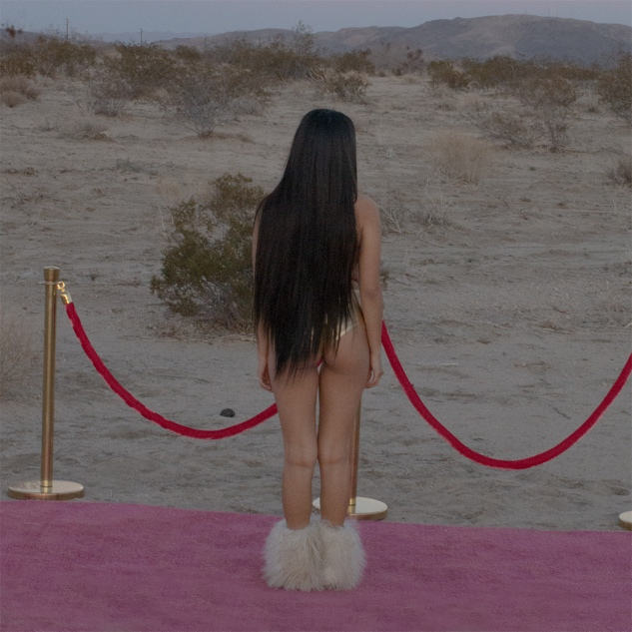
DOWNLOAD HI-RES ARTWORK

ABOUT NIKO RUBIO:
When creating her debut project, 22-year-old singer/songwriter Niko Rubio found a never-ending muse in the Pacific Coast Highway: the iconic stretch of road that runs along the ocean for nearly the entire length of California, including the Southern California South Bay area where she grew up. Expansive and euphoric, Niko’s radiant form of songwriting perfectly echoes the pure sense of possibility that accompanies driving down the PCH. Drawing inspiration from the collage of artists she’s come to admire throughout her life including Vampire Weekend, Lana Del Rey, Erykah Badu & twenty one pilots, as well as the mariachi & banda music her grandparents played at home, Niko’s music is an amalgamation of these influences, but unique in its effervescent melodies and unpredictable textures. Using cinematically detailed references and her effortlessly untamed vocals, Niko is ready to take those who listen to her debut EP Wish You Were Here and her subsequent releases on a sonic road trip along the highway where they became a possibility.

Press Contacts:
Jason Davis | jason.davis@atlanticrecords.com
Taylor Apel | taylor.apel@atlanticrecords.com

