FOR IMMEDIATE RELEASE
APRIL 14, 2023

OHGEESY OPENS THE GATES TO GEEZYWORLD 2

MULTIPLATINUM RAPPER UNVEILS EAGERLY AWAITED NEW SOLO MIXTAPE

HIGHLIGHTS INCLUDE THE SUPER-CHARGED NEW SINGLE,
“CHROME HEARTED (FEAT. TYGA)”
LISTEN HERE | WATCH OFFICIAL VIDEO

GEEZYWORLD 2 ARRIVES VIA ATLANTIC RECORDS ON FRIDAY, MAY 5

PRE-ORDERS/PRE-SAVES AVAILABLE NOW

DOWNLOAD HI-RES ARTWORK

“A decade into his career, OHGEESY is just getting started.” - HYPEBEAST

Multiplatinum rap hero OHGEESY has officially unveiled the release of his eagerly awaited new mixtape, GEEZYWORLD 2, arriving at last via Atlantic Records on Friday, May 5. Pre-orders/pre-saves are available now HERE.

GEEZYWORLD 2 is heralded by today’s premiere of the super-charged new single, “Chrome Hearted (Feat. Tyga),” available now at all DSPs and streaming services. An official companion video/visualizer directed by Mikey Rare, premieres today at YouTube HERE.

What’s more, GEEZYWORLD 2 – which follows OHGEESY’s acclaimed 2021 solo debut mixtape, GEEZYWORLD – includes such recent anthems as “Gallery,” “Knock Knock,” “Up, “1st Day of School,” and “GEEKALEEK (Feat. Cash Kidd),” all of which are joined by official music videos currently boasting a combined 10M+ views via YouTube alone. “GEEKALEEK (Feat. Cash Kidd)” – which sees OHGEESY flowing over a repurposed sample of Petey Pablo’s 2003 crunk smash, “Freek-A-Leek” – was met by instant praise from such outlets as REVOLT and Passion of the Weiss‘s “The Rap-Up,” which declared it “an early contender for song of the summer.”

Hailed in a recent HYPEBEAST feature interview as “a lone star and certified expert in experimentation, flow and writing killer hooks,” OHGEESY recently introduced fans to GEEZYWORLD 2 on a wide-ranging North American live run that saw him supporting GRAMMY® Award-nominated rapper YG’s “The Red Cup Tour” as well a top-billed hometown performance at Inglewood, CA’s Rolling Loud California. Additional dates will; be announced soon. For complete details and remaining ticket information, please visit www.ohgeesyofficial.com.

In addition, OHGEESY recently teamed with rising hip-hop star Bankrol Hayden for the star-studded new single, “Bop Slide (Feat. Blueface, OHGEESY & Maxo Kream),” available now at all DSPs and streaming services.

ABOUT OHGEESY:
California never gave rise to a rapper quite like OHGEESY. The Los Angeles-born Mexican American multiplatinum artist, entrepreneur, and visionary not only continues the legacy of his hometown, but he also puts a whole culture rarely represented in hip-hop on his back with pride, poise, and power. As such, he emerges as a trailblazer with vicious wordplay, vibrant storytelling, and a vital message. Breathing new life into the culture, he co-founded Shoreline Mafia during 2016. He locked down the group’s legacy with the double-platinum “Bands,” platinum-certified “Musty” and “Nun Major,” and the gold-certified “Bottle Service” and “Whuss The Deal.” During 2021, he served up his solo debut, GEEZYWORLD, which led him to his first sold-out tour. Among many highlights, “Get Fly” [feat. DaBaby] raked in over 37 million Spotify streams, while “Keeper” [feat. A Boogie Wit Da Hoodie] posted up 23 million Spotify streams. Right out of the gate, Pitchfork proclaimed, “GEESY is well placed to thrive as a lone star. GEEZYWORLD is a quintessential L.A. rap record.” On its heels, he supported the release with a massive sold-out headline tour. His world as a rising super star has expanded to include exclusive merchandise with his line OTXBOYZ sold through his GEEZYWORLD web site. At the same time, he co-owns Mexican seafood spot Sunset Mariscos inside of the famed Fred Segal store in West Hollywood.
Posting up hundreds of millions of streams and attracting widespread praise from GQ, Complex, UPROXX, XXL, OkayPlayer, and HotNewHipHop, he instigates another era for the West on GEEZYWORLD 2. GEEZYWORLD 2 is set to release on May 5th. Lead single, “Up,” bass thumps through ominous piano as the punchy production underlines his laidback flow. Produced by DJ Vision, a cinematic samurai-style guitar loop dissolves into a glitchy beat on “Knock Knock.” The highest streaming record to date at 14.7 million global streams from the upcoming project, “GEEKALEEK (Feat. Cash Kidd),” samples Petey Pablo’s 2003 smash, “Freek-a-Leek.” Elsewhere, he teams up with Tyga bringing South Central heat to the hypnotic “Chrome Hearted,” with more features to be announced.
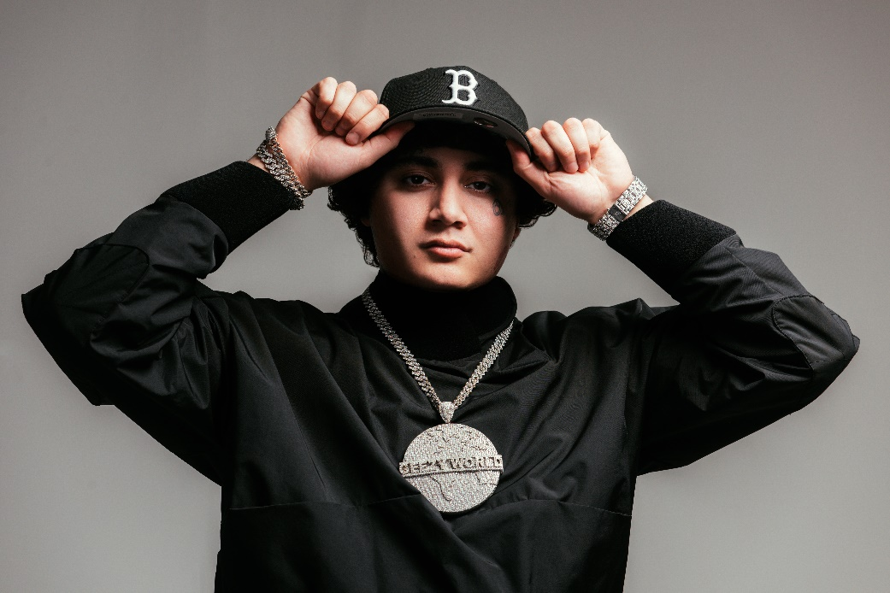
DOWNLOAD HI-RES PRESS IMAGE // PHOTO CREDIT: Emilio Sanchez
# # #
CONNECT WITH OHGEESY
OHGEESYOFFICIAL.COM | FACEBOOK | INSTAGRAM | TWITTER | YOUTUBE

PRESS CONTACT:
Brittany Bell | Brittany.Bell@atlanticrecords.com

