FOR IMMEDIATE RELEASE
APRIL 20, 2023

GENEVIEVE STOKES SHARES OFFICIAL VIDEO FOR “CAN I”

ALT-POP SONGSTRESS’ NEW CATCHING RABBITS EP OUT NOW

“THE CATCHING RABBITS TOUR” BEGINS MAY 14 WITH
HOMETOWN HEADLINE SHOW IN PORTLAND, ME

WATCH THE OFFICIAL VIDEO FOR “CAN I” HERE
STREAM CATCHING RABBITS HERE

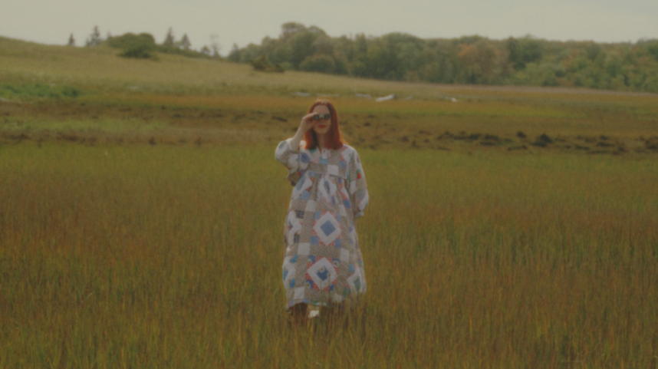
DOWNLOAD THUMBNAIL HERE

“there’s nothing sinister about the Abbie Pitre-directed clip, which matches the sunny disposition of the track while highlighting some locales integral to the songwriter’s early years.”
– FLOOD

Acclaimed alt-pop singer-songwriter-pianist, Genevieve Stokes, has shared the official video for “Can I,” a pleading, powerful and emotional track off her new EP, Catching Rabbits. Written by Stokes featuring additional production from the esteemed Tony Berg (Phoebe Bridgers, Paul McCartney), the lush, eerily beautiful video for the track premiered today on FLOOD. Filmed on location at Reid State Park, Harpswell Heritage Land Trust's Potts Point and Skolfield Shores Preserve in Portland, ME, the visual is now streaming at YouTube HERE.

“‘Can I’ was filmed in Harpswell, ME in September— my favorite time to be home,” Genevieve told FLOOD. “The concept was heavily inspired by Donnie Darko and The Wickerman.”

A dreamy exploration of what it means to heal and unlock your inner child, Catching Rabbits was heralded by the whimsical lead single “Habits” which now boasts nearly 52M global streams after earning more than 50M views across a series of TikTok teases prior to release. The fan favorite track is joined by an Alice’s Adventures in Wonderland-inspired music video streaming HERE. Directed by Abbie Pitre and Roman Spataro, the visual was quickly deemed “the woodland fairy fantasy of your dreams” by Teen Vogue. A gorgeous live performance of “Habits” – filmed in Stokes’ beloved hometown of Portland, ME – is also streaming now HERE. Further EP highlights include the brooding “You & Me,” self-soothing lullaby, “17,” emotionally charged “Can I,” and “Book of Memories,” the latter of which arrived with a haunting video alongside EP release, which premiered exclusively on PAPER.

Stokes – who spent much of the past year touring alongside artists including Noah Kahan, Briston Maroney, Sarah Kinsley, and Charlie Burg – will celebrate her new music with “The Catching Rabbits Tour,” a US headline run kicking off May 14th with a very special hometown performance at Portland, ME’s Portland House of Music & Events. A series of limited-edition tour posters featuring tarot cards created by Genevieve and her sister, Madeline Curtis, will be available exclusively on tour. Representing each song on the EP, the tarot card illustrations were also unveiled by PAPER earlier today. Complete details and ticket information can be found at genevievestokes.com/tour.

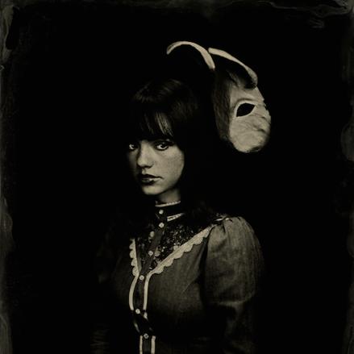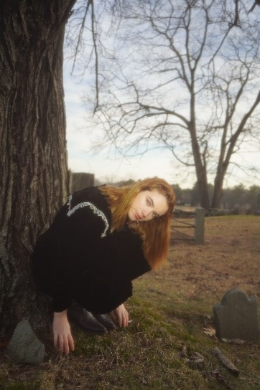
DOWNLOAD HI-RES ARTWORK + PRESS PHOTOS (CREDIT: ABBIE PITRE)
DOWNLOAD GENEIEVE’S BIO + PRESS ASSETS

ABOUT GENEVIEVE STOKES:
One of alternative pop’s brightest stars, recently named among People’s “Emerging Artists” to watch list, Genevieve first taught herself piano at the age of eight. Spending her teen years developing her own unique sound, she was inspired by iconic female musicians like Fiona Apple and Regina Spektor but infused her own repertoire with her deeply personal experience and perspective. Stokes drew attention and applause for her intimate yet lush approach to alternative pop, amassing over 7M streams all before releasing her debut EP, ascending esteemed playlists, and garnering support from Complex, EARMILK, Ones to Watch, and more. Named by Alternative Press as a “New Artist You Need To Hear,” Stokes made a striking major label debut with her angsty yet nostalgic 2021 EP, Swimming Lessons, highlighted by the standout tracks, “Surface Tension,” “Parking Lot,” and “Running Away.” Recorded in a cabin just a stone’s throw from the 21-year-old artist’s childhood home, the critically acclaimed project went on to earn over 16M streams worldwide while receiving praise from publications including Flaunt, NYLON, Billboard, Refinery29, FLOOD, and more.

“THE CATCHING RABBITS TOUR”

MAY
14 – Portland, ME – Portland House of Music & Events
16 – New York, NY – Mercury Lounge
17 – Washington, DC – DC9
20 – San Francisco, CA – Brick & Mortar
22 – Los Angeles, CA – The Moroccan Lounge

WHAT CRITICS ARE SAYING ABOUT CATCHING RABBITS

“There's a certain fragility that runs throughout the release that feels like pouring over the worn, yellowed pages of an old scrapbook, a tangible nostalgia crystalized in decaying amber” – PAPER

“It’s nearly impossible to not fall in love with Genevieve Stokes” – PEOPLE

“Genevieve Stokes takes us deep into her musical rabbit hole of ethereal dreams and alt-pop perfection with the release of her latest EP” – EUPHORIA

“Stokes’ embrace of her originality is admirable – the scarlet hues of the piano that lives at the heart of this EP become a signature for the artist’s tone” – ONES TO WATCH

CONNECT WITH GENEVIEVE STOKES
OFFICIAL | INSTAGRAM | TWITTER | YOUTUBE | FACEBOOK | TIKTOK

PRESS CONTACT:
ANDREW.GEORGE@ATLANTICRECORDS.COM

