FOR IMMEDIATE RELEASE
APRIL 7, 2023

GENEVIEVE STOKES UNVEILS NEW CATCHING RABBITS EP

ALT-POP SONGSTRESS SHARES EP RECORDED WITH RENOWNED
PRODUCER TONY BERG (PHOEBE BRIDGERS, PAUL MCCARTNEY)

HIGHLIGHTS INCLUDE LEAD SINGLE “HABITS” AND NEW SONG “BOOK OF MEMORIES”
“THE CATCHING RABBITS TOUR” BEGINS MAY 14 WITH
HOMETOWN HEADLINE SHOW IN PORTLAND, ME

WATCH THE OFFICIAL VIDEO FOR “BOOK OF MEMORIES” HERE
STREAM CATCHING RABBITS HERE

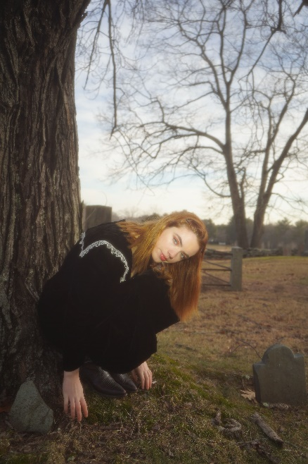
DOWNLOAD HI-RES ARTWORK + PRESS PHOTOS (CREDIT: ABBIE PITRE)
DOWNLOAD GENEIEVE’S BIO + PRESS ASSETS

“There's a certain fragility that runs throughout the release that feels like pouring over the worn, yellowed pages of an old scrapbook, a tangible nostalgia crystalized in decaying amber.” – PAPER

“It’s nearly impossible to not fall in love with Genevieve Stokes” – PEOPLE

Acclaimed alt-pop singer-songwriter-pianist, Genevieve Stokes, has shared her new EP, Catching Rabbits. Written by Stokes with production from renowned producer Tony Berg (Phoebe Bridgers, Paul McCartney, Taylor Swift), the six-track EP features the gifted songstress’ new song “Book of Memories” and arrives alongside the song’s hauntingly beautiful video which premiered today on PAPER. Watch the official visual streaming now at the Portland, ME-born, NOLA-based musician’s official YouTube channel HERE.

“This EP is more introspective and experimental than my first project and I think it reflects a change in my connection to reality and the relationships in my life,” says Genevieve. “‘Catching Rabbits’ is my more uplifting take on the phrase ‘chasing rabbits’— that it’s possible to achieve what seems out of reach, and to escape the tempting illusions of the mind.”

A dreamy exploration of what it means to heal and unlock your inner child, Catching Rabbits was heralded by the whimsical lead single “Habits” which now boasts nearly 52M global streams after earning more than 50M views across a series of TikTok teases prior to release. The fan favorite track is joined by an Alice’s Adventures in Wonderland-inspired music video streaming HERE. Directed by Abbie Pitre and Roman Spataro, the visual was quickly deemed “the woodland fairy fantasy of your dreams” by Teen Vogue. A gorgeous live performance of “Habits” – filmed in Stokes’ beloved hometown of Portland, ME – is also streaming now HERE. Further EP highlights include the brooding “You & Me,” self-soothing lullaby, “17,” and emotionally charged “Can I,” the latter of which arrived alongside the EP’s exclusive announcement via Rolling Stone.

Stokes – who spent much of the past year touring alongside artists including Noah Kahan, Briston Maroney, Sarah Kinsley, and Charlie Burg – will celebrate her new music with “The Catching Rabbits Tour,” a US headline run kicking off May 14th with a very special hometown performance at Portland, ME’s Portland House of Music & Events. A series of limited-edition tour posters featuring tarot cards created by Genevieve and her sister, Madeline Curtis, will be available exclusively on tour. Representing each song on the EP, the tarot card illustrations were also unveiled by PAPER earlier today. Complete details and ticket information can be found at genevievestokes.com/tour.

Now one of alternative pop’s brightest stars that People recently included in their “Emerging Artists” to watch list, Genevieve first taught herself piano at the age of eight, spending her teen years developing her own unique sound, inspired by iconic female musicians like Fiona Apple and Regina Spektor but infused with her deeply personal experience and perspective. Stokes drew attention and applause for her intimate yet lush approach to alternative pop, amassing over 7M streams all before releasing her debut EP, ascending esteemed playlists, and garnering support from Complex, EARMILK, Ones to Watch, and more.

Named by Alternative Press as a “New Artist You Need To Hear,” Stokes made a striking major label debut with her angsty yet nostalgic 2021 EP, Swimming Lessons, highlighted by the standout tracks, “Surface Tension,” “Parking Lot,” and “Running Away.” Recorded in a cabin just a stone’s throw from the 21-year-old artist’s childhood home, the critically acclaimed project went on to earn over 16M streams worldwide while receiving praise from publications including Flaunt, NYLON, Billboard, Refinery29, FLOOD, and more.

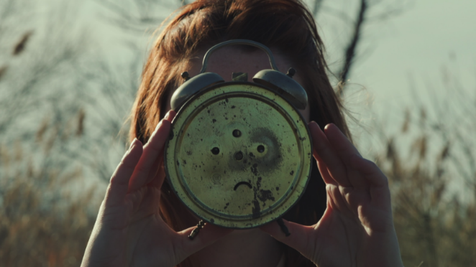
DOWNLOAD THUMBNAIL HERE

CATCHING RABBITS EP TRACKLIST:
Habits
You & Me
Can I
Book of Memories
Mara
17

“THE CATCHING RABBITS TOUR”

MAY
14 – Portland, ME – Portland House of Music & Events
16 – New York, NY – Mercury Lounge
17 – Washington, DC – DC9
20 – San Francisco, CA – Brick & Mortar
22 – Los Angeles, CA – The Moroccan Lounge

CONNECT WITH GENEVIEVE STOKES
OFFICIAL | INSTAGRAM | TWITTER | YOUTUBE | FACEBOOK | TIKTOK

PRESS CONTACT:
ANDREW.GEORGE@ATLANTICRECORDS.COM

