FOR IMMEDIATE RELEASE
APRIL 28, 2023

SARA KAYS AND ANSON SEABRA DUET ON “MISS ME THE SAME”

OFFICIAL VIDEO STARRING BOTH ARTISTS OUT NOW

LISTEN HERE | WATCH HERE

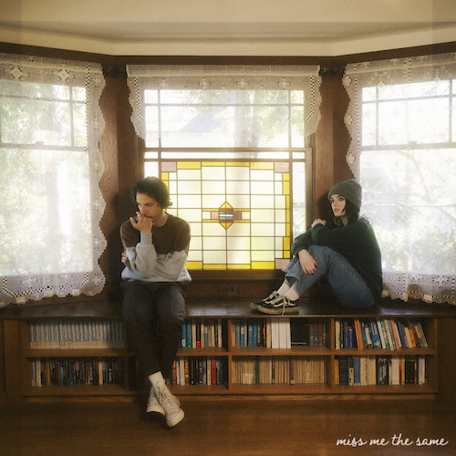
DOWNLOAD ARTWORK HERE
CREDIT: CHASE DENTON

RIAA Platinum-certified singer-songwriter Sara Kays has shared her new collaboration with Anson Seabra. “Miss Me The Same” is now available alongside an official music video co-starring both artists and streaming at YouTube HERE.

“I recently had the privilege of writing a song with Anson Seabra that we both loved and immediately knew we wanted to release,” says Sara. “I’ve been such a fan of his music for a while, and we’ve been trying to collaborate on something for a couple of years now, so I’m stoked it’s finally happening! The song is about feeling like you’re doing all the right things to move on from someone, but not being able to stop thinking about the other person and wondering if they’re feeling the same. Hope you love it as much as we do :’)”

“It’s a song about being on the other side of a breakup and feeling like there’s still something there,” Anson shared. “…that vague but potent feeling that maybe on some nights your ex is somewhere looking up at the moon thinking of you too.”

“Miss Me The Same (with Anson Seabra)” follows Kays’ recently released single, “Bored,” which arrived with an official video following an exclusive premiere via Rolling Stone – watch HERE. “Bored” and “Miss Me The Same” mark the latest Sara’s first new releases since a string of singles unveiled last year including “Math,” “When You Look At Me,” “Watching TV,” as well as a cover of Owl City’s “Fireflies,“ the latter of which quickly became a fan favorite last year as she performed on tour across North America opening for Alec Benjamin and MAX.

With over 638M worldwide streams and an intensely engaged and supportive audience on TikTok nearing 2M followers, Sara Kays is disarmingly raw about everything from body image to mental health, her authenticity shining through in her powerful lyricism and expressive voice. The Nashville-based musician saw her profile grow with 2021’s breakthrough EP, Struck By Lightning, highlighted by the RIAA Platinum-certified, viral breakup anthem, “Remember That Night?“. Kays quickly garnered critical acclaim spanning Billboard‘s “Emerging Artists Spotlight” and PEOPLE‘s “Talented Emerging Artists” lists, as well as making her national late night TV debut performing “Remember That Night?” on CBS’ The Late Show with Stephen Colbert. With more new music on the horizon, Sara is poised to stake a claim as one of today’s most powerful and poignant singer-songwriters.

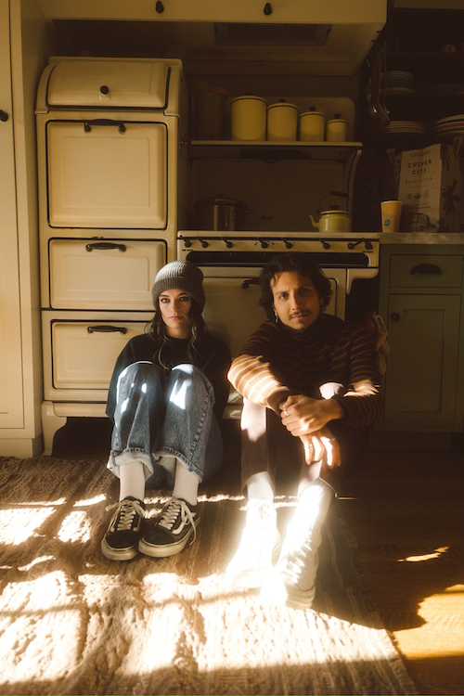
DOWNLOAD PRESS PHOTOS HERE
CREDIT: CHASE DENTON

WHAT CRITICS ARE SAYING ABOUT SARA KAYS:

“Sara Kays’ music has something to offer for everyone.” – PEOPLE

“Sara Kays knows what it takes to craft heartfelt lyrics spun with velvet, tight-knit arrangements that simply elevate the already high-flying material.” – AMERICAN SONGWRITER

“Normalizing life’s struggles that often seem easier to avoid, Sara has carved out a unique space…quickly creating a community through her message.” – FLAUNT

“Sara Kays has cultivated a devoted following by wearing her heart on her sleeve. The rapidly rising artist’s growing fanbase is a testament to her understated gift for empathetic songwriting.” – ONES TO WATCH

“One Of Pop Music’s Breakout Stars” – HUFFPOST

CONNECT WITH SARA KAYS:
SARAKAYS.COM | TIKTOK | TWITTER | INSTAGRAM | facebook | YOUTUBE | PRESS ASSETS

CONNECT WITH ANSON SEABRA:
ANSONSEABRA.COM | TWITTER | INSTAGRAM | FACEBOOK | YOUTUBE

PRESS CONTACT:
ANDREW.GEORGE@ATLANTICRECORDS.COM

