FOR IMMEDIATE RELEASE
APRIL 4, 2023

corook gets funky with “CGI”

nashville-based singer-songwriter shares groovy new single co-written with ben abraham

north american tour supporting maddie zahm wraps up next week at the troubadour in los angeles

listen to “CGI”

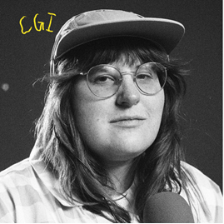
download artwork here

“If specificity is the soul of narrative, then corook is one of the most naturally gifted storytellers in the game.” – BILLBOARD

Self-produced and co-written with Ben Abraham (Demi Lovato, Sara Bareilles, Ben Platt), Nashville-based singer-songwriter corook has shared their groovy new song “CGI” available now via all DSPs and streaming services.

“I bought an old toy synth at goodwill for $15 and i am obsessed with it,” shares corook. “I brought it home to my little bedroom studio in Nashville and immediately made a loop of some vinyl crushed drums and played some dinky synth chords over it. A couple days later my buddy Ben Abraham came over and we danced and sang to it on loop for like 5 hours straight. I wanted it to be funky and jumpy and dancey and sweet. The song is about how hot i think my girlfriend is even after (almost) 5 years of dating. I’m just an underdog that somehow got the girl of their dreams and i will be writing dorky songs about it til the day i die.”

corook – pronounced ‘co-rook’ – kicked off their latest, more vulnerable musical era with the recent release of “i’m not doing well”. Earlier this year, they celebrated their 28th birthday with their first single of 2023, “the dog” and its heartbreaking music video (co-starring corook and their actual girlfriend) streaming now HERE. The poignant track was met by applause from PAPER, which raved, “Channeling Phoebe Bridgers, corook finds anguish and heartbreak in the small details of a breakup.”

After spending much of last year on the road, including their first-ever live runs (supporting K.Flay and Jukebox the Ghost) as well as their debut festival performance at Bonnaroo (featured in Rolling Stone) – the rising musician is currently traveling North America as special guest on Maddie Zahm’s sold-out “You Might Not Like Her” tour. The tour wraps next week with its final stop in Los Angeles at the famed Troubadour on April 11. For additional information, please visit www.corook.com.

Named as one of The Advocate’s “7 Queer Artists For Your Fall Playlist,” corook has become known for their ability to tackle deeply personal themes in their music and visuals through a humorous lens. Last spring, the genre-busting, Nashville-based musician blessed the world with their debut EP, achoo!, featuring such surprising and insightful tracks as “idk god,” “degree,” “bad friend,” and “sims” in addition to the fan favorite “snakes.” Further releases followed, among them the viral adult lullaby, “it’s ok!,” the unrestrained “BDSM,” the super-hot “hell yeah,” the heartfelt “your mom,” and the ode to self-worth, “smoothie.” corook also got vulnerable in front of the camera, reflecting on their mental health journey in an episode of Out Magazine’s “Love, Me” video series streaming now HERE.

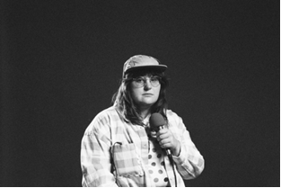
download press photo // credit: libby danforth

corook on tour

MARCH
10 – Kansas City, MO – Encore
12 – Minneapolis, MN – Amsterdam Bar & Hall
13 – Chicago, IL – SPACE
15 – Toronto, ON – Allied Music Center
17 – Boston, MA - Café 939 at Berklee
18 – Philadelphia, PA – World Café Live
20 – New York, NY – Bowery Ballroom
22 – Washington, DC – Union Stage
24 – Atlanta, GA – The Loft
27 – Nashville, TN – The Basement East

APRIL
11 – Los Angeles, CA – The Troubadour

connect with corook:
corook.com | instagram | tiktok | press assets

press contact:
andrew.george@atlanticrecords.com

