FOR IMMEDIATE RELEASE
APRIL 21, 2023

corook shares “if i were a fish (ft. olivia barton)”

nashville-based singer-songwriter releases viral fan-favorite track
following supportive reaction on tiktok exceeding 11.4M views

written with girlfriend olivia barton in response to internet hate
“if i were a fish” serves as a reminder to remember the joy in being different

corook set to perform at nashville PRIDE on june 25

listen to “if i were a fish” | watch official video here

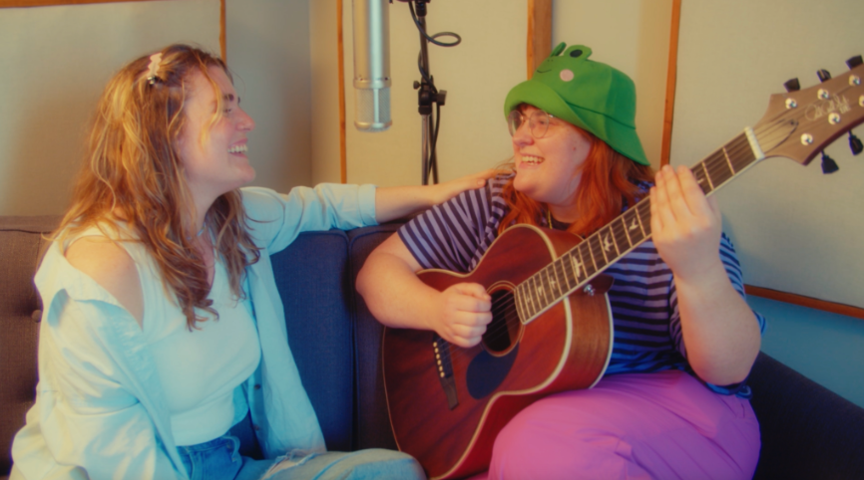
download hi-res press photos + artwork here

“If specificity is the soul of narrative, then corook is one of the most naturally gifted storytellers in the game.” – BILLBOARD

Nashville-based singer-songwriter corook has shared their heartwarming new song “if i were a fish (ft. olivia barton).” Co-written with their girlfriend Olivia, the track was originally posted to TikTok as a response to internet hate, and it received an incredible response with 11.4M views, 2.1M likes and 311.1K shares and counting. With over 13.7K creates, the video has also received support from fellow artists including Charlotte Lawrence, grandson and more. Written whilst feeling emotional, insecure, and out of place, the track came together in ten minutes. Following the outpour of love and support on social media, corook and Olivia worked quickly record a full version of the song – listen HERE and watch the official video featuring special behind-the-scenes moments from the making of the song HERE.

"I’m in a place in my adulthood where I am allowing myself to be the most me I can fathom being and I have never felt so out of place in my life,” shares corook. “Whether it be the genre of music I make to my gender identity, I don’t feel like I fit in anywhere. As I was crying about this to my girlfriend, Olivia Barton, she said ‘let’s make a song to feel better and we should make it as weird as possible.’ The first thing I said was ‘if I were fish I think people would appreciate all the things I am more.’ Thus became, if I were a fish. Writing that song with Olivia will go down as one of my favorite memories with her because I’d never felt more seen and loved by another human in my life. I guess it makes sense that the video capturing that memory went viral.”

corook – pronounced ‘co-rook’ – kicked off their latest, more vulnerable musical era with recent releases, “i’m not doing well” and “CGI,” the latter of which was included within Billboard’s “10 Cool New Pop Songs” and “Queer Jams of the Week” roundups. Earlier this year, they celebrated their 28th birthday with their first single of 2023, “the dog” and its heartbreaking music video (co-starring corook and their actual girlfriend) streaming now HERE. The poignant track was met by applause from PAPER, which raved, “Channeling Phoebe Bridgers, corook finds anguish and heartbreak in the small details of a breakup.”

After spending much of last year on the road, including their first-ever live runs (supporting K.Flay and Jukebox the Ghost) as well as their debut festival performance at Bonnaroo (featured in Rolling Stone) – the rising musician recently joined Maddie Zahm as special guest on her sold-out “You Might Not Like Her” tour. This summer, corook will be playing at Nashville PRIDE on June 25th. Tickets are available HERE. For additional information, please visit www.corook.com.

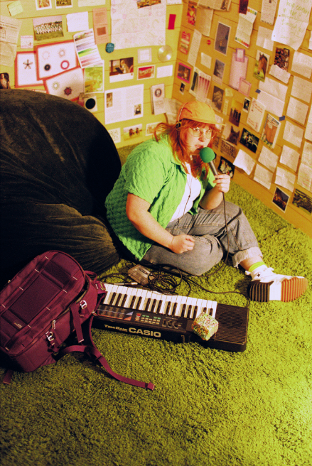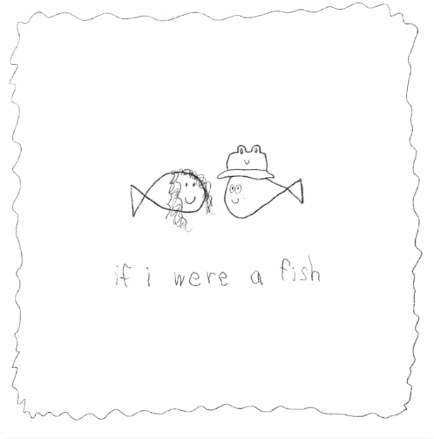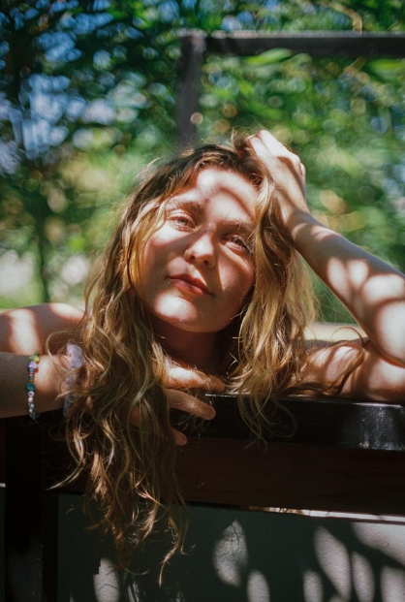
download hi-res press photos + artwork here

about corook
Named as one of The Advocate’s “7 Queer Artists For Your Fall Playlist,” corook has become known for their ability to tackle deeply personal themes in their music and visuals through a humorous lens. Last spring, the genre-busting, Nashville-based musician blessed the world with their debut EP, achoo!, featuring such surprising and insightful tracks as “idk god,” “degree,” “bad friend,” and “sims” in addition to the fan favorite “snakes.” Further releases followed, among them the viral adult lullaby, “it’s ok!,” the unrestrained “BDSM,” the super-hot “hell yeah,” the heartfelt “your mom,” and the ode to self-worth, “smoothie.” corook also got vulnerable in front of the camera, reflecting on their mental health journey in an episode of Out Magazine’s “Love, Me” video series streaming now HERE.

about olivia barton
Olivia Barton writes songs that sound like stream-of-consciousness journal entries—because they are. Olivia asks and answers questions in real time, taking you through a “diary of the healing process” (Sound of Boston). The 90s-inspired folk-pop songs live in a raw but playful space Olivia (sort of) jokingly describes as “somewhere between Elliott Smith and Hilary Duff.” After releasing her sophomore album This is a Good Sign at the end of 2022, she is gearing up for her biggest year yet supporting Lizzy McAlpine’s full US tour in spring of 2023.
This is a Good Sign has been written about in publications such as Stereogum and Brooklyn Vegan, charted at #3 on college radio, featured on Spotify editorial playlists, and gained the attention of dream collaborators, including Madi Diaz, Carol Ades, and Evan Stephens Hall of the band Pinegrove. The album’s opening track, “I Don’t Sing My Songs” is reflective of Olivia’s infectious ability to hold darkness and light in the same hand, starting by directly facing reality: “I stay inside / I call my dad / I wait to feel” and ending with an inner knowing: “Good feelings are so possible within me.” She leaves you feeling cracked open, seen, and vibrating with hope in the connectedness of things.

connect with corook:
corook.com | instagram | tiktok | press assets

connect with olivia barton:
instagram | tiktok

press contact:
andrew.george@atlanticrecords.com

