FOR IMMEDIATE RELEASE
APRIL 18, 2023

GROUNDBREAKING ALTERNATIVE ARTIST SAM AUSTINS RELEASES NEW SINGLE “OATMEAL PANCAKES”

OFF FORTHCOMING EP BOY TOY
DUE OUT MAY 26 VIA ATLANTIC RECORDS

RECENTLY NAMED TO THE NME 100: ‘ESSENTIAL EMERGING ARTISTS FOR 2023’

PLAYING SAN DIEGO’s BLEACHED FESTIVAL THIS AUGUST

LISTEN TO “OATMEAL PANCAKES” HERE | WATCH THE OFFICIAL VISUAL HERE
PRE-SAVE BOY TOY HERE

“riveting star quality… Sam Austins’ music has been described by Pusha T as ‘a mix between ‘My Beautiful Dark Twisted Fantasy’ and Prince,’ surely some of the highest praise you could get. Inspired by Motown and making music that incorporates indie, psych, R&B and beyond, Austins is a true Gen Z chameleon, but everything is imbued with a singular vision and unique voice.” – NME

“Sam Austins is a boundary-breaker, challenging long-held ideas of what it means to be an alternative artist.” – BILLBOARD

“Sam Austins is cooler than all of us… Blending his chic aesthetic with a love for 90s-inflected alternative and R&B grooves, Sam Austins melds past experience and future fantasy into powerful sonic motifs… watching his ascent is highly recommended.” – THE LINE OF BEST FIT

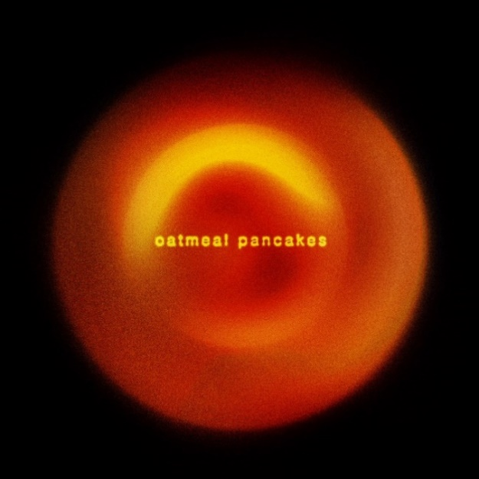
DOWNLOAD HI-RES SINGLE ARTWORK

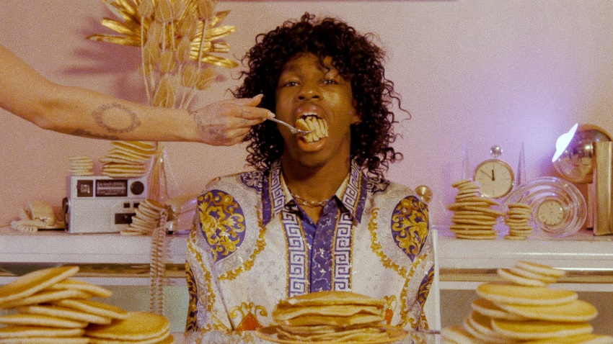
DOWNLOAD HI-RES VISUAL STILLS HERE

Today, groundbreaking alternative singer-songwriter/model/artist Sam Austins unveils new single “Oatmeal Pancakes” (listen HERE). The masterfully R&B-tinged, incredibly vulnerable slow-burn received a coveted radio premiere via LA’s KCRW, and is the latest offering from Austins’ forthcoming EP, Boy Toy, due out May 26 via Atlantic Records (pre-save HERE). Directed by Austins and Manfid Duran, fans can watch the accompanying official visual here.

Of today’s deeply personal release, “Oatmeal Pancakes,” Austins shares:

“‘Oatmeal Pancakes’ is a very special song to me on the ‘Boy Toy’ EP. It's an ode to someone with whom I shared a classic night of emotional intimacy. It was a little blip of connection that, at the time, I needed. The moment was both fleeting and unforgettable. I remember spending time with her in a beach house, outside of LA, drinking red wine and listening to classic 90s records for hours into the morning. I actually almost called this song ‘New D’Angelo.’ The morning after, she had made a special breakfast for me. It’s my new favorite meal, caramelized bananas on top of oatmeal pancakes.”

Boy Toy’s magnetic lead single “Keep You Company” (listen HERE + watch the official music video HERE) arrived last month to instant critical acclaim, hailed by The Line of Best Fit as “…a track atmospherically bubbling with potentiality, effortlessly catchy in its hook, and striking with its electric guitar line.” Recently named to the highly-regarded NME 100 (‘essential emerging artists for 2023’), Austins has quickly become known for this genre-bending merge of sounds and influences, “incorporat[ing] indie, psych, R&B and beyond,” and proving himself to be “a true Gen Z chameleon.”

The Detroit-bred, LA-based musician has poured every part of himself into Boy Toy – even creating a character named Samuel Salem Bonhart to “express the raw emotions of what I’ve experienced through a new set of eyes.” As Sam elaborates, “Myself, like this character, grew up exposed to iconic heroes like Rick James, Prince, and Bootsy Collins, who were known for their powerful vocals and larger-than-life stage presence. Taking on an obsession with that era of music, Samuel Salem Bonhart is the presence of that heartbroken rockstar who embodies the highs and lows of love and loss.”

Earlier this month, the rising artist lit up the stage at LA’s iconic Masonic Lodge at Hollywood Forever not once, but twice – first, alongside Jesse® (from the Neighbourhood) and Yeek, and then as support for Vagabon. This summer, Austins will join the likes of Joji, Omar Apollo, Blondshell, and many more at San Diego, CA’s stacked Bleached Fest [August 5-6 @ Waterfront Park].

“Oatmeal Pancakes” and “Keep You Company” follow “Dancing With The Devil” and “Matador” – two standout singles that Austins released in the fall of 2022, before embarking on his first-ever North American tour, supporting beloved indie artist Dora Jar. That tour saw Austins stop in cities from Boston to Chicago to San Francisco, and included sold-out shows at NYC’s Bowery Ballroom, as well as LA’s storied Troubadour, where the run culminated.

Boy Toy marks the first EP that the artist has shared since his standout, debut mixtape, 2021’s HOMELESS STAR, which featured top single “JOY FOR YOUTH” with Atlantic labelmate Sir Chloe. Since he first arrived onto the scene, Sam Austins has become known for crafting music that’s simultaneously uplifting and melancholic, vulnerable and wildly inventive – an ability that’s been recognized with playlist adds from New Music Friday, Lorem, and Apple Music’s New Music Daily, sync placement on HBO’s Euphoria, and a slot at Lollapalooza last summer.

PRAISE FOR SAM AUSTINS

“Creating immersive and genre-fluid sonic worlds as conduits for his stories about growing up between the Michigan suburbs and the roaring city of Detroit, Austins’ music buzzes with a propulsive energy and has been described by Pusha T as a mix between My Beautiful Dark Twisted Fantasy and Prince.” – NME

“‘Matador‘ has everything you could want from a pop banger, a catchy chorus, exciting production and an inspiring popstar. Like the trumpets that usher the track in and dramatically see it out, Sam Austin doesn’t mess around. He enters, says what he needs to say and leaves, but not without a few dramatic flourishes to keep us coming back.” – CLUNK

“Love can and is all-consuming. On ‘Matador,’ that raw passion comes to life with unbound expression. Between his own feverish vocal performance, the driving guitars at his side, and the searing trumpet blaring its brassy, buoyant melody, Sam Austins ensures we hang on every moment of this dazzling, dramatic song.” – ATWOOD MAGAZINE

DOWNLOAD HI-RES PRESS PHOTOS | CREDIT: KHALIL COPELAND

# # #

UPCOMING TOUR DATES:

AUGUST
5-6 – San Diego, CA – Bleached Fest @ Waterfront Park

# # #

ABOUT SAM AUSTINS:
Sam Austins is quickly rising to the forefront of contemporary art pop with his revolutionary fusion of energies, merging 90s alternative and R&B melodies with the aspirational aesthetics of high fashion and authentic tales of his Detroit youth. A series of increasingly acclaimed releases and performances saw the preternaturally gifted musician and in-demand model earning early acclaim and accolades from such outlets as VOGUE, HYPEBEAST, Pigeons & Planes, and many more.

Austins joined Atlantic Records’ legendary roster in 2021 and quickly unveiled his label debut mixtape, HOMELESS STAR, highlighted by such genre-defying singles as “KILOS,” “MIND ON DRUGS,” “DRIFTING AWAY,” and “JOY FOR YOUTH (with Sir Chloe),” all available now for streaming and download. The 10-track collection was greeted by critical acclaim from the likes of Billboard, which raved, “Austins carries his struggles proudly, channeling his experiences as inspiration for the creative direction and lyrical content of HOMELESS STAR…The avant-garde storyteller paints a picture of Detroit in the summer…he hones in on eclectic influences that manage to achieve synchronicity…part Blood Orange, part Tame Impala, yet entirely Austins.”

CONNECT WITH SAM AUSTINS
WEBSITE | FACEBOOK | INSTAGRAM | TWITTER | YOUTUBE

PRESS CONTACTS
Fairley McCaskill | Fairley.McCaskill@atlanticrecords.com
Katy Carmichael (Tour) | Katy.Carmichael@atlanticrecords.com
Alison Smith | Alison@tcbpr.com
Claire Marcus | Claire@tcbpr.com

