FOR IMMEDIATE RELEASE
APRIL 14, 2023

MULTIPLATINUM SINGER-SONGWRITER VANCE JOY
SHARES LIVE AT SYDNEY OPERA HOUSE
LISTEN HERE

16-TRACK ALBUM INCLUDES LIVE RENDITIONS OF SUCH CLASSIC HITS
AS “GEORGIA,” “MESS IS MINE,” “SATURDAY SUN,” “MISSING PIECE,”
AND THE 6X PLATINUM “RIPTIDE”

FINAL SHOWS ON EPIC IN OUR OWN SWEET TIME TOUR
BEGIN AUGUST 25 IN VANCOUVER, BC

HIGHLIGHTS INCLUDE STOPS AT MORRISON, CO’S RED ROCK AMPHITHEATRE,
NYC’S SUMMERSTAGE IN CENTRAL PARK,
AND NASHVILLE, TN’S HISTORIC RYMAN AUDITORIUM

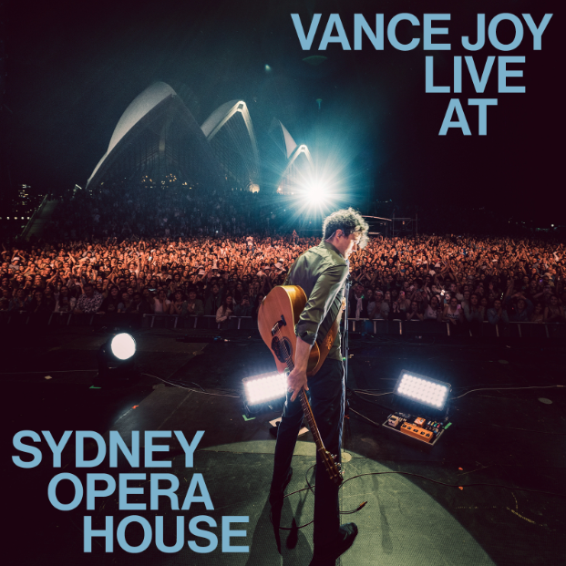
DOWNLOAD HI-RES IMAGE

Multiplatinum global superstar Vance Joy has shared Vance Joy Live At Sydney Opera House, a 16-track new album recorded last year during two very special headline performances at the world-famous Sydney Opera House Forecourt in Sydney, Australia. Vance Joy Live At The Sydney Opera House is available now HERE.

Recorded November 18 and 19, 2022 during the Australian leg of Joy’s sold out In Our Own Sweet Time World Tour, Vance Joy Live At The Sydney Opera House includes electrifying new renditions of such RIAA Platinum certified hits as “Georgia,” “Mess Is Mine,” and of course, the 6x Platinum-certified classic, “Riptide.” Highlights include live versions of “Clarity” and “Catalonia,” both originally featured on the Australian singer-songwriter’s acclaimed 2022 album, In Our Own Sweet Time, with the latter track joined by an official live performance video streaming now at YouTube HERE.

Joy recently unveiled the final leg of his epic In Our Own Sweet Time Tour, with North American
headline dates getting underway August 25 at Vancouver, BC’s Deer Lake Park and then making stops at such historic venues as Morrison, CO’s Red Rocks Amphitheatre (August 27), New York City’s SummerStage in Central Park (August 30), and Nashville, TN’s Ryman Auditorium (September 1-2). Support comes from Canada’s Dan Mangan & Ruby Waters as well as Joy’s fellow Australian, singer-songwriter Dan Sultan. The upcoming dates follow a recently wrapped North American live run that saw sold out shows across the US and Canada. For complete details and remaining ticket availability, please see www.vancejoy.com.

Vance Joy’s most personal full-length thus far, In Our Own Sweet Time includes such emotionally charged tracks as “Looking At Me Like That,” “Don’t Fade,” and the RIAA Gold-certified smash, “Missing Piece,” all joined by official music videos streaming now at YouTube. Currently boasting over 43.5M global streams, “Clarity” has fast proven a popular favorite around the world, ascending to the top 5 at Alternative radio outlets across America while also earning prestigious “Song of the Year” and “Best Pop Release” nominations from Australia’s 2022 ARIA Music Awards. In addition, the official music video for the album’s “Every Side of You” recently took home the ARIA for “Best Video” – Joy’s fourth ARIA Award to date.

Hailed by Rolling Stone as “a refreshing twist on the singer’s signature sound,” In Our Own Sweet Time has also been met by worldwide critical applause from such top media outlets as Billboard, V, UPROXX, NME, Guitar World, and American Songwriter, to name only a few.

LIVE FROM SYDNEY OPERA HOUSE TRACKLIST
- Missing Piece (Live)
- Mess Is Mine (Live)
- Like Gold (Live)
- Every Side Of You (Live)
- Wasted Time (Live)
- Don’t Fade (Live)
- We’re Going Home (Live)
- Clarity (Live)
- Saturday Sun (Live)
- I’m With You (Live)
- Looking At Me Like That (Live)
- Fire And The Flood (Live)
- Georgia (Live)
- Riptide (Live)
- Lay It On Me (Live)

VANCE JOY
IN OUR OWN SWEET TIME TOUR
NORTH AMERICA 2023

AUGUST
25 – Vancouver, BC – Deer Lake Park *
27 – Morrison, CO’s Red Rocks Amphitheatre +
30 – New York, NY – SummerStage in Central Park +

SEPTEMBER
1 – Nashville, TN – Ryman Auditorium +
2 – Nashville, TN – Ryman Auditorium +

* w/ Special Guest Dan Mangan & Ruby Waters
+ w/ Special Guest Dan Sultan

# # #

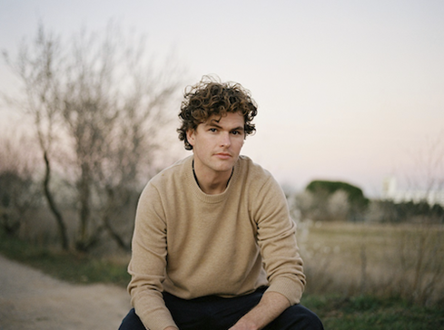
DOWNLOAD HI-RES IMAGE
PHOTO CREDIT: CELINA MARTINS

CONNECT WITH VANCE JOY:
WEBSITE | FACEBOOK | TWITTER | INSTAGRAM | YOUTUBE

For press inquiries, please contact:
Kelly McWilliam // Kelly.McWilliam@atlanticrecords.com
Libby Kober // Libby.Kober@atlanticrecords.com

