BALU BRIGADA RELEASE REFLECTIVE NEW SINGLE “DESIGNER”

ALONGSIDE DREAMY OFFICIAL VISUALIZER
LISTEN/WATCH HERE

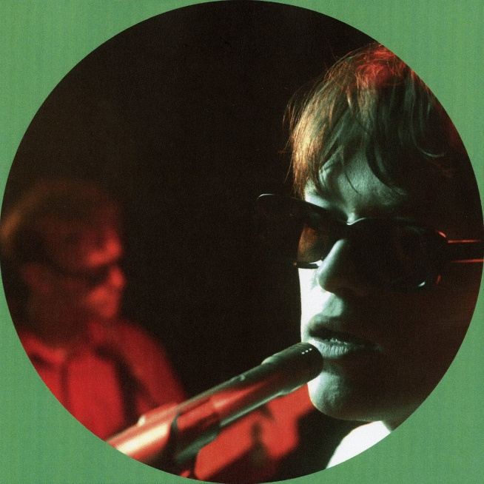
DOWNLOAD ARTWORK CREATED BY BALU BRIGADA HERE

“Balu Brigada is the groove-pop duo you've been waiting for.” - PEOPLE

Indie pop duo Balu Brigada have released another groovy single, "Designer”, a track showcases their signature blend of catchy hooks, slick production, and introspective lyrics. "Designer" allows Balu Brigada to explore themes of self-worth and the pressure to conform to societal ideals. Balu Brigada's unique sound has garnered them a loyal following and critical acclaim, with their music featured on Rolling Stone (Songs You Need to Know), People (Emerging Artists list), and many more.
Listen/watch HERE.

“Designer” accompanies the Brooklyn-based duo’s most recent single, “OH! Not Again” available HERE. They describe their sound as "…music that's bumpin' enough to dance to, as well as being emotionally poignant enough to cry to,".

Hailed by i-D as “an actual band of brothers making tunes stacked with hooks that’ll run circles around your brain for days,” multi-instrumentalist/songwriter/producer brothers Henry and Pierre Beasley, are habituated to finishing each other’s sentences both in everyday discourse and in song. Their dynamic sound draws from a wide range of influences, including indie pop, R&B, and hip-hop. The Beasleys have spent much of the past few years creating a unique future-facing sound of their own, prioritizing dual vocals, prominent bass hooks, and punchy drums while showcasing a left-of-center pop sensibility and natural ability to skate genres. Tracks such as “OH! Not Again,” and their debut EP I Should Be Home have already earned applause from such outlets as Rolling Stone, i-D, and People Magazine, which praised their “soaring falsetto choruses, synth hooks and an irresistible, underlying groove.”.

ABOUT BALU BRIGADA:
Born into a creative home, their dad a dancer and mother an actress/musician, Henry and Pierre Beasley each dipped their toes in acting during school before fully immersing themselves in their love for music. A truly homegrown talent, they started making music together young, when a 12-year-old Henry capitalized on his older brother status by appointing himself lead guitarist and forcing Pierre to learn bass – officially forming Balu Brigada when Pierre was old enough to almost pass as 18 and play in bars. The duo have spent the past few years fine tuning their skills in every aspect of their output.

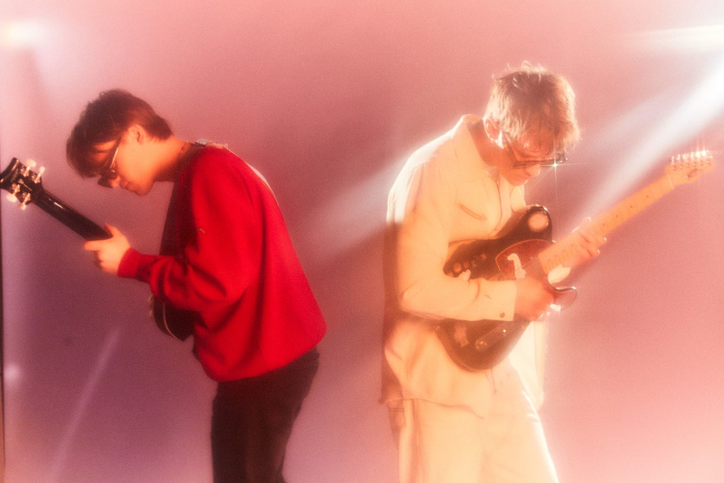
DOWNLOAD PRESS PHOTO HERE

CONNECT WITH BALU BRIGADA
FACEBOOK | INSTAGRAM | TWITTER | YOUTUBE

Press Contact:
Paige.Rosoff@atlanticrecords.com

