BRISTON MARONEY ANNOUNCES SOPHOMORE ALBUM ULTRAPURE
DUE OUT SEPTEMBER 22 VIA CANVASBACK MUSIC/ATLANTIC RECORDS
PRE-ORDER HERE

DEBUT SINGLE “BODY” OUT NOW
WATCH OFFICIAL VIDEO – CO-DIRECTED BY MARONEY – HERE
BUY/STREAM HERE

“Pretty flawless. Briston Maroney has pulled it off.”
Zane Lowe re: “Body” on New Music Daily [listen here]

FORTHCOMING LP – PRODUCED BY DANIEL TASHIAN – FEATURES MARONEY PLAYING EVERY INSTRUMENT

SECOND ANNUAL ‘PARADISE FESTIVAL’ – CURATED BY MARONEY – SET FOR OCT 12-14 AT BROOKLYN BOWL NASHVILLE

UNVEILS PLANS FOR FALL 2023 HEADLINE UK/EU TOUR

"Briston Maroney is writing powerful rock songs with grit and heart" – NPR

“Nashville-based singer-songwriter Briston Maroney … flaunts a keen understanding of the hooks that will explode in front of festival crowds.” – BILLBOARD

“Nashville’s next big star” – PAPER | “refreshing” – VULTURE

“A breath of fresh air in these dark times… Maroney’s musical chops and resumé belie his age.” – CONSEQUENCE

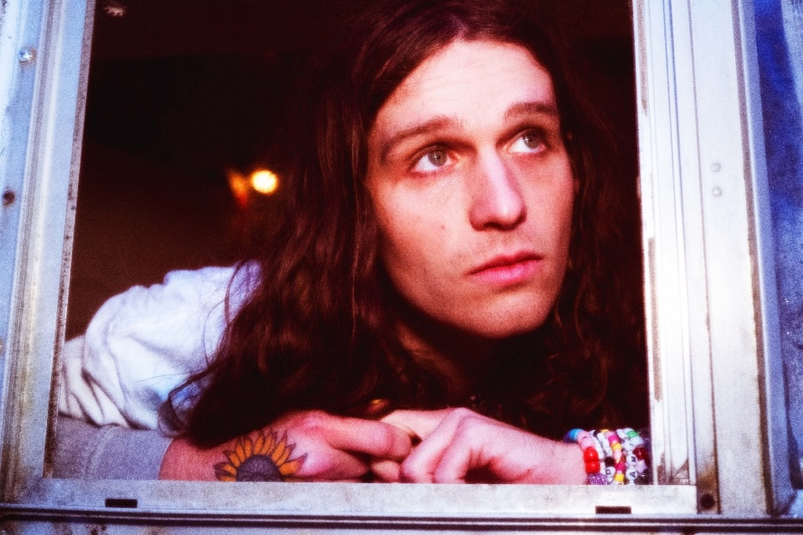
press photo credit: Muriel Margaret | download hi-res HERE
download additional images, boiler + Maroney’s album note HERE

May 16, 2023 – Acclaimed Nashville-based artist Briston Maroney has officially announced details of his forthcoming sophomore album – Ultrapure – due out Friday, September 22 via Canvasback Music/Atlantic Records (pre-order here; full tracklist enclosed below).

The record is previewed by lead single “Body,” out now on all platforms (buy/stream here) after being featured this morning alongside an interview with Apple Music’s New Music Daily and an interview with Briston and Zane Lowe.

“Body” arrives accompanied by an official music video (watch here), conceived and directed by Maroney, alongside close friend and longtime visual collaborator Drew Bauml. The video stars Maroney in his physical form, alongside an animated depiction of his soul. Evoking nostalgia, the visual “carries the emotion of a twenty-something discovering their own freedom for the first time.”

Produced by 2x GRAMMY®-winner Daniel Tashian (Kacey Musgraves) and engineered by Konrad Snyder (Noah Kahan, Rainbow Kitten Surprise), Ultrapure was handcrafted in Maroney’s adopted hometown of Nashville, TN and showcases the multi-faceted artist playing every single instrument.

The album marks a confident, cohesive, and deeply personal body of work from the young singer-songwriter.

Of its genesis, Maroney shares: My favorite moments in the human experience are ones that you don’t even realize have started, but feel so deeply when you realize they’ve ended. I refer to these as ‘Ultrapure’ moments. This album was my humble, unqualified, and earnest as hell attempt at sitting in those feelings until they had no choice but to burst out of my head. These songs are about a type of pain I hate and love, but mostly have a deep appreciation for.

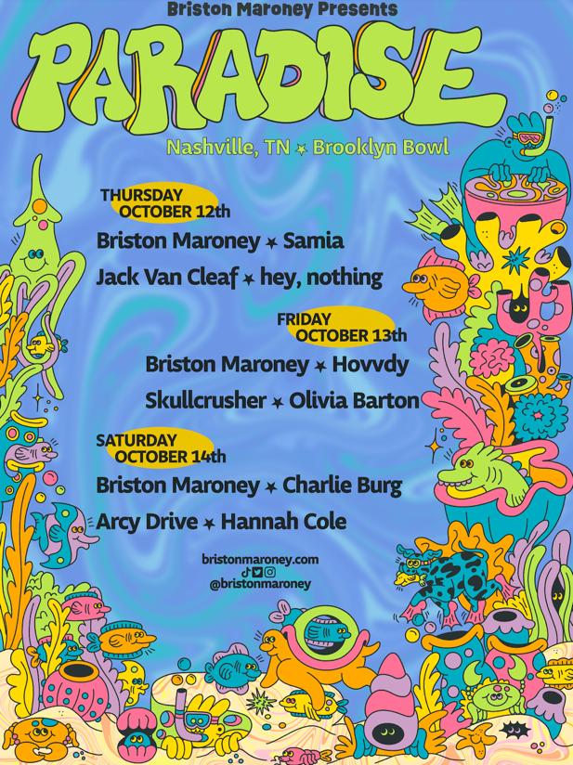
Also announced today is news of the second annual ‘Paradise Festival,’ set to return to Brooklyn Bowl Nashville this fall (October 12-14). Last year’s sold-out inaugural edition was curated in its entirety by Maroney, who closed out each night with high-energy and celebratory headline sets. Featuring a handpicked lineup of peers and with a portion of proceeds supporting Nashville-based nonprofits, the annual event further cements Maroney’s status as an artist who “has helped define a new generation of local music” (Nashville Scene).

Maroney has also unveiled plans for a headline UK/EU tour in support of the forthcoming LP, set for this fall. The run will kick off in Brighton, UK on October 31 and culminate in Cologne, Germany on November 16, with stops in London, Paris, Amsterdam, and many more cities in between [all upcoming tour dates enclosed below].

Pre-sales for Paradise Festival and UK/EU headline tour begin Wednesday, May 17 at 10am (local), with general on-sale beginning Friday, May 19 at 10am (local). Tickets and additional information available here.

Maroney’s debut LP Sunflower was released in 2021, following a trio of EP’s: Miracle, Indiana, and Carnival – the latter of which spurned the RIAA Platinum-certified single, “Freakin’ Out On The Interstate.” These releases amassed critical acclaim from the likes of NPR, Billboard, Vulture, NME, amongst many others, and led to sold-out headline tour dates across the US, Canada, UK and Europe; performances at marquee festivals around the world (from Bonnaroo to Outside Lands to Pitchfork Paris); opening slots for Jack White and Rainbow Kitten Surprise; and a feature collaboration with Manchester Orchestra on 2022’s Sunflower: Deluxe.

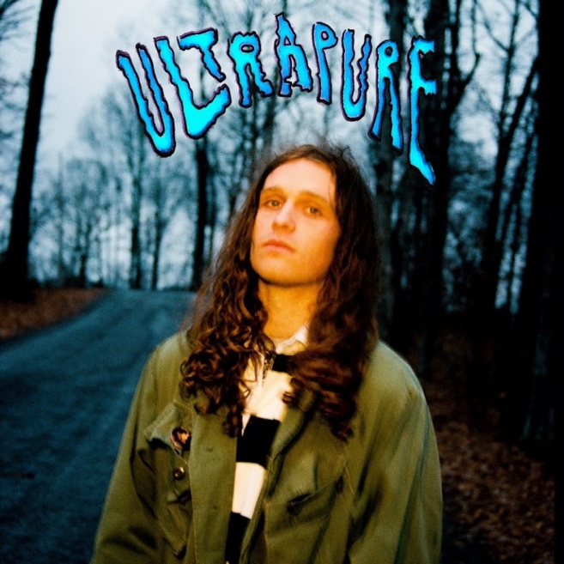
download hi-res album artwork HERE

ULTRAPURE TRACKLIST
- Intro
- Body
- Breathe
- Chaos Party
- Sunburn Fades
- Sunshine
- Delaware
- Detonator
- The Idea
- Spring
- Sink;Swim
- Skyline
- Ultrapure

###

BRISTON MARONEY | UPCOMING TOUR DATES
# festival performance

JULY
26 – Morrison, CO @ Red Rocks (supporting Noah Kahan)

SEPTEMBER
8 – Denver, CO @ Unlimited Sunshine Festival #

OCTOBER
12 – Nashville, TN @ Brooklyn Bowl Nashville – Paradise Festival #
13 – Nashville, TN @ Brooklyn Bowl Nashville – Paradise Festival #
14 – Nashville, TN @ Brooklyn Bowl Nashville – Paradise Festival #
31 – Brighton, UK @ Patterns

NOVEMBER
1 – London, UK @ Scala
3 – Manchester, UK @ Gorilla
4 – Glasgow, UK @ Stereo
5 – Leeds, UK @ Brudnell Social Club
7 – Nottingham, UK @ Rescue Rooms
8 – Bristol, UK @ Thekla
10 – Paris, FR @ Le Trabendo
11 – Brussels, BE @ Grand Salon
12 – Amsterdam, NL @ Melkweg OZ
14 – Hamburg, DE @ Knust
15 – Berlin, DE @ Gretchen
16 – Cologne, DE @ MTC Club

###

CONNECT WITH BRISTON MARONEY:
OFFICIAL I INSTAGRAM I YOUTUBE I FACEBOOK I TWITTER I TIKTOK

FOR ALL PRESS INQUIRIES, PLEASE CONTACT:
Libby Kober (National) | Libby.Kober@AtlanticRecords.com
Gabby Reese (Tour) | Gabrielle.Reese@AtlanticRecords.com

