FOR IMMEDIATE RELEASE
MAY 26, 2023

CATIE TURNER REMEMBERS HER “HOMETOWN” WITH NOSTALGIC NEW SINGLE
ALONGSIDE OFFICIAL MUSIC VIDEO

AMBITIOUS NEW PROJECT COMEDY & TRAGEDY: ACT 1 TO BE RELEASED JUNE 9TH

COMEDY & TRAGEDY: THE HEADLINE TOUR GETS UNDERWAY JUNE 3 IN DALLAS, TX

LISTEN TO “HOMETOWN” HERE | WATCH OFFICIAL MUSIC VIDEO HERE

DOWNLOAD HI-RES ARTWORK

Acclaimed singer-songwriter Catie Turner has shared her nostalgically charged new single, “Hometown” - Listen HERE. A powerful pop reflection on where Turner grew up and the insecurities that come with that place and the time spent there, “Hometown” is accompanied by an official companion video – Watch HERE. The track will be included on Catie’s ambitious new project Comedy & Tragedy: Act 1 set for release June 9th. See full tracklist below.

“‘Hometown’ is about when you feel unsafe and unfamiliar in what is supposed to be the most familiar place in the world,” says Catie Turner, “all because of a failed relationship. The fear of them seeing you, and you seeing them, so you hide out in your bedroom. This goes out to everyone who has worn their hood up on an outing to WaWa or refused to go to Trader Joe’s because they didn’t want to run into their ex’s mom!”

Comedy & Tragedy is a two-part collection of songs and visuals to be released throughout 2023. The project was first heralded by the deeply introspective (but still upbeat) “Hyperfixations,” featured in both Rolling Stone’s “Songs You Need To Know” and Ones To Watch’s “Now Watching.” The inspiring "Easy” followed earlier this month, originally teased on Turner’s popular TikTok (where it quickly amassed more than 1.1M likes) and joined by an official visualizer streaming HERE.

Comedy & Tragedy: Act 1 also includes Turner’s heart-wrenching breakthrough hit single, “God Must Hate Me,” which proved a worldwide viral phenomenon upon its original November 2021 release. Applauded by American Songwriter as “a platform for all sorts of reflections and interpretations…one of (Turner’s) most successful songs to date,” the track earned more than 1.2M streams in its first week, landing Catie on the cover Spotify’s influential “Next Gen Singer Songwriters” playlist. Now with almost 72.6M global streams, “God Must Hate Me” is joined by a powerful live performance video, filmed live at the historic St. Ann’s Church in Brooklyn, NY (streaming HERE).

Comedy & Tragedy: Act 1 and Comedy & Tragedy: Act 2 showcase Turner’s gift for intensely personal songcraft while simultaneously flexing her sonic versatility with a newfound creative edge. At the heart of the project is Catie’s belief in the dichotomy of drama – that truth cannot exist without both comedy and tragedy. Turner takes the theatrically inspired undertaking even further with Comedy & Tragedy: The Musical: The Series, now underway HERE.

Named by PEOPLE as one of “25 Emerging Musical Artists You Should Add to Your Playlist,” Turner will celebrate Comedy & Tragedy with her biggest US live run thus far. Comedy & Tragedy: The Headline Tour gets underway June 3 at Dallas, TX’s Deep Ellum Art Company with stops at New York City’s Mercury Lounge and West Hollywood, CA’s famed Troubadour. Tickets for all announced dates are on sale now; additional dates will be announced soon. For updates and ticket information, please visit www.catieturner.com.

CATIE TURNER
COMEDY & TRAGEDY: ACT 1
(Atlantic Records)
Release Date: Friday, June 9

Tracklist:
Comedy & Tragedy
Easy
God Must Hate Me
Hyperfixations
Control
Hometown

CATIE TURNER
COMEDY & TRAGEDY: THE HEADLINE TOUR

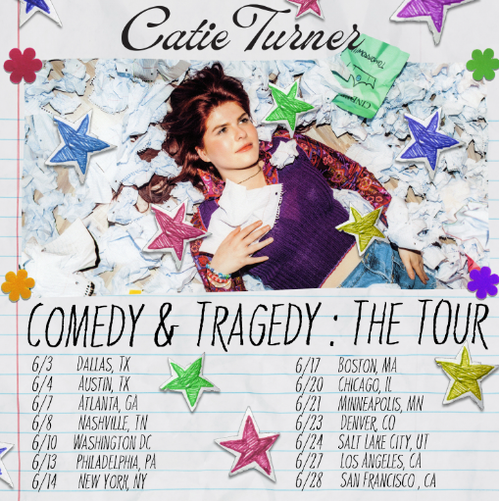

JUNE
3 – Dallas, TX – Deep Ellum Art Company
4 – Austin, TX – The Ballroom
7 – Atlanta, GA – Vinyl at Center Stage
8 – Nashville, TN – The Basement East
10 – Washington, DC – Union Stage
13 – Philadelphia, PA – World Café Live
14 – New York, NY – Mercury Lounge
15 – Brooklyn, NY – Baby’s All Right
17 – Boston, MA – Brighton Music Hall
20 – Chicago, IL – Lincoln Hall
21 – Minneapolis, MN – 7th Street Entry
23 – Denver, CO – Globe Hall
24 – Salt Lake City, UT – Kilby Court
27 – West Hollywood, CA – Troubadour
28 – San Francisco, CA – Brick & Mortar Music Hall

# # #

DOWNLOAD PRESS PHOTOS // CREDIT: CAITY KRONE

CONNECT WITH CATIE TURNER
OFFICIAL | FACEBOOK | INSTAGRAM |TIK TOK | TWITTER | YOUTUBE

For press inquiries, please contact:
Kelly McWilliam, Kelly.McWilliam@atlanticrecords.com
Paige Rosoff, Paige.Rosoff@atlanticrecords.com

