FOR IMMEDIATE RELEASE
MAY 24, 2023

DON TOLIVER EARNS THREE TELLY AWARDS FOR LOVE SICK

ACCLAIMED SHORT FILM WINS TRIO OF TOP PRIZES HONORING
EXCELLENCE IN VIDEO AND TELEVISION ACROSS ALL SCREENS

NEW ALBUM, LOVE SICK, AVAILABLE NOW

THEE LOVE SICK TOUR 2023 KICKS OFF JUNE 18 AT DENVER, CO’S FILLMORE AUDITORIUM

LOVE SICK STREAMING NOW EXCLUSIVELY ON PRIME VIDEO HERE

DOWNLOAD HI-RES ARTWORK

Hip-hop soul artist Don Toliver has received three prestigious Telly Awards honoring his self-written short film, Love Sick. The Telly Awards – which honor excellence in video and television across all screens – bestowed three top trophies upon the project in a trio of “Branded Content” categories, including two Gold Telly Awards: Craft (for Directing and Videography/Cinematography) and a Bronze Telly Award: General (for Music). Presented by Rotation – the hip-hop and R&B brand from Amazon Music – and directed by award-winning French filmmaker Alexandre Moors (Kendrick Lamar, Juice WRLD, Miley Cyrus) - produced by Good Company (Lemonade, Pharrell Williams, Adele), Love Sick is streaming now exclusively on Prime Video HERE.

Love Sick premiered earlier this year in tandem with Don Toliver’s acclaimed third studio album, Love Sick, available now in an Expanded Deluxe Edition HERE. The album includes such hit singles as “Leave The Club (Feat. Lil Durk & GloRilla),” “4 Me (Feat. Kali Uchis),” “Slow Motion (Feat. WizKid),”and the standout favorite, “Private Landing (Feat. Justin Bieber & Future).”

Don Toliver will celebrate the wide-ranging success of Love Sick with a major North American headline tour. Produced by Live Nation, Thee Love Sick Tour 2023 kicks off June 18 at Denver, CO’s Fillmore Auditorium and then travels through early July. Support comes from Pi’erre Bourne and other special guests to be announced. Tickets for all dates are on sale now HERE. In addition, a limited number of exclusive VIP packages are available HERE.

ABOUT DON TOLIVER:
Soul singer, songwriter, and artist Don Toliver has earned worldwide attention for a unique sound that calls out his myriad musical influences of hip-hop, smoked-out R&B, ambitious pop, and even a bit of rock ‘n’ roll, creating a genre-bending lane of his own. After the 2018 mixtape Donny Womack, the Houston, TX native assembled his full-length debut, Heaven Or Hell, which claimed spots on mid-year and year-end lists by Complex and XXL, while Rolling Stone championed him among the “10 Biggest Breakthrough Artists of 2020.” Don then joined forces with Internet Money, NAV, and Gunna for the 4x platinum banger “Lemonade,” which they also performed on NBC’s The Tonight Show Starring Jimmy Fallon. 2021 saw Don team with Lil Durk and Latto for “Fast Lane,” the lead track on Atlantic Records’ F9: The Fast Saga (Original Motion Picture Soundtrack), followed by the blockbuster release of Life of a DON, once again showcasing his fluid ability to exist in multiple soundscapes and featuring production by Mike Dean, Hit-Boy, Mustard, and more. Through it all, he has gathered billions of streams, scored platinum plaques, and received praise courtesy of everybody from such media outlets as V MAN, W Magazine, Interview, and more.

DON TOLLIVER
THEE LOVE SICK TOUR 2023

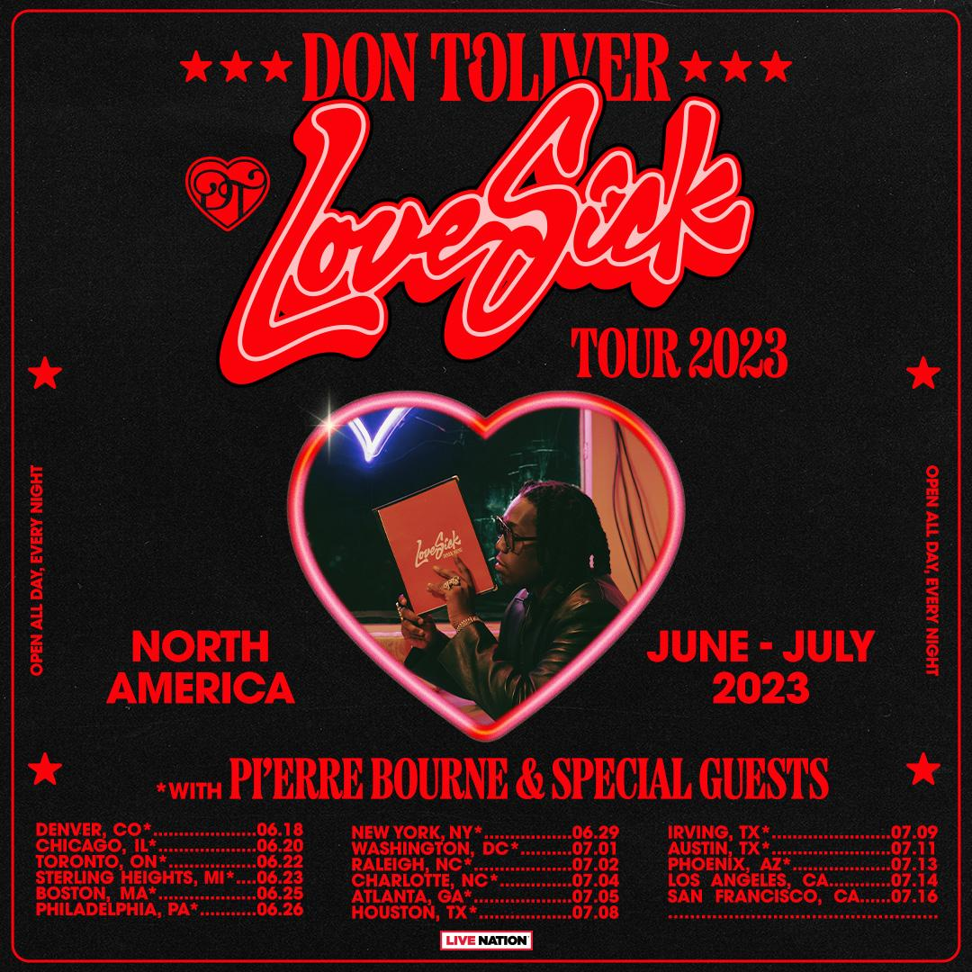

JUNE
18 – Denver, CO – Fillmore Auditorium
20 – Chicago, IL – Byline Bank Aragon Ballroom
22 – Toronto, ON – RBC Echo Beach
23 – Sterling Heights, MI – Michigan Lottery Amphitheatre at Freedom Hill
25 – Boston, MA – MGM Music Hall at Fenway
26 – Philadelphia, PA – Skyline Stage at The Mann
29 – New York, NY – Theater at The Garden

JULY
1 – Washington, DC – The Anthem
2 – Raleigh, NC – Red Hat Amphitheater
4 – Charlotte, NC – Skyla Credit Union Amphitheatre
5 – Atlanta, GA – Coca-Cola Roxy
8 – Houston, TX – 713 Music Hall
9 – Irving, TX – The Pavilion at Toyota Music Factory
11 – Austin, TX – Moody Amphitheater
13 – Phoenix, AZ – Arizona Financial Theatre
14 – Los Angeles, CA – YouTube Theater
16 – San Francisco, CA – The Masonic

# # #

CONNECT WITH DON TOLIVER
OFFICIAL I INSTAGRAM| TWITTER |FACEBOOK |YOUTUBE

PRESS CONTACT:
Brittany Bell, Brittany.Bell@atlanticrecords.com

