DAISY JONES & THE SIX RELEASE AURORA (DELUXE) – BUY/STREAM HERE

EXTENDED ALBUM FEATURES PREVIOUSLY UNRELEASED FAN FAVORITES –
OUT NOW BY OVERWHELMING POPULAR DEMAND

ALL SONGS CO-WRITTEN & PRODUCED BY GRAMMY® AWARD WINNER BLAKE MILLS

DAISY JONES & THE SIX DEBUTED AT #1 ON BILLBOARD EMERGING ARTISTS CHART

MUSIC FROM AURORA STREAMED OVER 150 MILLION TIMES

ADAPTATION OF NEW YORK TIMES BESTSELLING LITERARY PHENOMENON – PRODUCED BY AMAZON STUDIOS AND HELLO SUNSHINE – OUT NOW ON PRIME VIDEO

PURCHASE AURORA (ORIGINAL) ON VINYL HERE

“Stillwater walked so Daisy Jones & The Six could stage-dive… the harmonies on ‘Look At Us Now (Honeycomb)’ are infectious… you can imagine that The Six really were the biggest band in the world for a minute.” – ROLLING STONE

“Aurora is an unprecedented project for a book-to-screen adaptation and musical storytelling on television…” – ENTERTAINMENT WEEKLY

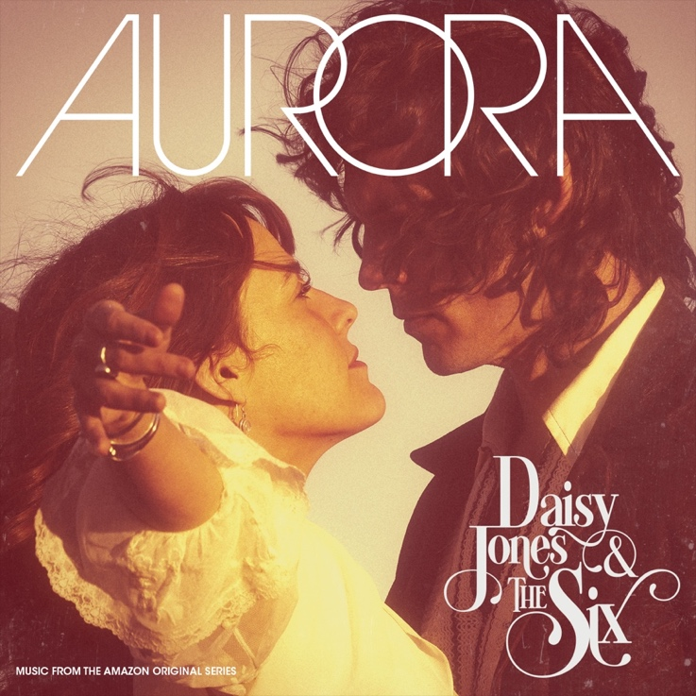
download hi-res deluxe artwork here

Atlantic Records is proud to release Aurora (Deluxe) – buy/stream here – the highly-anticipated, extended debut from Daisy Jones & The Six. The 20-track LP includes all 11 original album cuts, plus recent standalone singles – such as the beloved “Aurora (Live from SNL)” – and previously-unreleased fan favorites, including the stunning acoustic demo of “The River” and storied renditions of “Look At Us Now (Honeycomb)” and “The River (ft. Simone Jackson)” – both Live from Soldier Field – 1977.

Co-written and produced by GRAMMY®-winning songwriter, producer, and multi-instrumentalist Blake Mills (Bob Dylan, Fiona Apple, Alabama Shakes, John Legend, Perfume Genius), Aurora (Deluxe) arrives following massive demand from fans for new music – a demand which has only continued to grow since the Prime Video Original Series’ final episodes aired in late March.

The extended LP marks the latest addition to Daisy Jones & The Six’s growing catalog, which has amassed over 150 million global streams across platforms.

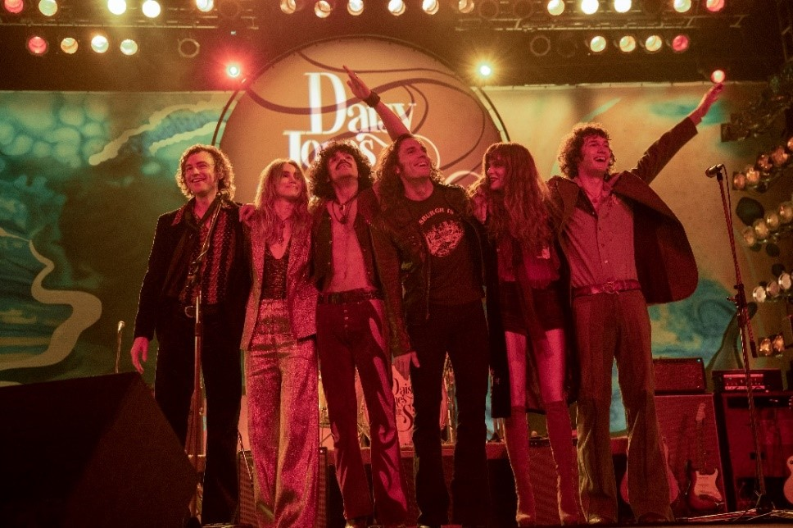
download hi-res photo here

Taken from page to screen to recording studio, Aurora – the original, 11-song record – marked the debut LP from the titular band of Taylor Jenkins Reid’s beloved, New York Times bestselling novel Daisy Jones & The Six.

Aurora was released to tremendous acclaim from critics and fans alike in early March, debuting at #1 on Billboard’s Soundtracks chart, #4 on the Billboard Vinyl Albums & Americana/Folk Albums charts, #9 on Top Current Albums, #10 on Top Albums, and more. Daisy Jones & The Six themselves debuted at #1 on Billboard’s Emerging Artists chart – becoming the first act from a scripted series or film to do so. (They also became the first such act to hit #1 on the iTunes Top Albums chart.)

Also released in March was the standout Amazon Original version of “Look At Us Now (Honeycomb),” performed by Marcus Mumford & Maren Morris. Originally released exclusively via Amazon Music (buy/listen here), that version will be available on all platforms beginning June 16.

‘Daisy Jones & The Six’ debuted as the #1 Prime Video series upon its March 3 premiere, and boasted a massive 1.5 billion social impressions within the first 3 days of the show’s rollout (watch all ten episodes of the limited series here). The highly-anticipated series arrived via Amazon Studios and Reese Witherspoon’s media company Hello Sunshine, who optioned Reid’s work in 2018 – before Daisy Jones & The Six ever even hit bookshelves. Upon the novel’s release in early 2019, it received coveted recognition as a ‘Reese’s Book Club Pick.’

With over 25 original songs, co-written by GRAMMY®-winning songwriter, producer, and multi-instrumentalist Blake Mills, Aurora and other music from throughout Daisy Jones & The Six boasts co-writing credits from several of the biggest names in music, including Marcus Mumford and Jackson Browne, with additional production from renowned record producer Tony Berg (Phoebe Bridgers, Andrew Bird), and alongside instrumentalists from The Who, Nine Inch Nails, Pearl Jam, David Bowie, Elton John, Jeff Beck, The Wallflowers, and more. Other co-writers on Aurora include Chris Weisman, Ethan Gruska, and Z Berg, among others.

Mills – who also executive produced the music from the series – recorded the entirety of Aurora with Keough and Claflin at Sound City Studios. The iconic Van Nuys, CA space – now jointly run by Mills and Berg – also serves as the backdrop in both the book and limited series for the creation of the album.

***

DAISY JONES & THE SIX – AURORA (DELUXE) TRACKLIST:
- Aurora
- Let Me Down Easy
- Kill You To Try
- Two Against Three
- Look At Us Now (Honeycomb)
- Regret Me
- You Were Gone
- More Fun To Miss
- Please
- The River
- No Words
- Look At Us Now (Honeycomb) [Acoustic Demo]
- Regret Me (Acoustic Demo)
- Let Me Down Easy (Acoustic Demo)
- The River (Acoustic Demo)
- Look At Us Now (Honeycomb) [Live from Soldier Field – 1977]
- Look Me In The Eye (The Dunne Brothers feat. Daisy Jones) [Live from Diamond Head Festival – 1975]
- The River (feat. Simone Jackson) [Live from Soldier Field – 1977]
- Ooh La La (Cassette Singalong)
- Aurora (Live from SNL)

ABOUT DAISY JONES & THE SIX – THE LIMITED SERIES:
Based on the best-selling novel by Taylor Jenkins Reid, Daisy Jones & The Six is a limited musical-drama series detailing the rise and precipitous fall of a renowned rock band. In 1977, Daisy Jones & The Six were on top of the world. Fronted by two charismatic lead singers—Daisy Jones (Riley Keough) and Billy Dunne (Sam Claflin)—the band had risen from obscurity to fame. And then, after a sold-out show at Chicago's Soldier Field, they called it quits. Now, decades later, the band members finally agree to reveal the truth. This is the story of how an iconic band imploded at the height of its powers.

The series stars Riley Keough as Daisy Jones, Sam Claflin as Billy Dunne, Camila Morrone as Camila Dunne, Will Harrison as Graham Dunne, Suki Waterhouse as Karen Sirko, Josh Whitehouse as Eddie Roundtree, Sebastian Chacon as Warren Rhodes, Nabiyah Be as Simone Jackson, and Tom Wright as Teddy Price, with a special guest appearance by Timothy Olyphant as Rod Reyes.

From Amazon Studios and Hello Sunshine, Daisy Jones & The Six is executive produced by Reese Witherspoon and Lauren Neustadter for Hello Sunshine and Brad Mendelsohn for Circle of Confusion. Scott Neustadter and Michael H. Weber created the series based on the novel by Taylor Jenkins Reid, who also produces. Scott Neustadter is executive producing and co-showrunning with Will Graham, who also serves as an executive producer. James Ponsoldt directed the first five episodes and serves as an executive producer, Nzingha Stewart directed four of the remaining episodes, and Graham directed one.

Daisy Jones & The Six premieres March 3, with new episodes released every Friday through March 24, exclusively on Prime Video in more than 240 countries and territories worldwide. For more information, visit the Amazon Studios Press Site.

***

CONNECT WITH DAISY JONES & THE SIX
WEBSITE | FACEBOOK | TWITTER | INSTAGRAM | YOUTUBE | TIKTOK

***

Atlantic Records Press Contact:
Libby Kober | Libby.Kober@atlanticrecords.com

Prime Video Press Contacts:
Melissa Armstrong | Melissa.Armstrong@amazonstudios.com
Kevin McAlpine | Kevin.McAlpine@amazonstudios.com
Reegan Smyth | Reegan.Smyth@amazonstudios.com

