FOR IMMEDIATE RELEASE

MAY 31, 2023

**JANELLE MONÁE RETURNS TO THE STAGE FOR**

**‘THE AGE OF PLEASURE’ NORTH AMERICAN TOUR**

**NEW ALBUM, THE AGE OF PLEASURE, RELEASING JUNE 9**

**TICKETS AVAILABLE STARTING THURSDAY, JUNE 1 WITH VERIZON PRESALES**

**GENERAL ONSALE BEGINS WEDNESDAY, JUNE 7 AT 10 AM LOCAL ON** [**TICKETMASTER.COM**](https://www.ticketmaster.com/janelle-monae-tickets/artist/1216463)

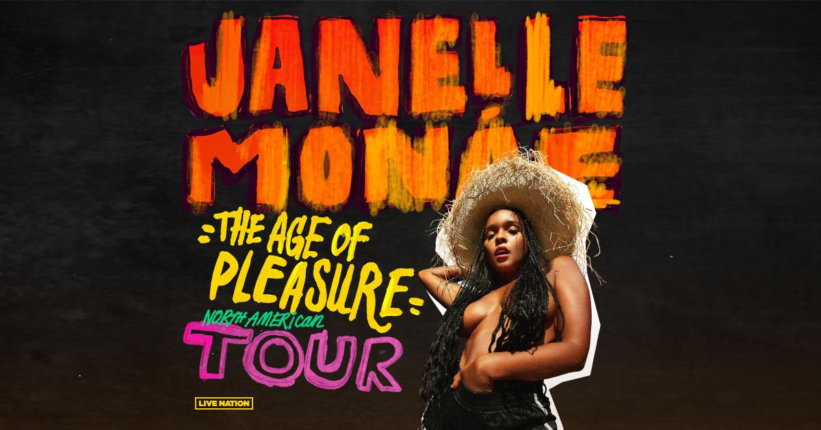For approved artist images and hi-res tour art, please download HERE

Today, critically acclaimed and award winning singer and actress **Janelle Monáe** announced her **Age of Pleasure Tour** across North America. Produced by Live Nation, the 26-city tour kicks off on August 30 at WAMU Theater in Seattle, WA, making stops in Atlanta, Chicago, Toronto, Kansas City, New York City, Brooklyn, and more before wrapping up in Inglewood, CA at YouTube Theater on October 18.

Monáe’s highly anticipated new album, *The Age of Pleasure*, will be releasing June 9th via Atlantic Records featuring her latest scintillating new single, “[**Lipstick Lover**,”](https://nam04.safelinks.protection.outlook.com/?url=https%3A%2F%2Fjanellemonae.lnk.to%2FLipstickLover&data=05%7C01%7CJessica.Nall%40atlanticrecords.com%7Caa38227d18e04ab4ab6608db501931a3%7C8367939002ec4ba1ad3d69da3fdd637e%7C0%7C0%7C638191841373998325%7CUnknown%7CTWFpbGZsb3d8eyJWIjoiMC4wLjAwMDAiLCJQIjoiV2luMzIiLCJBTiI6Ik1haWwiLCJXVCI6Mn0%3D%7C3000%7C%7C%7C&sdata=t5oY7MSyOIzElnJo1ekqqqHNK%2F%2BMDdhcnPkZ2zeqvF4%3D&reserved=0) available now via Wondaland Arts Society/Atlantic Records[.](https://janellemonae.lnk.to/Float) An official emotion picture, directed by Janelle Monáe andAlan Ferguson – Watch [**HERE**](https://nam04.safelinks.protection.outlook.com/?url=https%3A%2F%2Fjanellemonae.lnk.to%2FLipstickLoverVideo&data=05%7C01%7CJessica.Nall%40atlanticrecords.com%7Caa38227d18e04ab4ab6608db501931a3%7C8367939002ec4ba1ad3d69da3fdd637e%7C0%7C0%7C638191841373998325%7CUnknown%7CTWFpbGZsb3d8eyJWIjoiMC4wLjAwMDAiLCJQIjoiV2luMzIiLCJBTiI6Ik1haWwiLCJXVCI6Mn0%3D%7C3000%7C%7C%7C&sdata=JJaoUx4CQGJzM%2FKufQzqp0AHgOblg1vLlb1bpcHH%2B5Y%3D&reserved=0)**.**

Her tour promises to light up your body, soul and all of your senses with an unforgettable performance featuring songs off her latest album and classic hits from her discography.

**TICKETS:** Tickets will be available starting with Verizon presales (details below) beginning Thursday, June 1 at 10 AM Local. Additional presales will run throughout the week ahead of the general onsale beginning Wednesday, June 7 at 10 AM Local on [Ticketmaster.com](https://www.ticketmaster.com/janelle-monae-tickets/artist/1216463).

**VERIZON UP PRESALE:** Verizon will offer customers an exclusive presale for the Age of Pleasure Tour through Verizon Up. Customers will have access to purchase presale tickets for select shows beginning Thursday, June 1 at 10 AM local until Tuesday, June 6 at 10pm local. For more details visit [Verizon Up](https://www.verizon.com/featured/verizon-up/).

**AGE OF PLEASURE TOUR DATES:**

Wed Aug 30 – Seattle, WA – WAMU Theater

Thu Aug 31 – Vancouver, BC – UBC - Doug Mitchell Thunderbird Sports Centre

Sat Sep 02 – Portland, OR – RV Inn Style Resorts Amphitheater

Wed Sep 06 –Salt Lake City, UT – The Complex

Thu Sep 07 – Morrison, CO – Red Rocks Amphitheatre

Sat Sep 09 – Kansas City, MO – The Midland Theatre

Mon Sep 11 – Minneapolis, MN – Armory

Wed Sep 13 – St. Louis, MO – Stifel Theatre

Thu Sep 14 – Chicago, IL – Byline Bank Aragon Ballroom

Sun Sep 17 – Boston, MA – MGM Music Hall at Fenway

Mon Sep 18 – Philadelphia, PA – The Met

Wed Sep 20 – Montreal, QB – Mtelus

Thu Sep 21 – Toronto, ON – Massey Hall

Sun Sep 24 – Washington, DC – The Anthem*

Tue Sep 26 – New York City, NY – Radio City Music Hall

Thu Sep 28 – Brooklyn, NY – Kings Theatre

Mon Oct 02 – Charlotte, NC – Skyla Credit Union Amphitheatre

Tue Oct 03 – Nashville, TN – Ryman Auditorium

Wed Oct 04 – Birmingham, AL – Avondale Brewing Company

Fri Oct 06 – Atlanta, GA – Fox Theatre Atlanta

Mon Oct 09 – Dallas, TX – The Pavilion at Toyota Music Factory

Tue Oct 10 – Houston, TX – Bayou Music Center

Wed Oct 11 – Austin, TX – Moody Amphitheater

Sun Oct 15 – Phoenix, AZ – Arizona Financial Theatre

Tue Oct 17 – San Francisco, CA – Bill Graham Civic Auditorium

Wed Oct 18 – Inglewood, CA – YouTube Theater

*\* non-Live Nation date*

**ABOUT JANELLE MONÁE**

Janelle Monáe is without question one of the most celebrated artists of the modern era, an 8x GRAMMY® Award-nominated singer, songwriter, producer, performer, and fashion icon known worldwide for her inimitable style and visionary sound. With multiple celebrated albums, THE ARCHANDROID (2010), THE ELECTRIC LADY (2013), and DIRTY COMPUTER (2018), which was nominated for album of the year, and received numerous critically-acclaimed theatrical and television performances, and her unwavering activism for social justice and the LGBTQIA+ community, Monáe continues to be one of the most compelling and important artists of this generation.

**About Live Nation Entertainment**

Live Nation Entertainment (NYSE: LYV) is the world’s leading live entertainment company comprised of global market leaders: Ticketmaster, Live Nation Concerts, and Live Nation Sponsorship. For additional information, visit [www.livenationentertainment.com](http://www.livenationentertainment.com).

**MEDIA CONTACTS:**

**Janelle Monáe**

Ashley Kalmanowitz | [Ashley.Kalmanowitz@atlanticrecords.com](mailto:Ashley.Kalmanowitz@atlanticrecords.com)

Court Barrett | [cbarrett@id-pr.com](mailto:cbarrett@id-pr.com)

Elif Mamak | [emamak@id-pr.com](mailto:emamak@id-pr.com)

Jessica Nall | [jessica.nall@atlanticrecords.com](mailto:jessica.nall@atlanticrecords.com)

**Live Nation Concerts**

Monique Sowinski | [moniquesowinski@livenation.com](mailto:moniquesowinski@livenation.com)

Navier Grimes | [naviergrimes@livenation.com](mailto:naviergrimes@livenation.com)

To apply for media credentials for show coverage:

[livenation.com/pressrequests](https://lne.secure.force.com/mktEventSearch?category=PR)