FOR IMMEDIATE RELEASE
MAY 4, 2023

Galantis & JVKE drop “Fool 4 U” (feat. Enisa)

new collaborative single available now via Big Beat Records

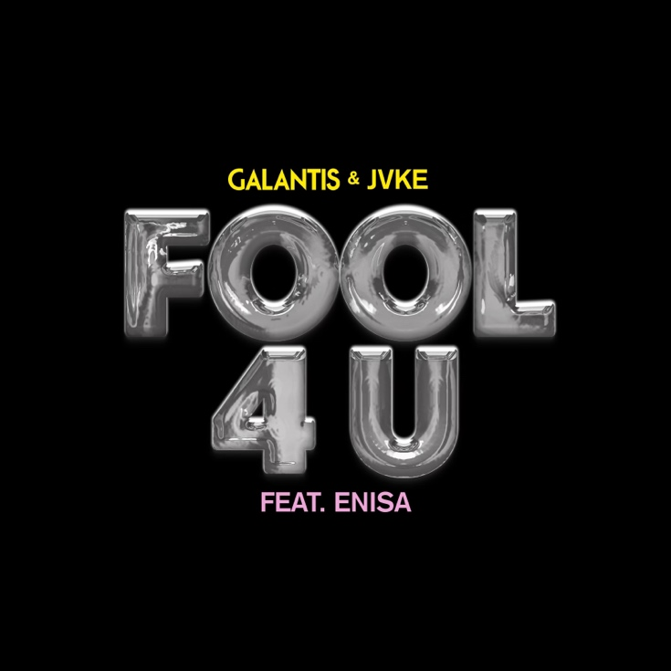
DOWNLOAD HIGH-RES IMAGES/ARTWORK

STREAM “FOOL 4 U”: LINK

Internationally-acclaimed collaborative project Galantis has reunited with viral sensation JVKE for intoxicating new single “Fool 4 U” featuring Enisa – available now via Big Beat Records. The trio flow together seamlessly, fusing distorted vocals and smooth melodies with a pulsating beat perfect to usher in the summer months ahead. The track marks the second collaboration between Galantis & JVKE, who first teamed up in early 2021 on their mesmerizing joint single “Dandelion.”

“It truly felt incredible to be back grinding in the studio with the one and only JVKE! He's seriously one of the most talented and exciting new artists around, and I just knew we had something really special with Fool 4 U... adding Enisa on vocals alongside JVKE took things to another level... couldn’t be more excited with how the tune turned out and really can't wait for people to hear it!”
- Christian Karlsson (Galantis)

Galantis will resume an exciting slate of live performances this month, including EDC Las Vegas on May 19th and a headline show at Academy LA on May 20th. June will also see the second annual set of Midsommar Eve headline shows at Brooklyn Mirage on June 29th and 30th. For full live routing and ticket information, please visit wearegalantis.com.

***

ABOUT GALANTIS:
Setting a new standard for songwriting in dance music, Galantis is a collaborative project led by Christian Karlsson (aka Bloodshy, one-third of Miike Snow). Galantis' debut album Pharmacy reached No. 1 on the Billboard Dance album chart on the strength of RIAA gold-certified single “Peanut Butter Jelly” and 2x platinum certified smash “Runaway (U & I)” – the latter of which earned GRAMMY nominations for “Best Dance Recording” and “Best Remixed Recording” – while 2017’s sophomore album The Aviary (featuring platinum certified single “No Money”) saw a top 10 debut in 23 countries. The third Galantis album, 2020’s Church, featured the chart-topping gold-certified single “Faith” with country music icon Dolly Parton featuring Mr. Probz, which saw a #1 debut on Billboard’s Dance/Electronic Chart before quickly reaching #1 on the Dance/Mix Show Airplay Chart where it remained for 5 weeks. Meanwhile, 2021’s gold-certified collaborative single “Heartbreak Anthem” with David Guetta & Little Mix proved a global sensation, spending 10 weeks on the Billboard Global 200 chart and 13 consecutive weeks in the top 10 on the UK Official Chart. Galantis has received over 4 billion cumulative worldwide streams, and over 1.7 billion video views to date.

The story of Galantis started back in 2009. Working as Bloodshy, Karlsson’s songwriting collaborations have included Madonna, Kylie Minogue, Katy Perry and Britney Spears (whose “Toxic” earned a GRAMMY for “Best Dance Recording”). This collaborative nature led to the birth of the Galantis project which had its live debut at 2014’s Coachella Valley Music and Arts Festival and has continued on years later as one of dance music's most dynamic and in-demand live performers.

C/O Atlantic Records
DOWNLOAD HIGH-RES IMAGES/ARTWORK

CONNECT WITH GALANTIS:
WeAreGalantis.com | Twitter | Facebook | YouTube | Instagram | Assets

CONTACT:
Ted Sullivan | Ted.Sullivan@atlanticrecords.com

