FOR IMMEDIATE RELEASE
MAY 30, 2023

INGRID ANDRESS TO OPEN FOR STEVIE NICKS THIS FALL

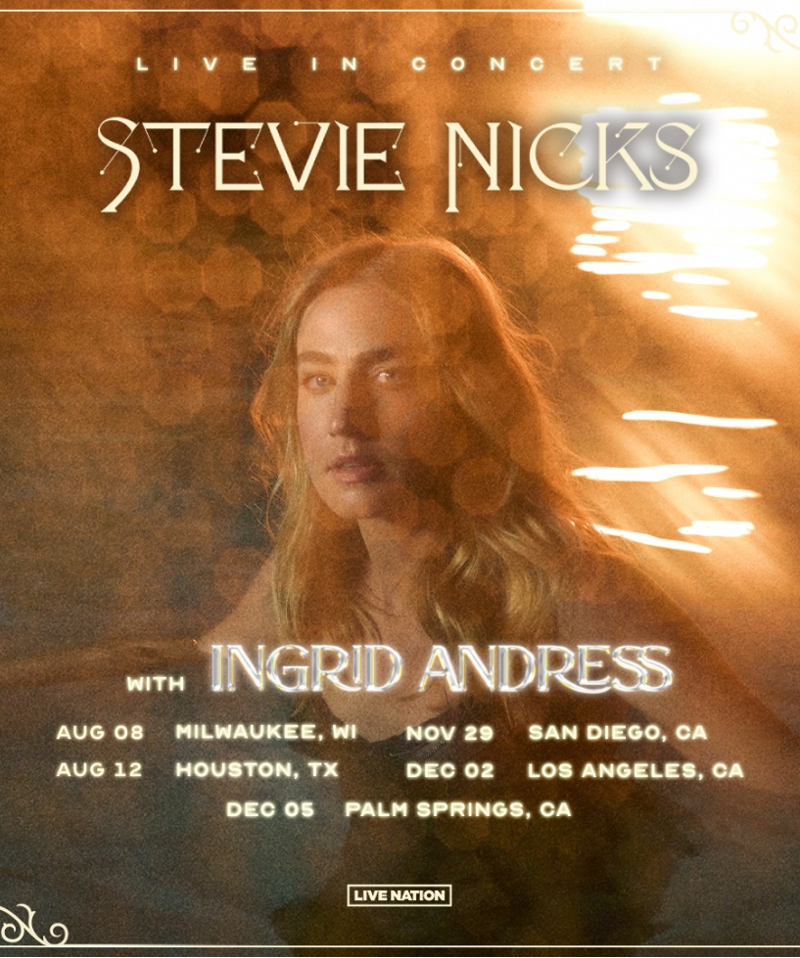

Announced today, 4x GRAMMY-nominee Ingrid Andress will join one of her heroes, the legendary Stevie Nicks, for a spree of dates from August to December 2023 (see a full list of dates below).

Andress recently wrapped her headlining The Good Person Tour Presented by 21Seeds, including sold-out shows at New York’s Gramercy Theatre, Boston’s Sinclair and more. She continues on Walker Hayes’ Duck Buck Tour throughout August and will open for Orville Peck in New York City in June. Andress is also set to perform at Spotify House during next month’s CMA Fest in addition to a Lollapalooza set in Chicago, IL in August.

Andress recently released the deluxe version of her celebrated sophomore album – Good Person (Deluxe) features three brand-new original tracks, including “Runnin (with JP Saxe).” Kelly Clarkson recently chose Good Person standout track, “Blue,” to perform during the fan-favorite ‘Kellyoke’ segment on her Emmy-winning daytime talk show The Kelly Clarkson Show (WATCH HERE). The album’s track listing also includes current single, “Feel Like This” (LISTEN HERE). As seen on The Late Show with Stephen Colbert and Jimmy Kimmel Live! and co-written by Andress, Ellis and Julia Michaels, the track “puts an informed, mature spin on love [with its] adult approach to the mysteries of relationships” (Billboard). The lauded singer/songwriter also recently earned her second career No. 1 with the GRAMMY-nominated, Platinum-certified hit “Wishful Drinking (with Sam Hunt).”

The singer/songwriter recently took to NPR’s “Tiny Desk” stage for their concert series, sharing beautiful, stripped-down, live versions of “Feel Like This,” “Yearbook” and her acclaimed No. 1 debut single, “More Hearts Than Mine”– Watch HERE. The latter is off her record-breaking debut, Lady Like, named “one of the year’s strongest albums” by Associated Press and one of Billboard’s Top 10 Best Country Albums of 2020. The celebrated LP scored Andress three GRAMMY nominations including Best New Artist, Best Country Album and Best Country Song for the multi-platinum No. 1 radio single “More Hearts Than Mine.” She is also a 4x ACM Award, 3x CMA Award and 4x CMT Music Award nominee.

Ingrid Andress with STEVIE NICKS: LIVE IN CONCERT
August 8 – Milwaukee, WI – Firserv Forum
August 12 – Houston, TX – Toyota Center
November 29 – San Diego, CA – Viejas Arena
December 2 – Los Angeles, CA – Kia Forum
December 5 – Palm Springs, CA – Acrisure Arena at Greater Palm Springs

###

CONNECT WITH INGRID ANDRESS:
FACEBOOK | TWITTER | INSTAGRAM | YOUTUBE

PRESS CONTACTS
Andrew George | Atlantic Records
Andrew.George@atlanticrecords.com

Mary Catherine Rebrovick | Warner Music Nashville
MaryCatherine@wmg.com

