FOR IMMEDIATE RELEASE
MAY 11, 2023

JANELLE MONÁE LIFTS THE CURTAIN ON THE AGE OF PLEASURE

AWARD-WINNING SUPERSTAR UNVEILS HUGELY ANTICIPATED NEW ALBUM

NEW SINGLE “LIPSTICK LOVER” PREMIERES TODAY
RELEASED ALONGSIDE OFFICIAL VIDEO

THE AGE OF PLEASURE ARRIVES VIA WONDALAND ARTS SOCIETY/ATLANTIC RECORDS
PRE-ORDERS/PRE-SAVES AVAILABLE NOW HERE

LISTEN HERE | WATCH HERE

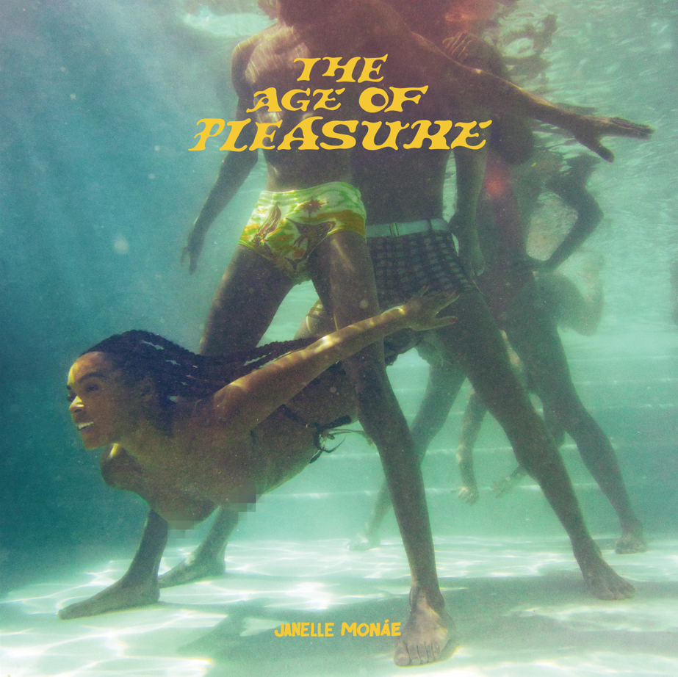
DOWNLOAD HI-RES ARTWORK

Janelle Monáe, music’s foremost freeassmuthafucka, has shared her scintillating new single, “Lipstick Lover,” available now via Wondaland Arts Society/Atlantic Records. An official music video premieres today at YouTube – Watch HERE.

“Lipstick Lover” heralds the arrival of Monáe’s hugely anticipated new album, THE AGE OF PLEASURE. Pre-orders/pre-saves – including limited edition vinyl – are available now HERE.

THE AGE OF PLEASURE also includes the acclaimed new single, “Float (Feat. Seun Kuti + Egypt 80).” Hailed by Pitchfork as “swaggering, brass-heavy…the sound of a top-tier talent doing a little victory dance,” the track is joined by an official dance video currently boasting over 1M views via YouTube HERE.

“Float” – which Monáe initially teased on her hugely popular Instagram – was first heard late last year as the official anthem of ABC/ESPN’s NBA Saturday Primetime campaign, with Janelle contributing voiceover narration to promo spots highlighting the biggest matchups and stars in the league. The track was used extensively throughout all NBA coverage through mid-March, spanning promos, Primetime matchups, in-game placement, social media, and more. In addition, “Float” was featured in an animated piece marking Los Angeles Lakers superstar LeBron James surpassing Kareem Abdul-Jabbar for the #1 spot on the NBA’s all-time regular-season scoring list, shared across ESPN’s socials and James’ Instagram to reach more than 275M combined followers.

Janelle Monáe is without question one of the most celebrated artists of the modern era, an 8x GRAMMY® Award-nominated singer, songwriter, producer, performer, and fashion icon known worldwide for her inimitable style and visionary sound. Her genre-bending debut album, THE ARCHANDROID, arrived in 2010 and immediately ascended to the top 20 on the Billboard 200 while also earning two GRAMMY® Award nominations including “Best Contemporary R&B Album” and “Best Urban/Alternative Performance” for the RIAA Gold-certified single, “Tightrope (Feat. Big Boi).”

THE ELECTRIC LADY entered the SoundScan/Billboard 200 at #5 upon its 2013 release, fueled by collaborations with such like-minded artists as Solange, Esperanza Spalding, and Monáe’s lifelong hero, the one and only Prince, as well as hit singles/music videos like the MTV Video Music Award-winning “Q.U.E.E.N. (Feat. Erykah Badu).” 2018’s DIRTY COMPUTER – which received a coveted GRAMMY® Award-nomination as “Album Of The Year” – features the RIAA Gold-certified hit singles “Make Me Feel” and “I Like That” and was accompanied by a groundbreaking “Emotion Picture” incorporating a number of the album’s visually stunning music videos.

Undoubtedly among the 21st Century’s most inventive and creative live performers, Monáe has traveled the globe for sold out headline tours, a range of festival appearances, and special guest runs alongside Bruno Mars, Amy Winehouse, No Doubt, Katy Perry, Erykah Badu, and Red Hot Chili Peppers. An in-demand collaborator, Monáe is featured on tracks by an incredibly diverse group of artists including Outkast, Big Boi, Kelly Clarkson, Sérgio Mendes, Of Montreal, The Coup, Grimes, Estelle, Paolo Nutini, The Internet, Chic, Duran Duran, Goodie Mob, and of course fun., whose “We Are Young (Feat. Janelle Monáe)” proved the biggest single of 2012, a worldwide #1 phenomenon named in three GRAMMY® Award categories: “Record of the Year,” “Song of the Year,” and “Best Pop Duo/Group Performance.”

2016 saw Monáe embark on her film acting career with stellar performances in two milestone films, Hidden Figures and Moonlight; both films received Academy Award nominations for Best Picture, with the latter winning the award at the 89th Academy Awards. Her filmography quickly grew to include acclaimed roles in 2018’s Harriet, 2020’s Antebellum, and 2022’s Glass Onion: A Knives Out Mystery, to name but a few. Monáe has also made countless TV appearances, including a lead role on Amazon Prime’s Homecoming and performances on NBC’s Saturday Night Live and TODAY, ABC’s Dancing With The Stars, PBS’ Sesame Street, MTV’s RuPaul’s Drag Race, Netflix’s We The People, and many more.

Recently honored with the National Board of Review’s 2022 “Best Supporting Actress” Award for her role in Glass Onion: A Knives Out Mystery, Monáe has received a long series of accolades and other honors, including three Critics Choice Awards, two Billboard Women In Music Awards, an NAACP Image Award, two Soul Train Awards (out of 13 nominations), an Essence Black Women in Hollywood Award, eight GRAMMY® Award nominations, and multiple nominations for BET Awards, BRIT Awards, and MTV Video Music Awards, along with many more laurels around the world.

Always an eclectic and creative visual presence, Monáe was chosen as the new face of CoverGirl in 2012, later became a spokesperson for the home audio company Sonos, and recently joined forces with Target for its “I Got The Juice” co-branded campaign for Marvel’s Black Panther: Wakanda Forever.

[INSERT PRESS PHOTO]
DOWNLOAD PRESS IMAGE

CONNECT WITH JANELLE MONÁE
OFFICIAL | FACEBOOK | INSTAGRAM | TWITTER | YOUTUBE

JANELLE MONÁE PR CONTACTS
Sheila Richman // Sheila.Richman@atlanticrecords.com
Fairley McCaskill // Fairley.McCaskill@atlanticrecords.com
Jessica Nall // Jessica.Nall@atlanticrecords.com
Kelly Bush Novak // kbushnovak@id-pr.com
Court Barrett // cbarrett@id-pr.com
Elif Mamak // emamak@id-pr.com

