FOR IMMEDIATE RELEASE
MAY 5, 2023

Matchbox Twenty release “Don’t Get Me Wrong”

Second taste of Multi-platinum band’s first new album in over a decade,
Where The Light Goes, arriving May 26th via Atlantic Records

50+ date spring/summer “Slow Dream Tour” kicks off May 16th

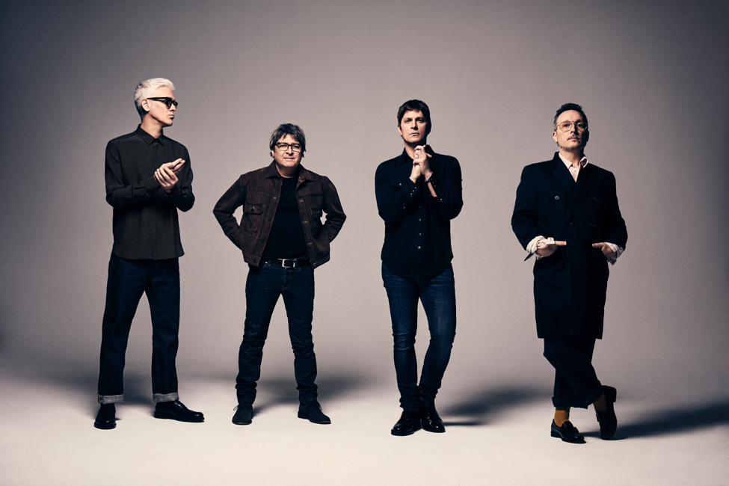
DOWNLOAD HIGH-RES IMAGES + ARTWORK

STREAM “DON’T GET ME WRONG”: LINK
WATCH “DON’T GET ME WRONG” PERFORMANCE VIDEO: LINK
PRE-SAVE WHERE THE LIGHT GOES: LINK

Multi-platinum, superstar hit making pop-rockers Matchbox Twenty have released “Don’t Get Me Wrong,” a second track from their highly anticipated fifth studio album Where The Light Goes (arriving May 26th via Atlantic Records). Produced by Gregg Wattenberg with Paul Doucette and Kyle Cook, the album finds the band surging with energy for another great batch of real, relevant, and relatable songs.

“A lot of times, when people have been together for years, you can have arguments that get really heated and keep you on edge. It’s only natural for someone to sometimes think it may be the end. This song was just someone saying, ‘I know I get mad sometimes, but I’m not going anywhere’”
– ROB THOMAS

“Don’t Get Me Wrong” follows the album’s energetic lead “Wild Dogs (Running in a Slow Dream),” which marked the band’s first new music release in over a decade. Already boasting over 3 million global streams, the single features a vibrant music video directed by Jay Sprogell (watch here), was just performed live the first time on The Kelly Clarkson Show (watch here), and got stripped back for a stunning acoustic rendition (stream here).

The band – Rob Thomas, Brian Yale, Paul Doucette, and Kyle Cook — will be hitting the road this month for their 50+ date spring/summer “Slow Dream Tour." Produced by Live Nation, the “Slow Dream Tour" will begin on Tuesday, May 16th at Rogers Arena in Vancouver, BC and conclude on Sunday, August 6th at Chicago’s Hollywood Casino Amphitheatre. The outing is the band’s first since 2017’s "A Brief History of Everything" tour which marked the 20th anniversary of their Diamond-certified debut album Yourself or Someone Like You. The “Slow Dream Tour” will feature support from Platinum-selling singer-songwriter Matt Nathanson for the first half of the tour and chart-topping singer-songwriter/producer Ben Rector on the second half. For full routing and ticket information, please visit matchboxtwenty.com.

Matchbox Twenty have quietly woven their songs into the very fabric of American popular culture. The band has sold over 40 million records worldwide, dominated charts, garnered multiple GRAMMY Award nominations, and played to millions of fans in arenas, amphitheaters, and stadiums across continents.

Earning hits in each of the last three decades, Matchbox has gone from perennially dominating radio airwaves and ruling MTV to piling up streams in the billions, speaking to the enduring appeal of their music. Fueled by such classic songs as “Real World,” “Back 2 Good” and the No. 1 smash hits “Push” and “3AM,” 1996’s Diamond-certified Yourself or Someone Like You proved a worldwide sensation and instantly established the band as global superstars. 2000 saw the band release the four-times Platinum Mad Season, containing the No. 1 singles “Bent” and “If You’re Gone.” Their third release, More Than You Think You Are, also was certified double-Platinum and featured the No. 1 hit, “Unwell.” 2007’s greatest hits compilation album with six new songs, “Exile On Mainstream” yielded yet another No. 1 track, “How Far We’ve Come,” while 2012’s North, exploded into the top position on the Billboard 200 release – Matchbox Twenty’s first-ever chart-topper and No. 1 debut.

Now nearly eleven years later, the band sounds refreshed as ever on Where The Light Goes, benefitting from the musicians’ respective solo journeys. Rob Thomas has proven one of the most highly decorated artists of recent years – releasing five solo albums and receiving three GRAMMY Awards, 11 BMI Awards, the first-ever Songwriters Hall of Fame Hal David Starlight Award, two Billboard "Songwriter of the Year" honors, and top 5 placement on Billboard’s Top 20 Hot 100 Songwriters of the aughts. Meanwhile, Paul Doucette has scored and contributed original music to film and television series such as Utopia, For All Mankind, and more.

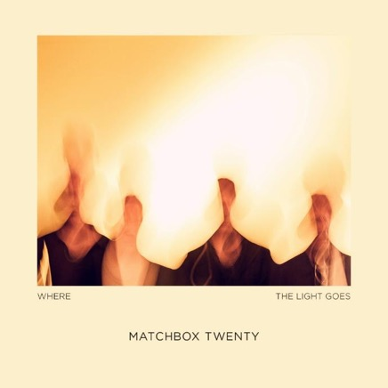
DOWNLOAD HIGH-RES IMAGES + ARTWORK

Where The Light Goes track list:
1. Friends
2. Wild Dogs (Running in a Slow Dream)
3. Rebels
4. One Hit Love
5. Warm Blood
6. Queen of New York City
7. Where the Light Goes
8. Hang on Every Word
9. Don’t Get Me Wrong
10. I Know Better
11. No Other Love (feat. Amanda Shires)
12. Selling Faith

Matchbox Twenty – “Slow Dream Tour”
5/16 – Vancouver, BC @ Rogers Arena*
5/18 – Auburn, WA @ White River Amphitheatre*
5/19 – Ridgefield, WA @ Sunlight Supply Amphitheater*
5/21 – Concord, CA @ Concord Pavilion *
5/ 22 – Hollywood, CA @ Hollywood Bowl*
5/ 24 – Fresno, CA @ Save Mart Center*
5/ 25 – Bakersfield, CA @ Mechanics Bank Arena*
5/27— Las Vegas, NV @ The Chelsea at the Cosmopolitan*
5/28 – Irvine, CA @ FivePoint Amphitheatre*
5/30 – San Diego, CA @ Cal Coast Credit Union Open Air Theatre*
5/ 31 – Phoenix, AZ @ Talking Stick Resort Amphitheatre*
6/2 – Sparks, NV @ Nugget Event Center*#
6/3 – West Valley City, UT @ USANA Amphitheatre*
6/4 – Boise, ID @Ford Idaho Center Amphitheater*
6/ 6 – Denver, CO @ Ball Arena*
6/8 – Omaha, NE @ CHI Health Center Omaha*
6/9 – Sioux Falls, SD @ Denny Sanford Premier Center*
6/10 – Welch, MN @ Treasure Island*#
6/13 – Cuyahoga Falls, OH @ Blossom Music Center*
6/14 – Clarkston, MI @ Pine Knob Music Center*
6/ 16 – Cincinnati, OH @ Riverbend Music Center*
6/17 – Moline, IL @ Vibrant Arena at The Mark*
6/ 18 – Kansas City, MO @ Starlight Theatre*
6/ 20 – St. Louis, MO @Hollywood Casino Amphitheatre*
6/ 21 – Oklahoma City, OK @ The Zoo*#
6/ 23 – Rogers, AR @ Walmart AMP*
6/24 – Memphis, TN @ Radians Amphitheatre*
6/ 27 – Birmingham, AL @ Oak Mountain Amphitheatre^
6/29 – Dallas, TX @ Dos Equis Pavilion^
6/ 30 – Houston, TX @The Cynthia Woods Mitchell Pavilion presented by Huntsman^
7/2 – Atlanta, GA @ Lakewood Amphitheatre^
7/3 – Nashville, TN @Bridgestone Arena^
7/ 5 – Jacksonville, FL @Daily's Place^
7/7 – West Palm Beach, FL @ iTHINK Financial Amphitheatre^
7/ 8 – Tampa, FL @ MIDFLORIDA Credit Union Amphitheatre at the FL State Fairground^
7/11 – Charlotte, NC @ PNC Music Pavilion^
7/ 12 – Raleigh, NC @ Coastal Credit Union Music Park at Walnut Creek^
7/14 – Burgettstown, PA @ The Pavilion at Star Lake^
7/15 – Holmdel, NJ @ PNC Bank Arts Center^
7/16 – Camden, NJ @ Freedom Mortgage Pavilion^
7/18 – Wantagh, NY @ Northwell Health at Jones Beach Theater^
7/19 – Bethlehem, PA @ The Wind Creek Event Center^
7/21 – Gilford, NH @Bank of New Hampshire Pavilion^
7/22 – Uncasville, CT @ Mohegan Sun Arena^
7/23 – Mansfield, MA @ Xfinity Center^
7/26 – Virginia Beach, VA @ Veterans United Home Loans Amphitheater at Virginia Beach^
7/27 – Bristow, VA @ Jiffy Lube Live^
7/29 – Syracuse, NY @ St. Joseph's Health Amphitheater at Lakeview^
7/30 – Saratoga Springs, NY @ Saratoga Performing Arts Center^
8/1 – Darien Center, NY @ Darien Lake Amphitheater^
8/ 2 – Toronto, ON @ Budweiser Stage^
8/ 4 – Toledo, OH @ Toledo Zoo Amphitheater^
8/ 5 – Noblesville, IN @ Ruoff Music Center^
8/ 6 – Tinley Park, IL @ Hollywood Casino Amphitheatre^

* Matt Nathanson supporting
^ Ben Rector supporting
~ Hudson Thames supporting
# Non-Live Nation show, visit matchboxtwenty.com for ticketing links

CONNECT:
MatchboxTwenty.com | Instagram | YouTube | Twitter | Facebook | Press Assets

CONTACT:
Sheila Richman | Sheila.Richman@AtlanticRecords.com
Ted Sullivan | Ted.Sullivan@AtlanticRecords.com

