FOR IMMEDIATE RELEASE
MAY 4, 2023

RIAA PLATINUM CERTIFIED RAPPER NOCAP RETURNS WITH TWO-PACK SINGLE
“CUBAN LINKS & DRUG HABITS”

ACCOMPANIED BY A COMPANION VISUAL DIRECTED BY TEOSHOTTHIS

SERVES AS THE FOLLOW-UP TO THE MAIN BIRD EP

YOUTUBE CHANNEL NOW BOASTING OVER 858M VIEWS

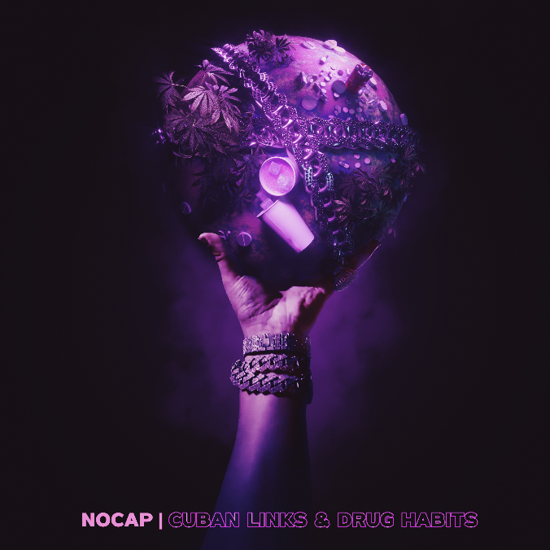
DOWNLOAD HI-RES ARTWORK
WATCH HERE | STREAM HERE

RIAA platinum-certified Mobile, AL rapper NoCap has returned with his latest release, the two-pack single “Cuban Links & Drug Habits.” The two tracks go hand in hand with one another despite their completely different energies. The duality of the records shows off NoCap’s talent and versatility as an artist who can body any beat you put him on and create something spectacular. Both tracks are linked in a new visual that takes you along the ride through the upbeat energy of the first track and seamlessly blends into the slowed down vibe of the second track. “Cuban Links & Drug Habits” serves as the follow-up to last year’s release of the 7-track EP, The Main Bird. Stay tuned for more releases this year from the rap phenom.

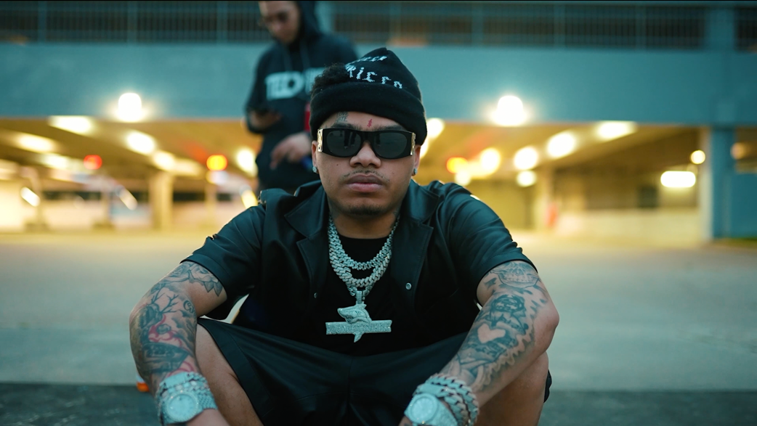

# # #

ABOUT NOCAP

By embracing the art of storytelling, NoCap narrates his life out loud. With over 2.2B global streams, an increasingly rapt fan following, and ecstatic praise from such outlets as Rolling Stone, Hypebeast, The FADER, Pitchfork, and more, the Mobile, AL-based rapper and singer dips in and out of turbulent and triumphant memories, all with the same careful attention to detail. 2019 saw the breakthrough release of such mixtapes as The Hood Dictionary and Steel Human, the latter highlighted by the debut single and RIAA platinum-certified anthem, “Ghetto Angels,” a YouTube favorite with views now exceeding 95M HERE. An array of high-profile projects followed, from collaborations with Lil Baby, DaBaby, YFN Lucci, and YoungBoy Never Broke Again to “Family (Feat. Quando Rondo),” featured on 2020’s smash Road To Fast 9 Mixtape. After spending half of 2021 behind bars, he unleashed his second RIAA gold-certified single, “Vaccine,” named by Pitchfork as one of “The 38 Best Rap Songs of 2021” and joined by an official music video currently boasting more than 86M views via YouTube HERE.

With the long-awaited release of MR. CRAWFORD, NoCap’s true story comes into focus like never before. MR. CRAWFORD includes tracks like “Shackles To Diamonds,” “I’ll Be Here,” “Vaccine,” “Very Special” and “Save The Day (Feat. Kodak Black).” Official music videos for these records can be found on his official YouTube channel HERE. The album also boasts notable features from YoungBoy Never Broke Again and Internet Money. Hailed by Pitchfork as “a standout voice in the Deep South,” NoCap celebrated MR. CRAWFORD with his biggest U.S. headline tour to date last Spring. NoCap followed up on the success of MR. CRAWFORD with a string of notable releases and his stand-out performance at last year’s Rolling Loud NYC in September. He ended the year with the release of The Main Bird 7-track EP.

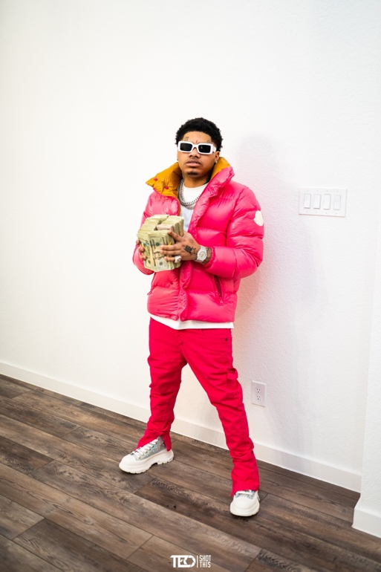

CONNECT WITH NOCAP
WEBSITE | FACEBOOK | TWITTER | INSTAGRAM | YOUTUBE

FOR ALL PRESS INQUIRIES, PLEASE CONTACT
ARIANA.WHITE@ATLANTICRECORDS.COM

