FOR IMMEDIATE RELEASE
MAY 5, 2023

OHGEESY UNVEILS GEEZYWORLD 2

EAGERLY AWAITED NEW SOLO ALBUM PREMIERES TODAY

HIGHLIGHTS INCLUDE THE BREAKOUT HIT SINGLE,
“GEEKALEEK (FT. CASH KIDD)”

IN-STORE POP UPS AND EVENTS ON MAY 6, 8, 9 AND 10
FEATURING CD SIGNINGS AND MEET AND GREETS WITH OHGEESY

GEEZYWORLD 2 AVAILABLE NOW VIA ATLANTIC RECORDS HERE

DOWNLOAD HI-RES ARTWORK

“A decade into his career, OHGEESY is just getting started.” – HYPEBEAST

“As he showcased his true diversity through collaboration, experimentation and elevated shit-talking, OHGEESY has never looked back –– and in the process, solidified himself as an iconic West Coast figure in the modern-day game.” – SIDEDOOR MAGAZINE

Multiplatinum West Coast rap hero OHGEESY is proud to announce today’s arrival of his long awaited new solo album, GEEZYWORLD 2, available everywhere now via Atlantic Records HERE. Recently featured as Sidedoor Magazine’s April cover star, OHGEESY delivers his second solo album including features from Kalan.FrFr, Chrishan, Kamaiyah, Guapo, and Mozzy, along with the newest anthem, “Games (Ft. Bino Rideaux & 03 Greedo).”

GEEZYWORLD 2 – which follows his acclaimed 2021 solo debut album, GEEZYWORLD – includes breakout hit single, “GEEKALEEK (Ft. Cash Kidd),” as well as the recently released special bonus remix, “GEEKALEEK REMIX (Ft. BIA).” Now boasting over 17.5M+ global streams and counting, “GEEKALEEK” – which sees OHGEESY flowing over a repurposed sample of Petey Pablo’s 2003 crunk smash, “Freek-A-Leek” – was met by instant praise from such outlets as REVOLT and Passion of the Weiss‘s “The Rap-Up,” which declared it “an early contender for song of the summer.” An official companion video, currently boasting more than 4M views, is streaming now at YouTube HERE.

The new album also features previously released singles, “Gallery,” “Knock Knock,” “Up, “1st Day of School,” and “Chrome Hearted (Ft. Tyga),” all of which are joined by official music videos currently boasting a combined 10M+ views via YouTube alone.

To celebrate release, there will be an in-store pop-up on Saturday, May 6th at Creative Soundz Recording in Los Angeles. In addition, OHGEESY will have in-store events, featuring CD signings and meet and greets, at Streetlight Records in San Jose (5/8), Streetlight Records in Santa Cruz (5/9) and Salzer’s Records in Ventura (5/10). Additional information below.

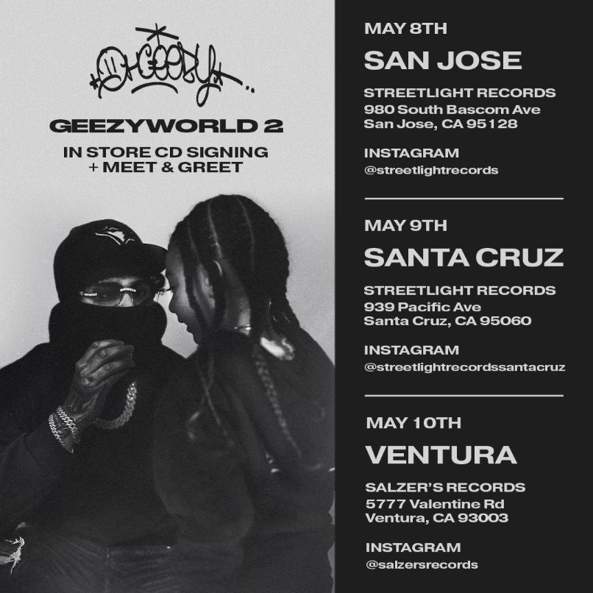

ABOUT OHGEESY:
California never gave rise to a rapper quite like OHGEESY. The Los Angeles-born Mexican American multiplatinum artist, entrepreneur, and visionary not only continues the legacy of his hometown, but he also puts a whole culture rarely represented in hip-hop on his back with pride, poise, and power. As such, he emerges as a trailblazer with vicious wordplay, vibrant storytelling, and a vital message. Breathing new life into the culture, he co-founded Shoreline Mafia during 2016. He locked down the group’s legacy with the double-platinum “Bands,” platinum-certified “Musty” and “Nun Major,” and the gold-certified “Bottle Service” and “Whuss The Deal.” During 2021, he served up his solo debut, GEEZYWORLD, which led him to his first sold-out tour. Among many highlights, “Get Fly (Ft. DaBaby)” raked in over 37M Spotify streams, while “Keeper (Ft. A Boogie Wit Da Hoodie)” posted up 23M Spotify streams. Right out of the gate, Pitchfork proclaimed, “GEESY is well placed to thrive as a lone star. GEEZYWORLD is a quintessential L.A. rap record.” On its heels, he supported the release with a massive sold-out headline tour. His world as a rising superstar has expanded to include exclusive merchandise with his line OTXBOYZ sold through his GEEZYWORLD web site. At the same time, he co-owns Mexican seafood spot Sunset Mariscos inside of the famed Fred Segal store in West Hollywood. Hailed in a recent HYPEBEAST feature interview as “a lone star and certified expert in experimentation, flow and writing killer hooks,” OHGEESY recently introduced fans to GEEZYWORLD 2 on a wide-ranging North American live run that saw him supporting GRAMMY® Award-nominated rapper YG’s “The Red Cup Tour” as well a top-billed hometown performance at Inglewood, CA’s Rolling Loud California. Additional dates will be announced soon. For updates, please visit www.ohgeesyofficial.com.

OHGEESY
GEEZYWORLD 2
(Atlantic Records)
DOWNLOAD HI-RES ARTWORK

TRACKLISTING:
Intro
Max Payne
GEEKALEEK (Ft. Cash Kidd)
Saturday (Ft. Kalan.FrFr)
Top Model
Wock (Ft. Chrishan)
Tour Bus
Droptop (Ft. Kamaiyah)
Perky (Ft. Kamaiyah)
Ghost Gun (Ft. Guapo)
Up
1st Day of School
Chrome Hearted (Ft. Tyga)
Intimate (Ft. Bino Rideaux)
Hot Girl
Girls (Ft. Bino Rideaux & 03 Greedo)
Blame Me
Gallery
Knock Knock
Not A Sound
Whip It
Shoebox (Ft. Mozzy)
GEEKALEEK Remix (Ft. BIA)

# # #

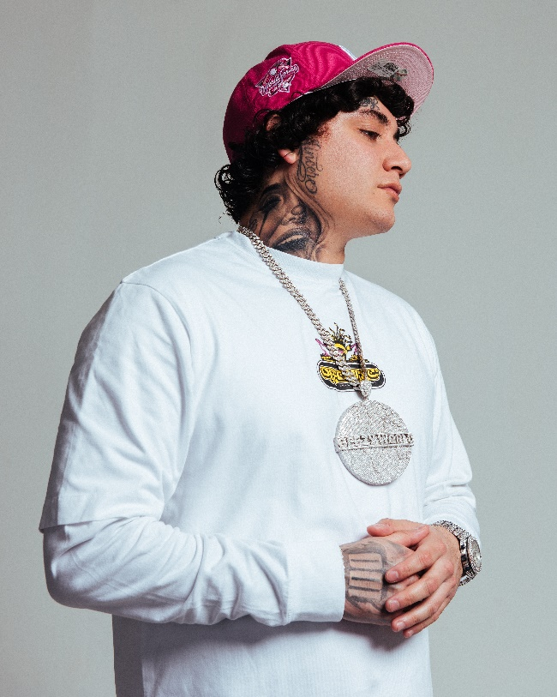
DOWNLOAD HI-RES PRESS IMAGE // PHOTO CREDIT: EMILIO SANCHEZ
# # #
CONNECT WITH OHGEESY
OHGEESYOFFICIAL.COM | FACEBOOK | INSTAGRAM | TWITTER | YOUTUBE

PRESS CONTACT:
Brittany Bell | Brittany.Bell@atlanticrecords.com

