FOR IMMEDIATE RELEASE
MAY 9, 2023

OHGEESY ANNOUNCES BIGGEST SOLO HEADLINE TOUR TO DATE

TRUE RELIGION PRESENTS GW2 TOUR GETS UNDERWAY MAY 30 IN SAN DIEGO, CA

HIGHLIGHTS INCLUDE PERFORMANCES AT
ANCHORAGE, AK’S SUMMER SOLSTICE FESTIVAL (JUNE 18),
NEW YORK CITY’S GRAMERCY THEATRE (SEPTEMBER 23),
AND LOS ANGELES, CA’S HOLLYWOOD PALLADIUM (OCTOBER 6)

SPECIAL GUESTS INCLUDE AG CLUB (MAY 30-JUNE 16) AND DJ VISION

TICKETS ON SALE NOW AT WWW.OHGEESYOFFICIAL.COM

EAGERLY AWAITED NEW SOLO ALBUM , GEEZYWORLD 2,
AVAILABLE NOW VIA ATLANTIC RECORDS HERE

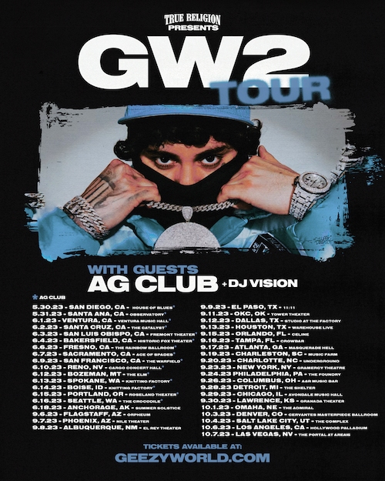
DOWNLOAD HI-RES TOUR ADMAT

“A decade into his career, OHGEESY is just getting started.” – HYPEBEAST

“As he showcased his true diversity through collaboration, experimentation and elevated shit-talking, OHGEESY has never looked back –– and in the process, solidified himself as an iconic West Coast figure in the modern-day game.” – SIDEDOOR

Multiplatinum West Coast rap hero OHGEESY has announced his biggest solo headline tour to date. True Religion Presents GW2 Tour gets underway May 30 at San Diego, CA’s House of Blues and travels through early October. Highlights of the epic US run include performances at Anchorage, AK’s Summer Solstice Festival (June 18), New York City’s Gramercy Theatre (September 23), and a massive homecoming show at Los Angeles, CA’s world-famous Hollywood Palladium (October 6). Special guests include AG Club (May 30-June 16) and DJ Vision. Tickets are on sale now at https://www.ohgeesyofficial.com/.

The GW2 Tour celebrates last week’s release of OHGEESY’s long awaited second solo album, GEEZYWORLD 2, available everywhere now via Atlantic Records HERE.

GEEZYWORLD 2 – which follows OHGEESY’s acclaimed 2021 solo debut album, GEEZYWORLD – includes the breakout hit single, “GEEKALEEK (Ft. Cash Kidd),” as well as the recently released special bonus remix, “GEEKALEEK REMIX (Ft. BIA).” Now boasting over 17.5M+ global streams and counting, “GEEKALEEK” – which sees OHGEESY flowing over a repurposed sample of Petey Pablo’s 2003 crunk smash, “Freek-A-Leek” – was met by instant praise from such outlets as REVOLT and Passion of the Weiss‘s “The Rap-Up,” which declared it “an early contender for song of the summer.” An official companion video, currently boasting more than 4.5M views, is streaming now at YouTube HERE.

In addition GEEZYWORLD 2 also includes singles, “Games (Ft. Bino Rideaux & 03 Greedo),” features from Kalan.FrFr, Chrishan, Kamaiyah, Guapo, and Mozzy, and such new anthems as “Gallery,” “Knock Knock,” “Up, “1st Day of School,” and “Chrome Hearted (Ft. Tyga),” all of which are joined by official music videos currently boasting a combined 10M+ views via YouTube alone.

OHGEESY
TRUE RELIGION PRESENTS
GW2 TOUR 2023

MAY
30 – San Diego, CA– House of Blues *
31 – Santa Ana, CA – Observatory *

JUNE
1 – Ventura, CA – Ventura Music Hall *
2 – Santa Cruz, CA – The Catalyst *
3 – San Luis Obispo, CA– Fremont Theater *
4 – Bakersfield, CA – Fox Theater *
6 – Fresno, CA – Rainbow Ballroom *
7 – Sacramento, CA – Ace of Spades *
9 – San Francisco, CA – The Warfield *
10 – Reno, NV – Cargo *
12 – Bozema, MT – The Elm *
13 – Spokane, WA – Knitting Factory *
14 – Boise, ID – Knitting Factory *
15 – Portland, OR – Roseland Theater *
16 – Seattle, WA –The Crocodile *
18 – Anchorage, AK – Sundown Solstice Festival

SEPTEMBER
6 – Flagstaff, AZ – Orpheum
7 – Phoenix, AZ – Nile Theater
8 – Albuquerque, NM – Sunshine Theater
9 – El Paso, TX – 11:11
11 – Oklahoma City, OK – Tower Theatre
12 – Dallas, TX – Studio at The Factory
13 – Houston, TX – Warehouse Live
15 – Orlando, FL – Celine
16 – Tampa, FL – Crowbar
17 – Atlanta, GA – Masquerade Hall
19 – Charleston, SC – Music Farm
20 – Charlotte, NC – Underground
22 – New York, NY – Market Hotel
23 – Washington, DC – The Howard
24 – Philadelphia, PA – The Foundry
26 – Columbus OH – A&R Music Bar
28 – Detroit, MI – The Shelter
29 – Chicago, IL – Patio Theater
30 – Lawrence, KS – Granada Theater

OCTOBER
1 – Omaha, NE – The Admiral
3 – Denver, CO – Cervantes Ballroom
4 – Grand Salt Lake City, UT – The Complex
6 – Los Angeles, CA – Hollywood Palladium
7 – Las Vegas, NV – The Portal at AREA15

w/ Special Guests AG Club (*)
+ DJ VISION

# # #

ABOUT OHGEESY:
California never gave rise to a rapper quite like OHGEESY. The Los Angeles-born Mexican American multiplatinum artist, entrepreneur, and visionary not only continues the legacy of his hometown, but he also puts a whole culture rarely represented in hip-hop on his back with pride, poise, and power. As such, he emerges as a trailblazer with vicious wordplay, vibrant storytelling, and a vital message. Breathing new life into the culture, he co-founded Shoreline Mafia during 2016. He locked down the group’s legacy with the double-platinum “Bands,” platinum-certified “Musty” and “Nun Major,” and the gold-certified “Bottle Service” and “Whuss The Deal.” During 2021, he served up his solo debut, GEEZYWORLD, which led him to his first sold-out tour. Among many highlights, “Get Fly (Ft. DaBaby)” raked in over 37M Spotify streams, while “Keeper (Ft. A Boogie Wit Da Hoodie)” posted up 23M Spotify streams. Right out of the gate, Pitchfork proclaimed, “GEESY is well placed to thrive as a lone star. GEEZYWORLD is a quintessential L.A. rap record.” On its heels, he supported the release with a massive sold-out headline tour. His world as a rising superstar has expanded to include exclusive merchandise with his line OTXBOYZ sold through his GEEZYWORLD web site. At the same time, he co-owns Mexican seafood spot Sunset Mariscos inside of the famed Fred Segal store in West Hollywood. Hailed in a recent HYPEBEAST feature interview as “a lone star and certified expert in experimentation, flow and writing killer hooks,” OHGEESY recently introduced fans to GEEZYWORLD 2 on a wide-ranging North American live run that saw him supporting GRAMMY® Award-nominated rapper YG’s “The Red Cup Tour” as well a top-billed hometown performance at Inglewood, CA’s Rolling Loud California. For updates, please visit www.ohgeesyofficial.com.

# # #

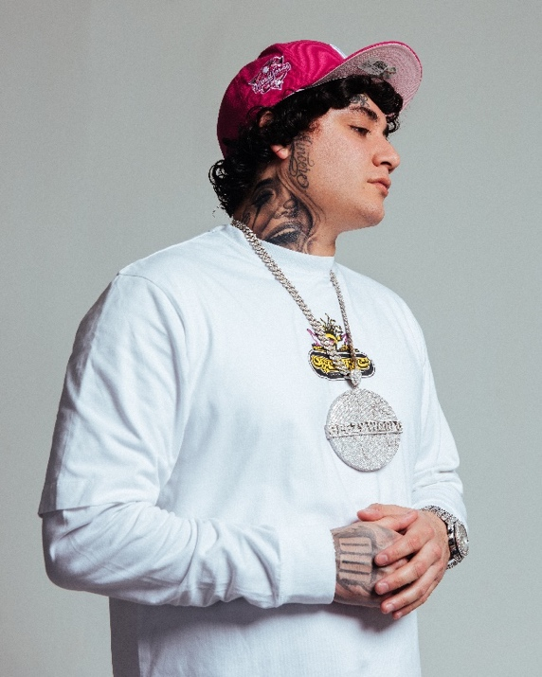
DOWNLOAD HI-RES PRESS IMAGE // PHOTO CREDIT: EMILIO SANCHEZ
# # #
CONNECT WITH OHGEESY
OHGEESYOFFICIAL.COM | FACEBOOK | INSTAGRAM | TWITTER | YOUTUBE

PRESS CONTACT:
Brittany Bell | Brittany.Bell@atlanticrecords.com

