FOR IMMEDIATE RELEASE
MAY 24, 2023

HAYLEY KIYOKO GIVES US THE “GREENLIGHT”

GLOBAL HEADLINE PANORAMA TOUR CONTINUES WITH BACK TO BACK
SOLD-OUT SHOWS AT NEW YORK’S IRVING PLAZA ON MAY 30 & 31

DEBUT NOVEL GIRLS LIKE GIRLS OUT MAY 30

PERFORMING NEW TRACK AT “CAN’T CANCEL PRIDE” ON JUNE 15

LISTEN TO “GREENLIGHT”

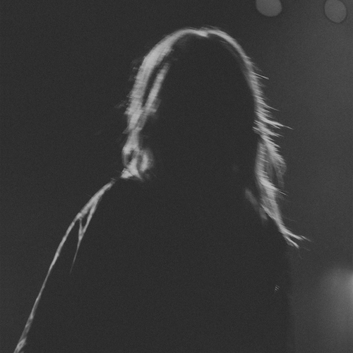
DOWNLOAD HI-RES ARTWORK + PRESS PHOTO
CREDIT: TREVOR FLORES

Trailblazing pop star Hayley Kiyoko has kicked off summer early with her newest single “Greenlight,” co-written with Jesse St. John (Britney Spears, Kim Petras, Charli XCX) and produced by Oliver “German” Peterhof (Justin Bieber, Camilla Cabello, Zara Larsson) – Listen HERE.

“I’ve spent a lot of time and energy trying to prove my worth to people but have realized that if a situation in life is stopping you from moving forward or making you feel trapped, it’s okay to pivot in a new direction,” shared Kiyoko. “Once I embraced that mindset, so many new doors opened. ‘Greenlight’ is about making an active decision to put your energy into the things that are working. Of course there will be roadblocks along the way, but we become our best selves when we surround ourselves with people who challenge us in a healthy way, encourage us to keep digging deeper and support our overall journey.”

“Greenlight” has already proven to be a fan favorite and show-stopping highlight of Kiyoko’s hugely successful global headline run, The PANORAMA Tour, set to travel through early June. Produced by Live Nation, the tour has seen Hayley performing SOLD-OUT shows around the world, with remaining highlights including a SOLD-OUT two-night stand at NYC’s Irving Plaza (May 30-31). For complete details and remaining ticket availability, please visit www.hayleykiyokoofficial.com.

The multi-hyphenate talent will next break new ground with the publication of her debut novel, Girls Like Girls, a coming-of-age romance based on her breakthrough hit song and viral video arriving via Wednesday Books on May 30. Pre-orders are available now HERE. Girls Like Girls has already been met with advance praise from Publishers Weekly, which declared it to be “a pitch-perfect tale” and a “powerfully romantic read.”

Kiyoko will be performing “Greenlight” at Proctor & Gamble and iHeartMedia’s “Can’t Cancel Pride 2023 – The Future Starts Now,” an evening recognizing the LGBTQ+ community and celebrating organizations creating a more inclusive and equal world, streaming live from the iHeartRadio Theater in LA on June 15 at 8:00 pm (ET)/5:00 pm (PT).

Last year saw the acclaimed release of Kiyoko’s sophomore album, PANORAMA, available now via Atlantic Records HERE. Co-written by Kiyoko and co-produced with Danja (Beyoncé, Britney Spears) and Pat Morrisey & Kill Dave, the album – which includes singles, “For The Girls,” “Chance,” and “Found My Friends” – received rave reviews from such leading publications as The New York Times, FADER, Billboard, SPIN, PAPER, V Magazine, Variety, Entertainment Weekly, and more. The trailblazing musician also graced the cover of Teen Vogue’s Music issue and was declared “Artist Of The Year” by Out Magazine as she covered their annual “Out100” issue.

Adoringly known as “Lesbian Jesus” to her legion of fans, Kiyoko has become one of pop’s most celebrated artists since releasing 2018’s landmark debut album EXPECTATIONS, which, according to Rolling Stone, placed her “at the forefront of an unapologetically queer pop movement.” In #20GAYTEEN, she was nominated for two MTV Video Music Awards, winning “Push Artist Of The Year.” Since her 2015 debut, Hayley has amassed over 1.1B global streams and more than 2.29M YouTube subscribers, accrued over 840M lifetime YouTube views, and sold-out numerous venues across the country and abroad on her previous headline tours. Lauded as one of “The 21st Century's Most Influential Women Musicians” by NPR, among other milestones, Hayley continues to impact and inspire her community through nuanced storytelling and lyricism, encouraging hope as her resounding message.

PRAISE FOR PANORAMA

“‘PANORAMA’ reasserts that Kiyoko is more than meets the eye. Much like the humanitarian inclinations of Jesus in classic Bible tales, Kiyoko is more than an actress, pop star or lesbian icon: She's a vessel of love and kindness, mirroring the fuel that has kept her going in even the darkest and loneliest of times.”
– PAPER

“From the delicious takedown of opener ‘Sugar at the Bottom’ to the intimate confessions of the lush closer ‘PANORAMA,’ Kiyoko’s sophomore LP is the sound of an artist ready soar higher in the mainstream.”
– BILLBOARD

“’PANORAMA’ is a careful balancing act of mining the past without getting stuck in it, while also taking time to celebrate Kiyoko in her current state of physical and mental revitalization – a joyous celebration of showing up for yourself.”
– FADER

“Hayley Kiyoko’s new album ‘PANORAMA’ is here, and it’s bop after bop”
– TEEN VOGUE

“Kiyoko’s strongest effort to date…The songs flow perfectly into each other, and the album sends a message of resilience, personal growth, and self-love”
– OUT

HAYLEY KYOKO
THE PANORAMA TOUR

MAY
25 — Philadelphia, PA — Brooklyn Bowl Philadelphia
27 — Toronto, ON — The Danforth Music Hall
28 — Montreal, QC — Théâtre Corona
30 — New York, NY — Irving Plaza
31 — New York, NY — Irving Plaza

JUNE
1 — Boston, MA — House of Blues Boston
2 — Silver Spring, MD — The Fillmore Silver Spring

CONNECT WITH HAYLEY KIYOKO:
WEBSITE | FACEBOOK | TWITTER | INSTAGRAM | TIKTOK | YOUTUBE | PRESS ASSETS

PRESS CONTACT:
Andrew George / Atlantic Records
andrew.george@atlanticrecords.com

