FOR IMMEDIATE RELEASE

MAY 9, 2023

RAVYN LENAE RISES TO #1 WITH “SKIN TIGHT”

R&B SONGSTRESS ACHIEVES FIRST-EVER #1 AS BREAKTHROUGH SINGLE
ASCENDS TO TOP OF BILLBOARD’S “ADULT R&B AIRPLAY” CHART

CRITICALLY ACCLAIMED ALBUM, HYPNOS, AVAILABLE NOW VIA ATLANTIC RECORDS

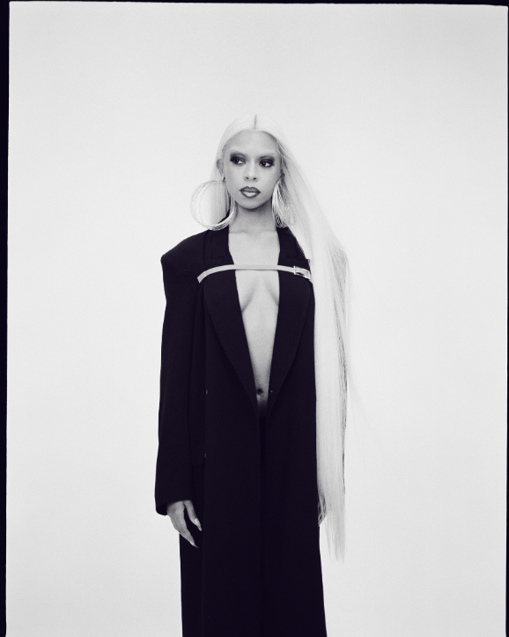
DOWNLOAD PRESS PHOTO // CREDIT: ALEX HARPER
STYLIST: TIMOTHY LUKE // HAIR STYLIST: JACOB DILLON // MUA: LAURA DUDLEY

Acclaimed R&B singer-songwriter Ravyn Lenae has earned her first-ever #1 single as her breakthrough hit single, “Skin Tight (Feat. Steve Lacy),” ascends to the top of this week’s Billboard “Adult R&B Airplay” chart. Recorded in Los Angeles with her longtime collaborator Steve Lacy, the towering new track is joined by both a companion music video (streaming HERE) as well as an intimate, stripped-down alternate version (streaming HERE).

“Skin Tight” is of course featured on Lenae’s breathtaking new album, HYPNOS, available now via Atlantic Records HERE. The album – which also includes such tracks as “Light Me Up,” “Cameo,” “Mercury (Feat. Fousheé),” and the Kaytranada-produced “Xtasy” – has been met by critical acclaim from such national publications as Billboard, Complex and Pitchfork, among others. The latter named it a “Best New Music” release, writing in an 8.5/10 rave, “HYPNOS arrives as a mature reintroduction, a love-stained, moody transport that flies through Lenae’s world with a featherlight cadence. Lenae surveys the recent history of soul, alternative R&B, and even Afrobeats with precision. But most importantly, her debut showcases her ascendant vocal prowess as she moves across her wide range with ease. Lenae’s transcendental poise establishes her as a resonant voice in R&B…Even as she touches on trends and familiar themes, it’s Lenae’s delivery, confidence, and alluring presence that makes HYPNOS stand apart. As she considers her anxieties, hopes, and doubts, she reveres the musical icons before her in ways that show just how ready she is for her own turn.”

In addition, Lenae has received a wide array of media attention spanning a stunning NPR Tiny Desk Concert celebrating Black Music Month to exclusive feature profiles in Harper’s Bazaar and Chicago Magazine. Last summer also saw the premiere of HYPNOS: In Context with Ravyn Lenae, an in-depth new documentary streaming now at YouTube.

Lenae marked the arrival of HYPNOS with a series of electrifying headline shows in North America, Europe, and the United Kingdom, as well as a sold out Chicago show supporting Erykah Badu and a major North American tour supporting Omar Apollo. Upcoming dates include festival appearances at Brussels, Belgium’s CORE Festival 2023 (May 27) and London, UK’s Cross The Tracks (May 28), along with an eagerly awaited headline show at London’s famed Village Underground (May 31). For complete details and ticket information, please visit www.ravynlenae.com/tour.

# # #

With her skyscraping delivery and unparalleled level of lyrical intimacy Raven Lenae is rapidly forging her own lane into the world of female R&B, balancing extremes with finesse, focus, and fire. Now boasting over 300M worldwide streams and counting, she honed her voice through intense classical training at Chicago’s High School For The Arts, inspired by a broad range of artists, from India.Arie and OutKast to Antonio Vivaldi and Reynaldo Hahn. The young artist immediately made waves with her breakthrough debut EP, 2016’s Moon Shoes, earning over 12M individual plays while also reaching the top 25 on the iTunes Store’s “Top R&B/Soul Albums” chart. Crush followed in 2018 and instantly established Lenae as a fan favorite and critical darling, with its sultry lead single, “Sticky,” amassing over 32M global streams while drawing praise from such national publications as Pitchfork, The FADER, and Billboard, which declared it to be “one of the most sumptuous, supple, meditative and detailed dispatches from a soulful young singer’s mind in recent memory.”

Widely praised as a sensational live performer – including headline shows and a blockbuster U.S. tour alongside fellow R&B sensation SZA – Lenae was among the top stars and rising artists featured on Raedio/Atlantic Records’ Insecure: Music From The HBO Original Series, with her “Rewind” prominently featured in one of Season 4’s key moments.

# # #

PRAISE FOR RAVYN LENAE & HYPNOS

“Ravyn Lenae offers something distinct and different, something charged in a very personal kind of energy…HYPNOS has the feeling of creative release, a sense of emotions expunged and experiences extinguished. A gorgeous listen with a deep, lasting resonance, HYPNOS finds Ravyn Lenae rising to the challenge of her peers, and raising the bar once more.”
– CLASH (8/10)

“A debut that feels like a career in the making…Led by the Steve Lacy-charged lead single ‘Skin Tight,’ a vibey playground for Lenae’s layered vocals and a proper point-of-return after Lacy’s executive-produced Crush EP in 2018, the album is a promise that patience, in fact, pays off.”
– BILLBOARD

“HYPNOS is a colorful and otherworldly debut, aligning with its obvious influences but also way beyond that, capturing the same unconventional essence as Janet Jackson in her ‘90s prime. Ravyn Lenae is invigorating and distorting R&B, fit for her Gen Z digital milieu.”
– LOUD AND QUIET (8/10)

“Ravyn Lenae provides an elevated ascension with her new offering while remaining true to her core…There’s an air of enchantment merged with innocence while still feeling like a love that’s not child’s play.”
– VIBE

“Jam-packed with feminine energy…On HYPNOS, Ravyn’s ever-evolving musical state is prevalent, but it’s also evident that she’s her most confident on this album.”
– OKAYPLAYER

“Lenae creates a world that’s sensual, self-reflective, and magical…Although HYPNOS incorporates elements of sci-fi and Afrofuturism, Lenae also infuses old-school influences into her original take on R&B... HYPNOS doesn’t only illustrate Ravyn Lenae’s love for the cosmos, but her craft illustrates her capacity for magical empathy. Her world-building comes from the voices of loved ones, blending generations and timelines—she looks back as much as she looks forward…HYPNOS is only the beginning of Ravyn Lenae turning her desires into reality.”
– FLOOD

# # #

CONNECT WITH RAVYN LENAE
WEBSITE | FACEBOOK | INSTAGRAM | TWITTER | YOUTUBE

PRESS CONTACTS
Fairley McCaskill | Fairley.McCaskill@atlanticrecords.com
Nick Dierl |Nick@orienteer.us

