FOR IMMEDIATE RELEASE

MAY 5, 2023

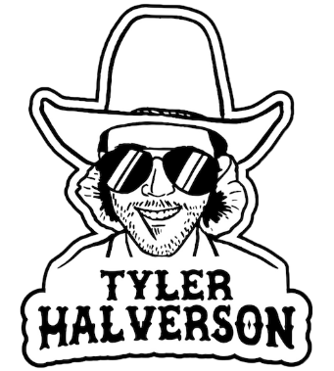

**TYLER HALVERSON FINDS LOVE AND TROUBLE ON LABEL DEBUT “HER”**

**SOUTH DAKOTA TROUBADOUR CELEBRATES SIGNING TO ATLANTIC RECORDS**

**WITH CONFESSIONAL NEW SONG**

**UPCOMING LIVE DATES INCLUDE ARENA SHOWS SUPPORTING COUNTRY STAR PARKER MCCOLLUM**

**“HER” AVAILABLE NOW** [**HERE**](https://tylerhalverson.lnk.to/her) **| WATCH OFFICIAL MUSIC VIDEO** [**HERE**](https://www.youtube.com/watch?v=iINId4UC6RY)

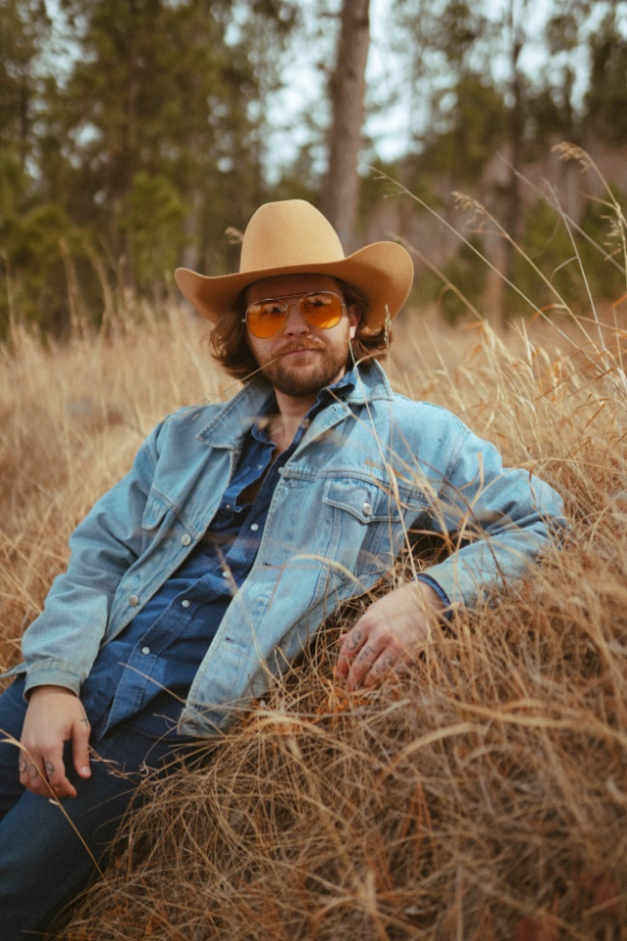

[DOWNLOAD](https://warnermusicgroup.box.com/s/1ecaov70c0h3q3fvbpgi9zeux4o5nqb3) HI-RES IMAGE

**“*‘Her’ is about a crazy blue-eyed girl that don’t come around no more. It’s a tip of the hat to the bad break we’ve all had, but keeping your head up and hoping the right one will come along.*” – TYLER HALVERSON**

South Dakota troubadour **Tyler Halverson** has shared his confessional new song, “[Her](https://tylerhalverson.lnk.to/her),” available now via Atlantic Records at all DSPs and streaming services [HERE](https://tylerhalverson.lnk.to/her) alongside an official music video streaming via YouTube [HERE](https://www.youtube.com/watch?v=iINId4UC6RY). Marked by dusty acoustic guitars, rustling harmonica, and Halverson’s crooning vocals, his label debut track’s comforting storytelling sets the stage for more new music due this summer.

Born and raised in the tiny town of Canton, SD (pop. 3054), Tyler Halverson isn’t just any cowboy. He’s got the hat and the boots, but he also plays a mean guitar and writes an even meaner tune. He has no problem bouncing around the country chasing adventure *(or a girl)*, and is telling his different kind of cowboy tale with his self-described “Amerijuana Music,” bridging honest storytelling with songcraft inspired by country powerhouses Garth Brooks, George Strait, and Hayes Carll as much as Boyz II Men, Taking Back Sunday, and The Used.

Halverson fell in thrall to music at an early age, receiving his first guitar while in middle school. A local bluegrass festival convinced him to focus on music, throwing down at 4H and FFA festivals before heading to Nashville to attend the prestigious Belmont University. Upon graduation, he decided to hit the road and spent an extended run traveling around South Dakota, Montana, and Wyoming, all the while writing and playing his songs on social media. Halverson’s original approach caught fire with a string of independent releases including “Beer Garden Baby,” “Mac Miller,” and “Your Bar Now” (with Kylie Frey), amassing tens of millions of streams. Now, with his Atlantic Records debut single and more to come, Tyler Halverson is eager to take the next step on what has already proven an amazing journey. “*I’m finding myself,*” says Halverson. “*I feel like I’m an artist and I’m finally about to do something.”*

Halverson will celebrate “Her” with a live schedule that includes festival appearances through early September, and arena shows supporting Parker McCollum. Halverson is represented by legendary Nashville manager Erv Woolsey (George Strait, LeeAnn Womack) and Allen Mitchell of The Erv Woolsey Mgmt Company. For complete details and updates, please visit [tylerhalverson.com](https://tylerhalverson.com/shows).

# # #

**TYLER HALVERSON**

**ON TOUR 2023**

**MAY**

5 – San Angelo, TX – The Martial Pint

6 – Stillwater, OK – Tumbleweed Dancehall & Concert Venue

12 – The Woodlands, TX – Dosey Doe (The Big Barn)

13 – Fort Worth, TX – Magnolia Motor Lounge

18 – Fort Worth, TX – PBR World Finals Concert Series

19 – Helotes, TX – John T. Floore’s Country Store

20 – San Marcos, TX – Cheatham Street Warehouse

**JUNE**

3 – Graham, TX – The Food Truck Championship of Texas

9 – Crosby, TX – Crosby Fair & Rodeo

10 – Brenham, TX – Welcome Texas General Store

24 – Farwell, TX – Alpo’s Barn

**JULY**

2 – Greeley, CO – Independence Stampede

8 – Wichita, KS – Intrust Bank Arena*

28 – San Angelo, TX – Wild West Fest

**AUGUST**

12 – Laramie, WY – Tom Horn Days

**SEPTEMBER**

3 – Colville, WA – FarmJam Festival

8 – Tuscaloosa, AL – Tuscaloosa Amphitheater*

9 – Beaumont, TX – Ford Arena*

*\*Supporting Parker McCollum*

# # #

**CONNECT WITH TYLER HALVERSON**

[**OFFICIAL**](https://tylerhalverson.com/) **|** [**INSTAGRAM**](https://www.instagram.com/tylerhalverwho/?hl=en) **|** [**TWITTER**](https://twitter.com/tylerhalverwho?ref_src=twsrc%5Egoogle%7Ctwcamp%5Eserp%7Ctwgr%5Eauthor) **|** [**YOUTUBE**](https://www.youtube.com/channel/UCMLvFEQq86Dv3Tfb0EOaQKg?app=desktop) | [**TIKTOK**](https://www.tiktok.com/@tylerhalverwho?lang=en) **|** [**FACEBOOK**](https://www.facebook.com/TylerHalverwho/)