INDIE-ELECTRONIC DUO THE HELLP RELEASES NEW SINGLE
“CALIFORNIA DREAM GIRL” – LISTEN HERE

SOLD-OUT HEADLINE SHOWS TONIGHT AT TERAGRAM BALLROOM IN LA + MAY 31 AT BOWERY BALLROOM IN NY

THE HELLP IS: NOAH DILLON + CHANDLER RANSOM LUCY

“The Hellp prefigured the vibe shift of Indie Sleaze” – THE GUARDIAN

“Noah Dillon is leading a creative revolution” – i-D

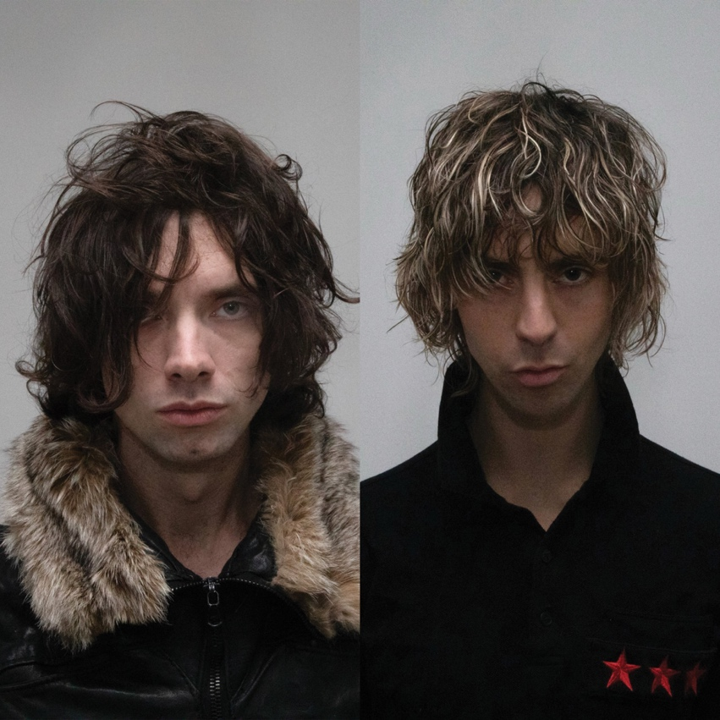
Chandler Ransom Lucy (L) + Noah Dillon (R)
photo courtesy of the artist; download hi-res here

May 16, 2023 – Los Angeles-based indie-electronic duo The Hellp announces the release of their new single “California Dream Girl” – (listen HERE) – and marking the duo’s debut release with Atlantic Records.

Comprised of songwriter and vocalist Noah Dillon and producer Chandler Ransom Lucy, The Hellp bears a wide range of sonic influences – equally influenced by the songwriting of Bruce Springsteen’s Nebraska as they are by the production of Crystal Castles.

Tonight (May 16), The Hellp will celebrate the release of “California Dream Girl” with a sold-out headline show at LA’s Teragram Ballroom. On May 31, they’ll headline another sold-out show at New York’s Bowery Ballroom.

The duo has already gained an incredibly dedicated following throughout New York and LA, regularly hosting sold-out performances at pop-up parties and tastemaker industry events. They’ve been widely credited with catalyzing the latest iteration of ‘Indie Sleaze,’ even prompting The Guardian to suggest they “prefigured the vibe shift” of the genre’s return. Via opening slots at their live shows and DJ sets, they’ve helped showcase their peers within the genre, including NY-based act The Dare.

Outside of The Hellp, Chandler is an accomplished model and Noah is a renowned photographer whose work has been commissioned by the likes of GQ, Balenciaga, Versace, Gucci, Nike, and more – leading international fashion magazine i-D to declare: “Noah Dillon is leading a creative revolution.”

The two first met on the set of a Hot Mess photo shoot, the art platform Noah founded alongside acclaimed model/stylist Luka Sabbat.

Despite their credibility and reputation within the worlds of high art and fashion, both artists come from entirely humble beginnings; Noah lived in his car for a full year while putting himself through medical school, and Chandler is an entirely self-taught producer who has worked in construction for the majority of his adult life.

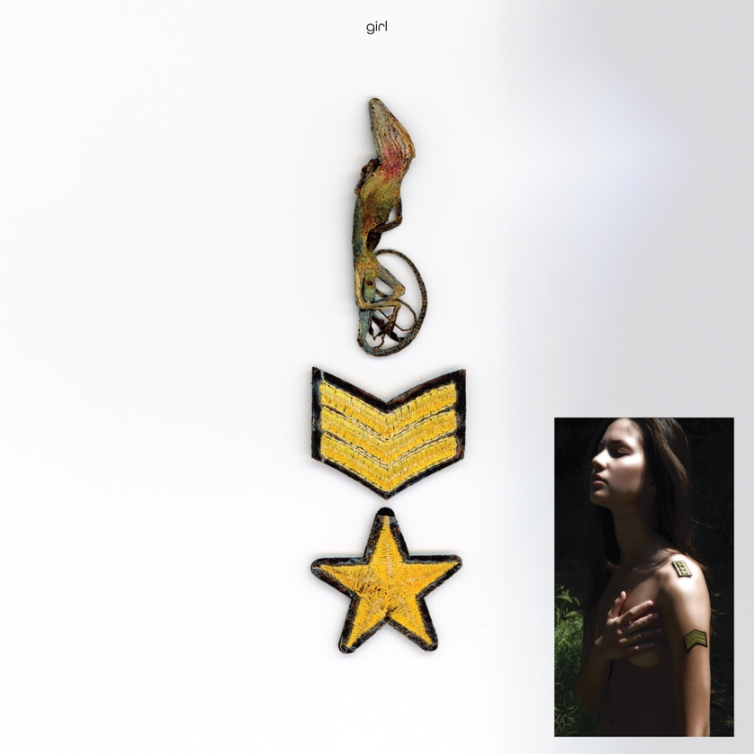
download hi-res “California Dream Girl” single artwork here

###

ABOUT THE HELLP:
The Hellp are an electronic music duo from Los Angeles, consisting of members Noah Dillon and Chandler Ransom Lucy. Outside of The Hellp, Noah is known for his photography and videography/documentary film. His work has been commissioned by the likes of GQ, Balenciaga, Versace, Gucci, Nike, and more. He founded the art platform Hot Mess alongside Luka Sabbat, and has lectured on his work at both Yale University and Otis College of Fine Arts. Chandler is an accomplished model who has been featured in many of Noah’s photographs, starred in several music videos, and been the face of a Midnight Studios lookbook.

Both artists come from entirely humble beginnings; Noah lived in his car for a full year while putting himself through medical school, and Chandler is an entirely self-taught producer who has worked in construction for the majority of his adult life.

###

CONNECT WITH THE HELLP
INSTAGRAM | TIKTOK | YOUTUBE

FOR ALL PRESS INQUIRIES, PLEASE CONTACT:
Libby Kober | Libby.Kober@atlanticrecords.com

