FOR IMMEDIATE RELEASE
JUNE 26, 2O23

BURNA BOY IS JOINED BY 21 SAVAGE FOR “SITTIN’ ON TOP OF THE WORLD”
VISUAL

WATCH/SHARE | DOWNLOAD/STREAM

WON BEST INTERNATIONAL ACT AT LAST NIGHT’S 2023 BET AWARDS

SET TO BECOME THE FIRST NIGERIAN MUSICIAN TO HEADLINE A STADIUM IN THE U.S. WITH HIS
CITI FIELD APPEARANCE IN NEW YORK ON JULY 8TH

RECENTLY MADE HISTORY WITH A SOLD-OUT PERFORMANCE AT LONDON STADIUM AND
CO-HEADLINED THE UEFA CHAMPIONS LEAGUE FINAL KICK-OFF SHOW

BECAME FIRST AFRICAN ARTIST TO REACH 1 BILLION STREAMS ON AUDIOMACK

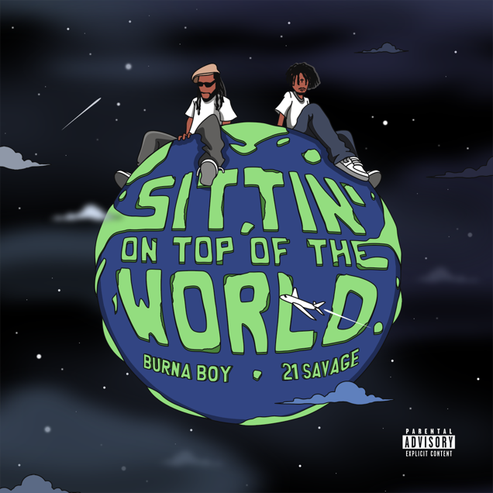
DOWNLOAD HI-RES ARTWORK

GRAMMY® Award-winning global superstar Burna Boy teams up with multi-platinum artist, 21 Savage, for the official visual for “Sittin’ On Top Of The World.” Produced by Skread, the single features a sample of Brandy’s 1998 hit "Top Of the World" ft. Mase and comes alongside the visual for the summer anthem. The visual, directed by Troy Roscoe, gives a timeless 90’s/early 00’s feel, complete with a flurry of beautiful women, classic cars, and strikingly fun graphics.

“Sittin’ On Top Of The World” showcases Burna’s romantic side addressing how he likes to shower his special lady with the finer things. The track arrives on the heels of his groundbreaking milestone as the first African artist to achieve 1 billion streams on its platform along with securing the 2023 BET Award for Best International Act as well as nominations for Best Male R&B/Pop Artist, Video Director of the Year and Viewer’s Choice Award, making this his 5th consecutive year that he’s been nominated.

Produced by Live Nation, the African Giant will be bringing his explosive performance to Citi Field in New York on July 8th making him the first Nigerian artist to headline a stadium in the U.S. Earlier this year, Burna Boy made jaw dropping appearances at Coachella, Dreamville Music Festival, Afro Nation Miami, the 2023 NBA All-Star Game halftime show and an incredible sold-out headline stop in front of 40,000 fans at Paris’ La Défense Arena. He also recently performed in front of a sold-out audience at London Stadium and co-headlined the 2023 UEFA Champions League Final Kick-Off Show in Istanbul, Turkey.

Burna Boy reached new heights with his sixth studio album “LOVE, DAMINI,” marking his highest U.S. debut to date on the Billboard Top 200 and his RIAA-certified platinum single “Last Last” topping the Billboard U.S Afrobeats Songs chart for 8 weeks before later claiming the #1 spot at Urban radio. The album also went on to become the #1 album on Apple Music in 47 countries while finishing at #2 in the UK and Netherlands, becoming his highest charting album in those territories. LOVE, DAMINI was selected as a The New York Times’ Critics Pick with additional praise from Rolling Stone, Billboard, Vulture, Variety, and many more.

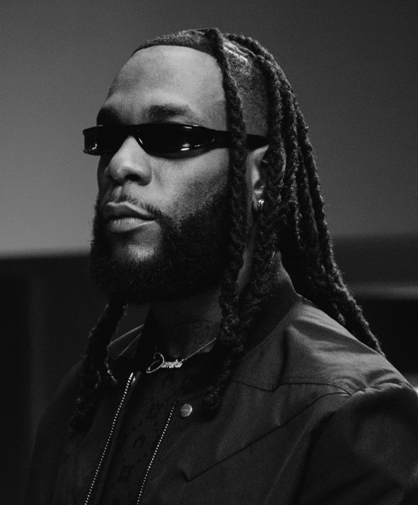
DOWNLOAD HI-RES ARTWORK + PRESS PHOTO
CONNECT WITH BURNA BOY
TWITTER | FACEBOOK | INSTAGRAM | YOUTUBE |TIKTOK
PRESS CONTACTS
Corey Brewer | Corey.Brewer@atlanticrecords.com
Selam Belay | Selam.Belay@atlanticrecords.com

