FOR IMMEDIATE RELEASE
JUNE 16, 2023

CKAY RELEASES SAD ROMANCE DELUXE

“CAPTURE MY SOUL” IS ONE OF FOUR NEW TRACKS ON THE DELUXE VERSION

THE ALBUM ALSO INCLUDES “HALLELUJAH,” “NWAYI,” AND “NNEKA”

DOWNLOAD HERE

The emo-Afrobeats singer-songwriter eagerly anticipated, Sad Romance Deluxe album, is a delight for his fans. In his most recent single release, "nwayi" (Igbo for "woman"), CKay returned to his signature emo-Afrobeats atmosphere. The song's 1 million streams are quickly approaching, with Sad Romance Deluxe, Africa's boyfriend making a comeback. It includes four new songs, including "hallelujah feat. Blaqbonez," "nwayi," "nneka," and "capture my soul feat. Joeboy."
Recent performances by CKay include those at the Weekend Festival in Finland, the HIPHOP OPEN festival in Stuttgart, Lollapalooza in Paris, the HIPHOP OPEN festival in Stuttgart, and one in his hometown Nigeria. 'hallelujah' is currently at the top of Apple Music's Top Songs Chart (NG) in Nigeria after receiving 12 million streams since its debut. Since this release, CKay's monthly listeners on Spotify have climbed by 7.68% to 13.6M. Sad Romance has received over 400 million streams. African music icons Davido, Ayra Starr, Focalistic, Mayra Andrade, and Ronisia all appeared on the debut album. The album's lead single, "captures my soul," continues the soft, tropical feel that CKay introduced in "nwayi." The main track for the album ‘captures my soul’ picks up where ‘nwayi’ left off with CKay’s smooth, tropical sound.
CKay explains the meaning of the main track:
“capture my soul” is a song that literally captures your soul when you listen to it. It is an expression of surrender to love. It’s a continuation of my emo-afrobeat sound and was produced by myself and BMH. BMH is a musical genius who always brings my ideas to life. He did his thing for sure on this one too. I decided to release a deluxe edition of Sad Romance because I grew romantically since the original and I have a fresh, positive outlook on love: Hearts get broken worldwide every day. It’s okay to be sad, but at a certain point, you have to move on and live your life. Go to a party, go indulge, go do whatever. But make sure you aren’t scared to fall in love again. It’s never deep.”
Fans from all over the world will have the chance to observe how CKay shares with us his emotional love story, revealing his frail side and addressing important topics that people encounter in their daily lives.
ABOUT CKAY
Chukwuka Ekweani, known publicly as CKay, is the rising star in the ever-burgeoning Afrobeats scene. A multi-talented artist, whether behind the boards as a producer or in front of the mic performing his self-penned songs, it is CKay’s single-minded vision that shines through. The self-defined Emo-Afrobeat star has and continues to soar up charts across the globe thanks to his first globally recognized single ‘love nwantiti’.
The Nigerian singer, songwriter, and producer originally released ‘love Nwantiti (ah ah ah)’ back in 2019 as part of his debut EP, CKay The First. In 2021, CKay became the most streamed artist of the year and became the first African artist with two tracks on the Global Spotify Top 30 simultaneously. ‘love nwantiti’ has been certified platinum/multi-platinum in five countries, including the United States, India and Italy. The viral hit has also been certified gold in the UK, Australia, South Africa and New Zealand. CKay became the first African artist in 50 years to hold a top 5 position on the UK Singles Chart for 4 straight weeks with ‘love nwantiti’.
CKay has continued to create a global presence with accomplishments such as the “most Shazam-ed song in the world”. ‘Emiliana’, followed suit and racked in global chart positions and currently has just over 400 million streams worldwide. ‘Emiliana’ peaked at #1 on the UK Afrobeats Chart, #2 on Shazam Top 200 (Afrobeats), and #1 in six countries on Apple Music.
CKay’s debut album Sad Romance was released last year and has since had over 380 million streams worldwide. With over 3.5 billion streams to his name and new music slated for 2023, CKay is in a prime position to continue his upward trajectory as a globally recognized singer-songwriter and producer.

The Sad Romance Deluxe album is out now, listen/stream here: http://ckay.lnk.to/sad_romance_deluxe

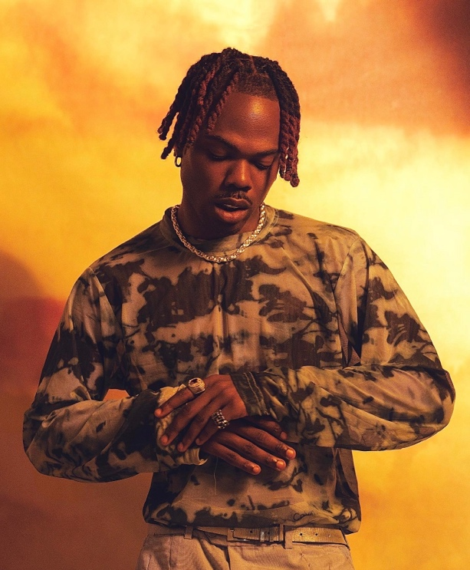

CONNECT WITH CKAY:
TWITTER | FACEBOOK | INSTAGRAM | TIKTOK | YOUTUBE

PRESS CONTACT:
ARIANA.WHITE@ATLANTICRECORDS.COM

