FOR IMMEDIATE RELEASE
JUNE 8, 2023

JASON DERULO HEATS UP THE SUMMER WITH “SLOW LOW”

MULTIPLATINUM GLOBAL SUPERSTAR SHARES LATEST
IN STRING OF CLUB-POP SMASHES

LISTEN TO “SLOW LOW”

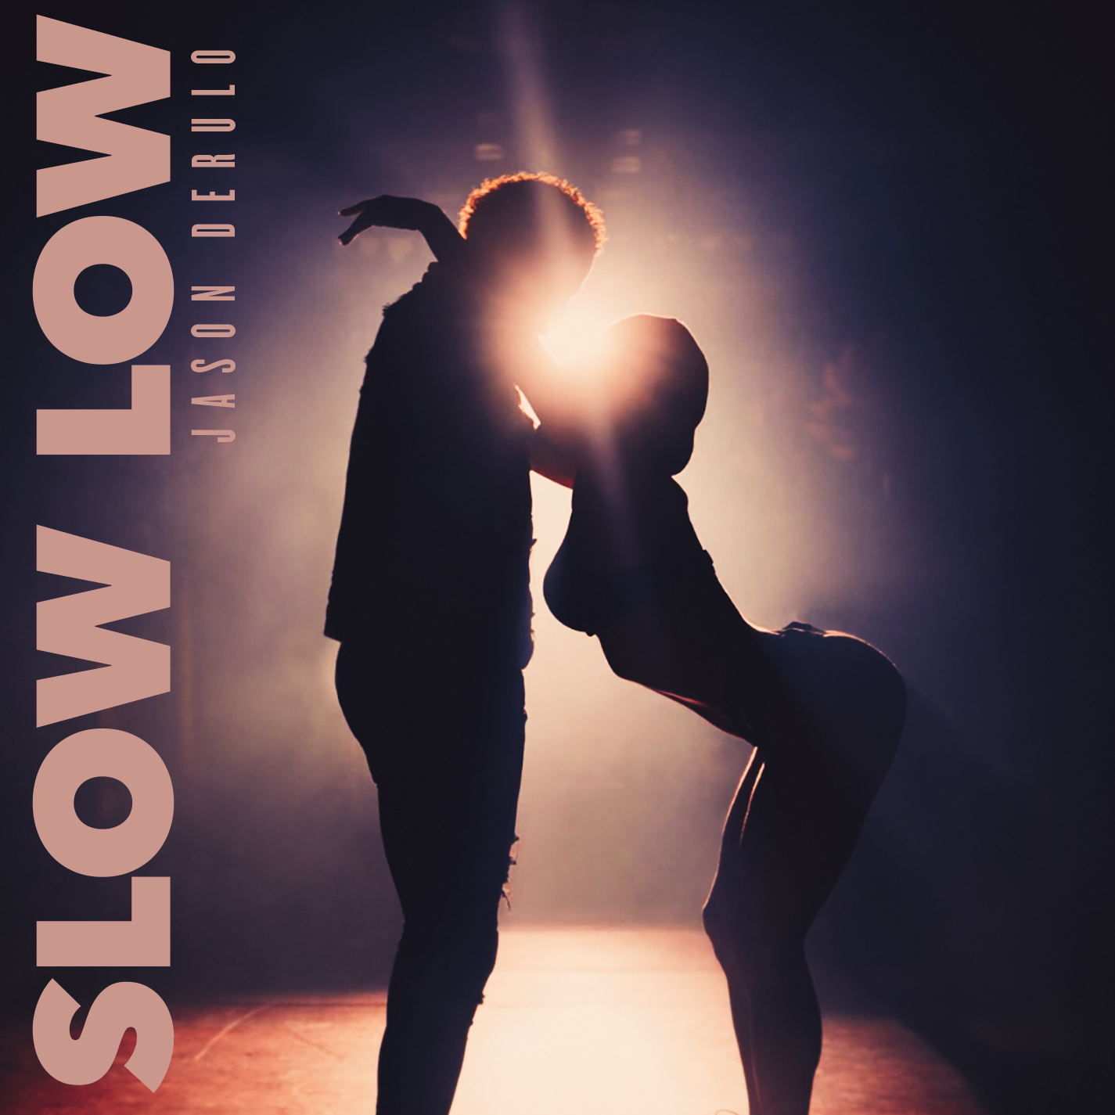
DOWNLOAD HI-RES ARTWORK HERE

Multiplatinum global superstar Jason Derulo has shared his latest summer smash, “Slow Low”, available now via Atlantic Records at all DSPs and streaming services HERE. Written by Jason Derulo and Shawn Charles, produced by Pink Slip (One OK Rock, Royal & The Serpent), and Jackson Morgan (Machine Gun Kelly, Sam Fischer), The change of tempo in “Slow Low” is a never-been-done-before creative choice that is sure to get everyone’s attention. Jason is no stranger to being a trendsetter and being first.

“Slow Low” marks the latest in a string of blockbuster hits from Derulo, including “When Love Sucks (Feat. Dido),” available now via Atlantic Records at all DSPs and streaming services HERE. Written by Jason Derulo and Shawn Charles and produced by Pink Slip, the sultry track interpolates Dido’s 1999 top 3 hit single, “Thank You,” famously sampled in Eminem’s classic “Stan.”

Other recent releases include “Glad U Came,” available now via Atlantic Records at all DSPs and streaming services HERE. Written by Jason Derulo and Shawn Charles and produced by Pink Slip, Jakke Erixson (Ava Max, Lauren Spencer Smith), Sam Martin (David Guetta, Maroon 5), Spencer Bastian (Rita Ora, Chromeo), and Tor Eimon (Faouzia, Chloe Tang), the smoothly dynamic track has earned more than 4M worldwide streams and is accompanied by an official lyric video streaming at YouTube HERE.

This winter saw the release of Derulo and David Guetta’s feel-good collaboration, “Saturday/Sunday.” The ultimate showcase for both artists’ signature approach towards club-ready pop anthems, the irresistibly energetic track is joined by an official dance video streaming at Derulo’s hugely popular YouTube channel HERE.

Derulo – who is currently starring among the coaching panel on The Voice Australia – celebrated “Saturday/Sunday” with a full-length live performance on the third annual NFL TikTok Tailgate, the league’s ultimate pregame party before Super Bowl LVII, live from State Farm Stadium in Glendale, AZ. In addition, portions of Derulo’s performance – which saw him joined by a pack of robot dogs and included such hits as the RIAA platinum-certified “Talk Dirty” – was televised in the FOX Super Bowl LVII Pregame Show.

ABOUT JASON DERULO
Forward-thinking, genre-defying, and massively creative, Jason Derulo has staked his claim as one of the most dynamic forces on the global pop landscape. Since breaking through with his 5x RIAA Platinum-certified single, “Whatcha Say,” the award-winning singer-songwriter who has a net worth in excess of $100 million, has sold more than 250M singles worldwide and achieved 15 Platinum singles including “Wiggle“, “Talk Dirty“, “Want to Want Me,” “Trumpets,” “It Girl“, “In My Head,” “Ridin’ Solo,” “Don’t Wanna Go Home,” “Marry Me,” “ The Other Side,” “Get Ugly,” “Swalla,” “Savage Love” and “Take You Dancing.” Since the start of his solo recording career in 2009, he has earned over 18.2B worldwide streams, and built an unstoppable social media following of over 117M followers across all platforms. Now at work on his highly anticipated fifth album – and full-length debut for Atlantic Records – Derulo has delivered an ongoing series of smash singles that have drawn a stunning 500M+ views, including the irresistibly buoyant “Acapulco,” the RIAA platinum-certified “Take You Dancing,” and Jawsh 685 x Jason Derulo’s 3x platinum-certified chart-topper, “Savage Love (Laxed – Siren Beat).” The latter track – and its official BTS remix – proved an unstoppable international sensation upon its 2020 arrival, peaking at #1 on Billboard’s “Hot 100” as well as atop charts in 16 additional countries around the world.

A truly multi-dimensional creator, Derulo has also established himself as an actor and businessman, investing in enterprises like Catch L.A. and Rumble Boxing, becoming part-owner of Bedlam Vodka, launching an innovation-minded podcast, and developing a line of supplements and fitness products with the Najafi Group and BodyBuilding.com. What’s more, Derulo unveiled Jason Derulo’s UZO, an immersive new graphic novel from Z2 Comics based on a TikTok character created by the artist himself.

With his TikTok regularly amassing over 10M views per post, Derulo notes that the platform has drastically reshaped his relationship with his fans. Derulo is now amongst TikTok’s biggest superstars, currently the 4th most followed male on the video-sharing platform with the 11th biggest account overall. He continues to see his already astronomical TikTok presence growing daily, now boasting more than 57.9M followers worldwide and over 1.2B likes. Reclaiming his title as the TikTok king, last year saw the summer smash single “Slidin’” released alongside a fan-challenged TikTok video to his own rendition of the electric slide (streaming HERE). His knack for laying undeniably catchy melodies on top of fun, upbeat productions, was the formula for his Summer takeover. To celebrate the single, Derulo hosted a wildly extravagant ”Slidin’” Weekend in Miami with some of his closest creator friends. The weekend included a private “Slidin’” jet set from LA to Miami; an insanely large “Slidin’” mansion; a sexy “Slidin’” yacht party; hibachi, dinners, clubbing and more (watch HERE).

# # #

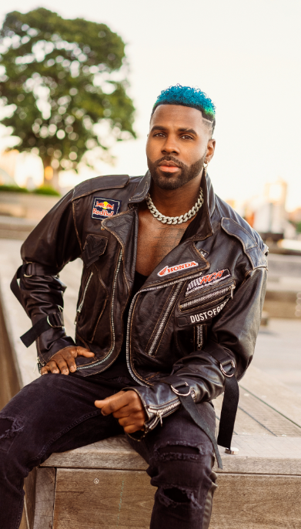
DOWNLOAD PRESS PHOTO HERE
PHOTO CREDIT: PETER O’DOWD

CONNECT WITH JASON DERULO
OFFICIAL | FACEBOOK | INSTAGRAM | TIKTOK | TWITTER | YOUTUBE

PRESS CONTACT FOR JASON DERULO
FAIRLEY MCCASKILL | FAIRLEY.MCCASKILL@ATLANTICRECORDS.COM

