FOR IMMEDIATE RELEASE
JUNE 15, 2023

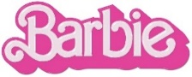
KAROL G ENTERS THE WORLD OF BARBIE IN VIDEO FOR “WATATI (FT. ALDO RANKS)”

GLOBAL RECORDING ARTIST SHARES OFFICIAL VISUAL FOR
ACCLAIMED NEW SINGLE FROM STAR-STUDDED BARBIE THE ALBUM

WATCH HERE

BARBIE + BARBIE THE ALBUM ARRIVE EVERYWHERE ON JULY 21ST

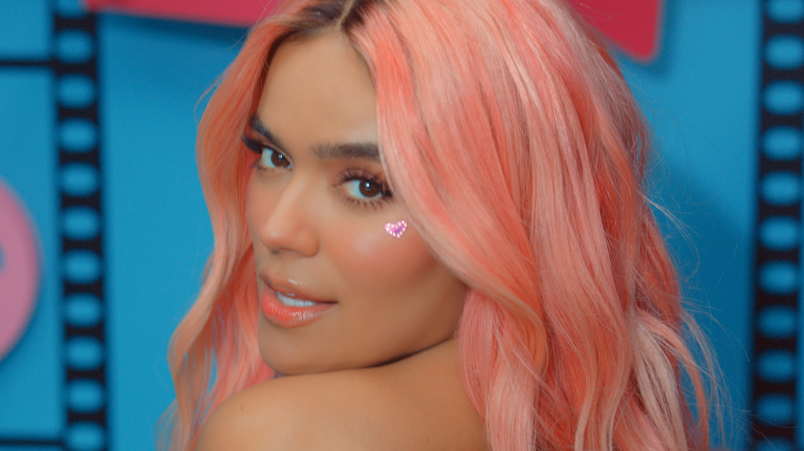
DOWNLOAD HI-RES IMAGES HERE

“A hard-hitting reggaeton with EDM tones” – BILLBOARD

“KAROL G brings reggaeton into the world of the upcoming ‘Barbie’ movie” – LATINA

“a lively reggaeton tune that brings even more color to an already-vibrant Barbie universe” – UPROXX

Global recording artist KAROL G has shared the official video for “WATATI (ft. Aldo Ranks),” the fierce new single from the star-studded BARBIE THE ALBUM. The high-energy anthem is now complemented by a visual directed by Mike Ho (Nicki Minaj, Megan Thee Stallion, Saweetie) starring KAROL herself as she enters the actual World of Barbie. Watch the official video, shot on-site at the World of Barbie in LA, HERE.

World of Barbie at Santa Monica Place is an interactive exhibit which gives guests the chance to live out their life-size Barbie® dream. Visit Barbie® Dreamhouse, Fashion Studio and Laboratory (among others), watch fun Barbie® content at Barbie® Theater, and check out World of Barbie Museum to learn more about how Barbie® dolls have inspired generations of girls to dream big. Tickets are available HERE.

Upon release, “WATATI” immediately received critical acclaim with ROLLING STONE calling it a “reggaetón party” and HOLA! stating it’s an “exciting addition, poised to be a hit.” Preceded by “Dance The Night” from 3x GRAMMY® Award-winning global superstar Dua Lipa, and followed by last week’s release of “Angel” from UK-based artist and producer PinkPantheress, the soundtrack’s lead singles have already amassed an impressive 150M+ combined global streams and video views.

BARBIE THE ALBUM is the groundbreaking musical companion to the highly anticipated summer event film Barbie, starring Margot Robbie and Ryan Gosling as Barbie and Ken and distributed by Warner Bros. Pictures. Pre-orders are available now HERE with the album arriving in stores and at all online retailers on Friday, July 21st in conjunction with the theatrical release of the feature film.

BARBIE THE ALBUM will also feature massive new tracks from an unprecedented lineup of artists including Nicki Minaj and Ice Spice, Lizzo, Charli XCX, PinkPantheress, Ava Max, Dominic Fike, Khalid, The Kid LAROI, Tame Impala, HAIM, GAYLE and FIFTY FIFTY feat. Kali. Barbie star Ryan Gosling also joins the robust roster of soundtrack artists with his iconic original song performed as his character, Ken.

ABOUT KAROL G
Karol G is a multi-platinum global recording artist, an international pop culture icon, and a leading Latin Music powerhouse. The two-time Latin GRAMMY® winner and recipient of 199 Diamond certifications from the RIAA in the United States is a top-selling artist with 77 billion combined career streams. Known for her ability to shatter records, Karol became the first female artist to debut at #1 on the Billboard 200 with a Spanish-language album, broke the all-time record for the biggest female Latin album by first-day streams on Apple Music, and had the biggest debut ever for a Spanish Album by a Female Latin Artist on Spotify. She is currently the most watched Artist of 2023 on YouTube excluding features with over 990 million Views this year alone. The superstar also attained the highest grossing North American tour of all time by a Latin female artist and ranked in on Pollstar’s Top 10 most successful music tours in the world with her "$trip Love Tour."

ABOUT BARBIE
To live in Barbie Land is to be a perfect being in a perfect place. Unless you have a full-on existential crisis. Or you’re a Ken. Warner Bros. Pictures Presents a Heyday Films Production, a LuckyChap Entertainment Production, an NB/GG Pictures Production, a Mattel Production, Barbie. The film will be distributed worldwide by Warner Bros. Pictures and released in theaters only nationwide on July 21, 2023 and internationally beginning July 19, 2023.

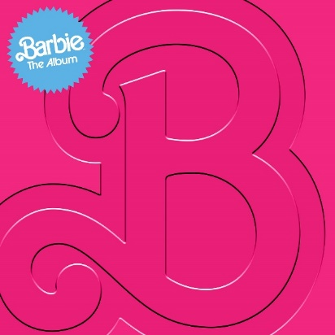

WHAT CRITICS ARE SAYING ABOUT BARBIE THE ALBUM:

“this thing is a tasting menu of who’s who” – ELLE

“It looks like there won't be any skippers on this album” – E! NEWS

“The Barbie soundtrack features *the* most star-studded ensemble” – COSMOPOLITAN

“Barbie definitely has some sick beats playing in those plastic headphones” – BILLBOARD

“The blockbuster-in-waiting is coming with an appropriately loaded soundtrack” – FADER

“Barbie The Album will be a veritable toybox of the biggest pop stars today.” – GRAMMY.COM

CONNECT:
BARBIETHEALBUM.COM | INSTAGRAM | TIKTOK | TWITTER | FACEBOOK | PRESS SITE

PRESS CONTACT:
ANDREW GEORGE
ANDREW.GEORGE@ATLANTICRECORDS.COM

