2x GRAMMY® AWARD-WINNING MULTI-PLATINUM ARTIST
LAUREN DAIGLE
ANNOUNCES RELEASE DATE
FOR COMPLETE 23-TRACK ALBUM
LAUREN DAIGLE

SET FOR SEPTEMBER 8, 2023
VIA ATLANTIC RECORDS/CENTRICITY MUSIC

DAIGLE TO PERFORM CHART-TOPPING HIT SINGLE
“THANK GOD I DO”
JULY 11 ON LIVE WITH KELLY AND MARK

LISTEN TO THE FIRST 10 SONGS
OF LAUREN DAIGLE HERE

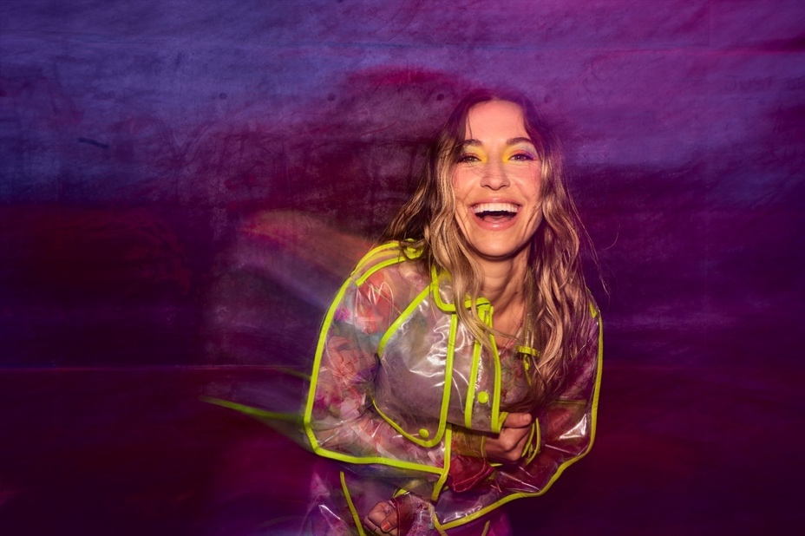
Download Hi-Res HERE | Photo Credit: Jeremy Cowart

“…one of the best singers in contemporary pop.” – VARIETY

“…filled with songs that highlight her brand of personal pop and soulful roots.” – BILLBOARD

“Songs on part one of Daigle's self-titled project take listeners on a sonic hop-scotch, from the soft-touch 1960s pop on ‘Waiting’ to feel-good jam ‘These Are The Days,’ introspective ballad ‘To Know Me,’ R&B-infused ‘New’ and the roots-inspired standout ‘St. Ferdinand.’” – THE TENNESSEAN

“With a new self-titled album coming out and a growing legion of fans, Daigle is now sharing her soulfully raspy voice and her deeply held faith with the world.” – SOUTHERN LIVING

Today, two-time GRAMMY® Award-winning singer-songwriter Lauren Daigle announces the release date for her highly-anticipated complete 23-track, self-titled album, Lauren Daigle. The full body of work will arrive Friday, September 8, 2023 via Atlantic Records/Centricity Music, showcasing the multi-faceted artist’s stunning and powerful voice, rich storytelling, and incredible musicality, and including standout songs “Salvation Mountain,” featuring Gary Clark Jr. as well as “Be Okay” which was written with Ellie Holcomb and will be released ahead of the album on August 4th.

Says Daigle:

“In May, I released the first 10 songs from my self-titled album. It had been a while since I had put out new music, so I wanted to share these songs as soon as they were ready to go. This is just the beginning of the journey to the complete story of the 23-song album, which I am excited to announce is coming out September 8. These 23 tracks represent all that I am – they embody my soul and my spirit. I can’t wait for you all to hear them.”

Download Hi-Res Album Artwork HERE

LAUREN DAIGLE: Tracklist

- Thank God I Do
- Saint Ferdinand (feat. Jon Batiste and Natalie Hemby)
- New
- Waiting
- To Know Me
- Kaleidoscope Jesus
- Valuable
- Don’t Believe Them
- Ego
- These Are The Days
- Salvation Mountain (feat. Gary Clark Jr.)
- Back To Me
- 21 Days
- Love Me Still
- Interlude #1
- Turbulent Skies
- Sometimes
- Interlude #2
- Inherited
- He’s Never Gunna
- Be Okay
- Interlude #3
- You’re All I’ll Take With Me

Led by GRAMMY®-winning producer Mike Elizondo (Twenty One Pilots, Mary J. Blige, Fiona Apple, Carrie Underwood) and featuring co-writes with award-winning songwriters, including Natalie Hemby, Amy Wadge, Shane McAnally, Jason Ingram, Lori McKenna, and Jon Greene, Lauren Daigle marks a new creative chapter for the Louisiana-born artist.

Daigle shared the album’s first 10 songs in May to immediate critical acclaim from the likes of Billboard, The Tennessean, and Variety, the latter of whom declared her “one of the best singers in contemporary pop.”

Also in May, Daigle performed soulful cut “These Are The Days” live on the season finale of American Idol, before joining season 21’s runner-up Megan Danielle for a powerful rendition of current single, “Thank God I Do” (watch HERE).

“Thank God I Do” is currently a Billboard #1 single, Top 15 at Hot AC Radio and Top 10 at AC Radio, where it continues to rise. Daigle will bring the stunning ballad to Live with Kelly and Mark on Tuesday, July 11 (check local listings), marking her latest live TV performance of the song.

Later this year, Daigle will embark on her highly-anticipated US arena tour – The Kaleidoscope Tour – which kicks off on September 6 in Memphis, TN, and includes stops in LA, New Jersey, Boston, Atlanta, Seattle, Baton Rouge, and many more cities in between. Tickets are now on sale at www.laurendaigle.com, and all upcoming tour dates are enclosed below.

***

With over a billion streams and years of sold-out US and international tours to her name, Lauren Daigle continues to cement her status as a modern vocal powerhouse with a global, ever-growing fanbase.

Since the release of her GRAMMY® Award-winning, platinum-certified 2018 album Look Up Child – which includes the breakthrough, newly-6x platinum-certified hit single “You Say” – Daigle has been a mainstay on the Billboard charts. When Look Up Child debuted at No. 3 on the Top 200 Albums chart, Daigle became the first female artist in history to simultaneously hit the Top 10 on both Billboard’s Pop and Christian Album charts. She went on to break another record when the LP reached 100 weeks at No. 1 on the Top Christian Albums chart, which is the greatest number of weeks that any artist has spent at the top of any individual album chart. Similarly, “You Say” is the longest-running No. 1 to appear on any weekly Billboard chart. Born in Lake Charles, Louisiana, Daigle is a two-time Grammy®, seven-time Billboard Music Award, four-time American Music Award, and ten-time GMA Dove Music Award winner.

Off stage, Daigle remains committed to investing her time to promote music education, work with at-risk youth, and provide care for children, the elderly, and those in need through The Price Fund, an organization she founded in 2018. To date, she has distributed over $2.5 million to 42 nonprofits around the world.

***

LAUREN DAIGLE: UPCOMING TOUR DATES
*NOT PART OF KALEIDOSCOPE TOUR

JULY
6 – Milwaukee, WI – Summerfest*
13 – Philadelphia, PA – TD Pavilion at the Mann*
14 – Lewiston, NY – Artpark Amphitheater*
15 – Mineral City, OH – Alive Music Festival*
20 – Paso Robles, CA – California Mid-State Fair*

SEPTEMBER
6 – Memphis, TN – FedExForum
7 – Bossier City, LA – Brookshire Grocery Arena
8 – Baton Rouge, LA – Raising Cane’s River Center
14 – Grand Rapids, MI – Van Andel Arena
15 – Indianapolis, IN – Gainbridge Fieldhouse
16 – Hoffman Estates, IL – NOW Arena
28 – Wichita, KS – INTRUST Bank Arena
29 – Des Moines, IA – Wells Fargo Arena
30 – Minneapolis, MN – Target Center

OCTOBER
4 – Charleston, WV – Charleston Coliseum
5 – Louisville, KY – KFC Yum! Center
6 – Atlanta, GA – State Farm Arena
19 – Boston, MA – Agganis Arena
20 – Newark, NJ – Prudential Center
21 – Baltimore, MD – CFG Bank Arena
26 – Kansas City, MO – T-Mobile Center
27 – St. Louis, MO – Enterprise Center
28 – Columbus, OH – Schottenstein Center

NOVEMBER
10 – Los Angeles, CA – Crypto.com Arena
11 – Phoenix, AZ – Desert Diamond Arena
14 – Sacramento, CA – Golden 1 Center
16 – Portland, OR – Moda Center
17 – Spokane, WA – Spokane Arena
18 – Seattle, WA – Climate Pledge Arena
30 – Tulsa, OK – BOK Center

DECEMBER
1 – Ft Worth, TX – Dickies Arena
2 – San Antonio, TX – AT&T Center
7 – Greensboro, NC – Greensboro Coliseum
8 – Knoxville, TN – Thompson-Boling Arena
9 – Greenville, SC – Bon Secours Wellness Arena

CONNECT WITH LAUREN DAIGLE
Website | Facebook | Instagram | Twitter | TikTok | YouTube

For More Information, Please Contact:
Sheila Richman | Atlantic Records | Sheila.Richman@atlanticrecords.com
Katy Carmichael | Atlantic Records | Katy.Carmichael@atlanticrecords.com

Paul Freundlich | PFA Media | paulf@pfamedia.net
Alicia Krass | PFA Media | akrass@pfamedia.net
