FOR IMMEDIATE RELEASE
JUNE 8, 2023

MAHALIA UNVEILS NEW SINGLE “CHEAT” FEAT. POP POWERHOUSE JOJO

ACCOMPANIED BY COMPANION VISUAL

IRL ALBUM RELEASING JULY 14TH

IN REAL LIFE UK AND EUROPE TOUR LAUNCHING THIS FALL

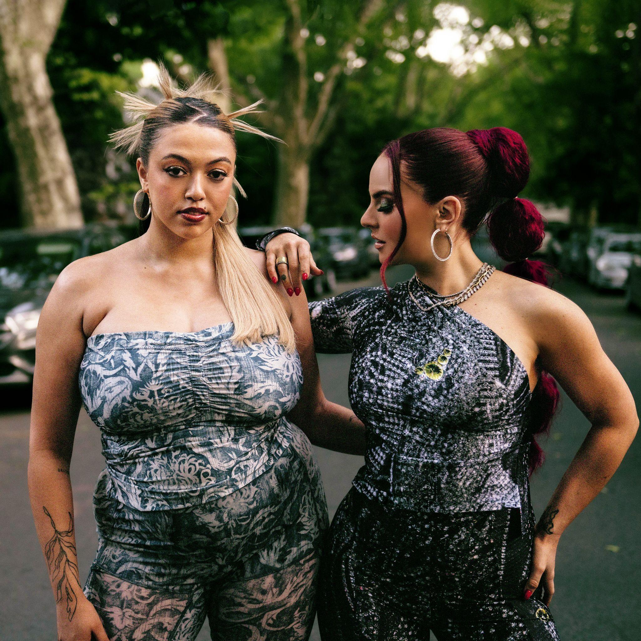
DOWNLOAD HI-RES ARTWORK
LISTEN/WATCH HERE
PREORDER IRL

Further to the release of her brilliant and bold new single ‘Terms and Conditions’ last month and the announcement of her highly anticipated second album ‘IRL’ (an abbreviation of in real life) today, British star Mahalia has unveiled her brand new single ‘Cheat’, featuring none other than pop powerhouse, JoJo.

"I can’t quite believe this one is real. I have been a fan of JoJo for as long as I can remember so having her on this record really is a dream come true for me.” Mahalia says of the record. “I love watching people come together through hardship and everything about this song represents that. For me, it is a song about strength, power, and letting go."

The single also arrives with a bold and vibrant accompanying video. Shot in New York and directed by filmmaker Boma Iluma, the visual is reminiscent of some of the most recognized, unapologetic duets of the 90s. The pair deliver the ultimate performance; one that champions the power and strength of female solidarity during a period of infidelity.

“I loved teaming up with Mahalia on this fully infectious bop,” JoJo states on the collaboration. “Not only can I not get the melodies out of my head… but I’ve BEEN THERE. And it feels good to be singing with my friend about this very real part of growing up: Realizing that some boys are for the streets and will never change.”

In addition to the album announcement last month, Mahalia also announced a huge UK and European Tour for the end of 2023. The ‘In Real Life Tour’ begins in Leeds on October 8th and concludes in Berlin on November 7th. The
UK-leg also includes a stop at London’s prestigious Eventim Apollo (FKA Hammersmith Apollo) on 19th October. Tickets are available to purchase via www.mahaliamusic.com.

In the world of music, there are shining beacons of light – artists, producers, musicians – that make us happy listeners and effortlessly provide us with inspiration. One of those UK artists is undoubtedly Mahalia. Her debut album 'Love and Compromise’ landed in the summer of 2019 and soon became a critically acclaimed introduction. Through her music, she effortlessly weaves soul, contemporary R&B, and 70s in one intoxicating concoction. Passionate in her commitment to a heartfelt display of emotion, she combats the current trend in music of toxicity in this terrain and calls for a balance in perspectives. As a result, Mahalia says that “[This culture] has not allowed people to feel all-encompassing, suffocating emotions.” Throughout her 2022 release, ‘Bag Of You’, she even apologizes for her neediness, but still battles through her conflictions to be transparent, admitting she wants her lover all to herself. In her head, Mahalia wants to make her fans feel in the way that an older generation of lovers made her feel. Citing Bonnie Raitt’s ‘I Can’t Make You Love Me’, as well as Anthony Hamilton’s ‘Charlene’ as exemplary love staples.

Emboldened by her inflections, insights, and young adulthood, Mahalia is not only breaking the mold on her second album but is determined to live life cognizantly. “This is a real reflection of the journeys I've had, what actually happened, and a celebration of everyone who got me there. There are names and family members I mention because it all helped in shaping who I am,” Mahalia rationalizes. With an innocent, yet assured gleam appearing on her face, “I’m so proud of this album, and so proud of how much I challenged myself to just let those stories out.”

The last few years have marked many achievements for the Leicester-born star. Beginning 2020 with her second BRIT nomination, Mahalia featured on up-and-coming fellow Midlands rapper Pa Salieu’s debut mixtape, ‘Send Them To Coventry’, whilst also gracing the tracklist of Headie One’s #1 album ‘Edna’. Subsequently, Mahalia also received a GRAMMY nomination for ‘All I Need’ - Jacob Collier’s single of which she features alongside US rapper, Ty Dolla $ign. Shortly after, Mahalia concluded the year with three MOBO nominations for ‘Best Female Act’, ‘Best R&B/Soul Act’ and ‘Album Of The Year’ for her debut album, ‘Love and Compromise’, winning in the first two categories. In 2021, Mahalia was also nominated for her first ever Ivor Novello award for her 2020 collaboration with UK lyricist Pa Salieu for his single ‘Energy’ and subsequently concluded the year with an incredible headline show at London’s prestigious venue, O2 Brixton Academy. Adding to her long list of achievements Mahalia opened for Adele at her 2022 BST shows in Hyde Park last Summer whilst also joining Alicia Keys during her o2 Arena shows in London - she then concluded the year on a high, winning her third MOBO Award for Best R&B/Soul Act.

Besides the awards and nominations, it’s also been a time of deep personal growth, one that Mahalia describes as a real rollercoaster in her personal and professional life. Reflection has been the thread running through Mahalia’s writing and the singer hopes that her music will encourage her listeners to carve out time to also look back and re-evaluate: “We’re all fixated on how we can make ourselves better, but I want people to also reminisce on lovely or painful situations they’ve lived through and how they’ve helped shape the people they are now.”

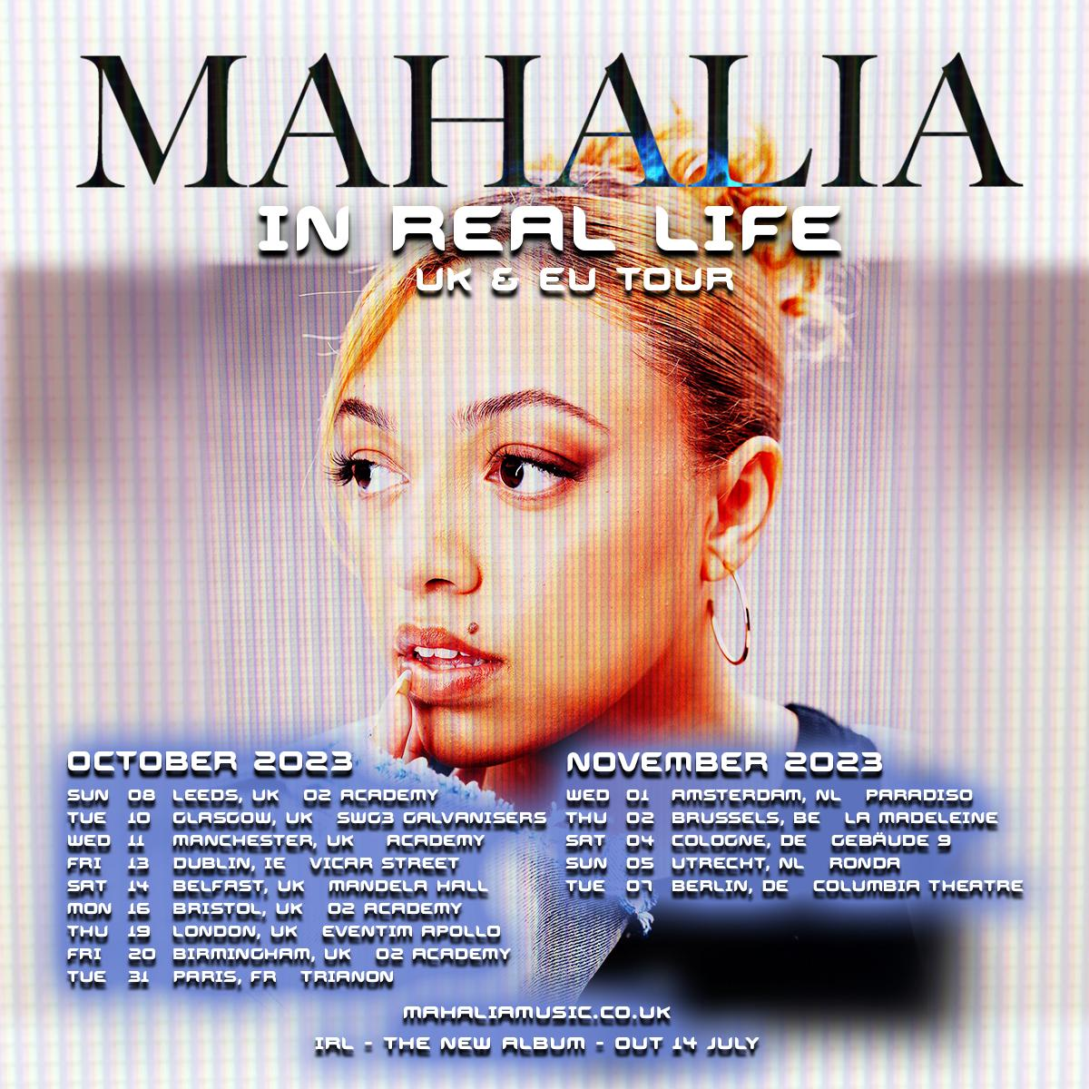

IN REAL LIFE – UK & EUROPE TOUR

October 2023
Sun 08 – Leeds – O2 Academy
Tue 10 – Glasgow – SWG3 Galvanisers
Wed 11 – Manchester – Academy
Fri 13 – Dublin – Vicar Street
Sat 14 – Belfast – Mandela Hall
Mon 16 – Bristol – O2 Academy
Thu 19 – London - Eventim Apollo
Fri 20 – Birmingham – O2 Academy
Tue 31 – Paris, FR – Trianon

November 2023
Wed 1 – Amsterdam, NL – Paradiso
Thu 2 – Brussels, BE – La Madeleine
Sat 4 – Cologne, GE – Gebäude 9
Sun 5 – Utrecht, NL – Ronda
Tue 7 – Berlin, GE – Columbia Theatre

# # #

CONNECT WITH MAHALIA
OFFICIAL WEBSITE | TWITTER | FACEBOOK | INSTAGRAM

PRESS CONTACT
ARIANA WHITE | ARIANA.WHITE@ATLANTICRECORDS.COM

